*Introduction to Open Educational Resources (OERs)*

University of Melbourne

8 September 2022

Project coordinators: Zachary Kendal, Amy Perkins-White

Project team members: Emily Clarke, Ben Gilmour, Monica Raszewski, Mary Stone

Steering committee: Eleanor Colla, Dimity Flanagan, Peta Humphreys, Ashley Sutherland, Kylie Tran

*Except where otherwise noted, this subject content is licensed under a*[*Creative Commons Attribution-ShareAlike 4.0 International*](https://creativecommons.org/licenses/by-sa/4.0/) *licence.*

Contents

[Subject overview 3](#_Toc113541333)

[Module 1: What are OERs? 4](#_Toc113541334)

[1.0. Introduction 4](#_Toc113541335)

[1.1. OER, OEP, and the 5 R's 4](#_Toc113541336)

[1.2. Creative Commons licences 7](#_Toc113541337)

[1.3. Quiz 11](#_Toc113541338)

[Module 2: Benefits of OERs 13](#_Toc113541339)

[2.0. Introduction 13](#_Toc113541340)

[2.1. Social justice 13](#_Toc113541341)

[2.2. Flexibility 16](#_Toc113541342)

[2.3. Quiz 18](#_Toc113541343)

[Module 3: Situating OERs 20](#_Toc113541344)

[3.0. Introduction 20](#_Toc113541345)

[3.1. OERs in the open scholarship ecosystem 20](#_Toc113541346)

[3.2. The global context of OERs 26](#_Toc113541347)

[3.3. Quiz 30](#_Toc113541348)

[Module 4: Find & Evaluate 32](#_Toc113541349)

[4.0 Introduction 32](#_Toc113541350)

[4.1 Finding OERs 32](#_Toc113541351)

[4.2. Evaluating OERs 37](#_Toc113541352)

[4.3 Quiz 39](#_Toc113541353)

[Module 5: Adapt & Create 40](#_Toc113541354)

[5.0 Introduction 40](#_Toc113541355)

[5.1. The process of adapting or creating OERs 40](#_Toc113541356)

[5.2. Copyright, IP, and licensing OERs 44](#_Toc113541357)

[5.3. Practical tips for adapting or creating OERs 48](#_Toc113541358)

[5.4. Quiz 52](#_Toc113541359)

[Continue your learning 54](#_Toc113541360)

[Appendix 1: The 5 R’s of OER (infographic) 56](#_Toc113541361)

[Appendix 2: Explore the licences (H5P interactive) 57](#_Toc113541362)

[Appendix 3: Open research (H5P interactive) 59](#_Toc113541363)

[Appendix 4: OERs around the world (H5P interactive) 63](#_Toc113541364)

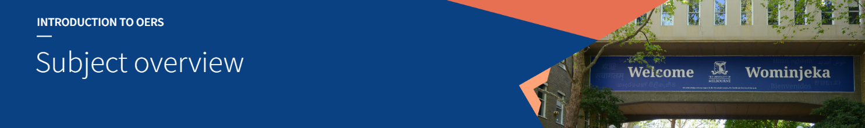

# Subject overview

#### Open Educational Resources and Scholarly Services

Scholarly Services is introducing a limited service offering in Open Educational Resources (OERs) to progress goals around openness, equity and inclusion laid out in [*Scholarly Information Futures (2020-2025)*](https://about.unimelb.edu.au/__data/assets/pdf_file/0029/126794/RFQ01543-ScholarlyInformationFutures20202025-v4B.pdf) (*SIF*).

Over the past year, the OER Project Group\* has worked to identify the knowledge and resource requirements to support this service. As a result, the project group has taken the opportunity to facilitate the creation of a professional development course for liaison teams.

Completing these online modules will equip participants with the required knowledge to confidently advise academics on OERs.

#### About this course

The course, *An Introduction to Open Educational Resources*, is the deliverable of project 1 “Building staff capability in OERs for Scholarly Services staff”\*\*.

Following the completion of project 1, Scholarly Services will progress to project 2, “OER Resources for Academic Staff and Students”. Once advice is available on Library webpages, liaison team members will be able to direct and guide academics through the appropriate resources.

While this course was created for liaison team members, we encourage any staff with an interest in this area to speak with their manager about undertaking the course.

#### The initial service offering

The initial service offering will focus on the promotion of existing OERs that academics and students may wish to use in their teaching, learning, and research.

Where appropriate, liaison teams will provide broad information and advice on finding, using, and re-using OERs. They will also direct academics and students to examples of OERs, this may range from examples of published OERs, information on a variety of industry and provider websites, and various other resources.

#### Service development

The service does not extend to the support of publishing OERs at this stage. Representative of the *SIF* timeframe, Scholarly Services is keen to monitor the uptake and interest in OERs before further decisions are made on service development.

As with all forms of service delivery by SASS staff, it is important that any service expansion is preceded by a clear demand from our academic community and an assessment on required resource levels.

*\* OER Project Group: Eleanor Colla, Dimity Flanagan, Peta Humphreys, Ashley Sutherland and Kylie Tran*

*\*\* “Building staff capability in OERs for Scholarly Services staff” project team: Zachary Kendal and Amy Perkins-White (Project Co-Leads), Emily Clarke, Ben Gilmour, Monica Raszewski and Mary Stone*

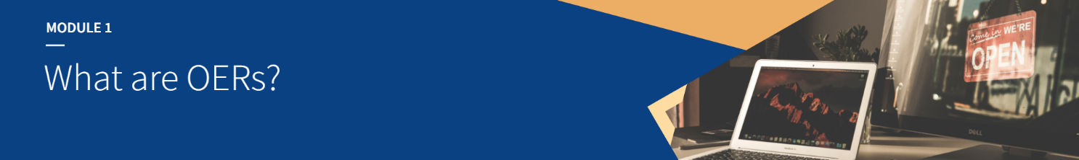

# Module 1: What are OERs?

## 1.0. Introduction

#### Learning outcomes

By the end of this module, you’ll be able to:

* Define open educational resources (OERs) and open educational practices (OEPs).
* Understand the meaning of the 5 R activities.
* Differentiate between OERs and DRM-free resources.
* Classify the various Creative Commons licences.

#### Time commitment

~ 20 minutes.

## 1.1. OER, OEP, and the 5 R's

### 1.1.1. What are OERs?

Open educational resources (OERs) are learning and teaching materials that are either in the public domain or have been released under an open licence. OERs can be freely used, changed, or shared with others.

Educational resources include courseware, textbooks, games or activities, video or audio clips, and subject or course syllabi.

### 1.1.2. What are the 5 R's?

According to David Wiley’s (n.d.) influential definition, a true OER is one that is “either (1) in the public domain or (2) licensed in a manner that provides everyone with free and perpetual permission to engage in the 5R activities.”

Wiley describes these 5 R’s as follows:

1. **Retain** – make, own, and control a copy of the resource (e.g., download and keep your own copy).
2. 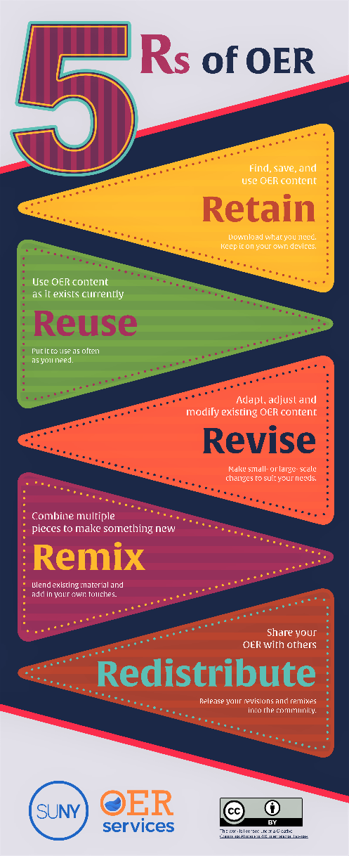**Revise** – edit, adapt, and modify your copy of the resource (e.g., translate into another language).
3. **Remix** – combine your original or revised copy of the resource with other existing material to create something new (e.g., make a mashup).
4. **Reuse** – use your original, revised, or remixed copy of the resource publicly (e.g., on a website, in a presentation, in a class).
5. **Redistribute** – share copies of your original, revised, or remixed copy of the resource with others (e.g., post a copy online or give one to a friend).

It’s important to remember, however, that openness is always a scale. As we’ll see when we look at Creative Commons licences, some open licences don’t allow full engagement with the 5 Rs – they may not permit revising or remixing, for example. Such resources are still OERs – still free to download, use, and share – but they do not meet the best-practice standards of ‘true’ OERs.

Nonetheless, the 5 R’s have become a touchstone for definitions of OERs. Wiley’s above definitions were published with a Creative Commons Attribution licence at [opencontent.org/definition](https://opencontent.org/definition/). You can download a copy of the infographic to the right for later reference and reuse here: [5Rs of OER infographic.pdf](https://wiki.ubc.ca/images/c/c9/5Rs_of_OER_Infographic.pdf)(accessible version: [5RsofOER.docx](#_Appendix_1:_The)).

### 1.1.3. What is OEP?

Open educational practice (OEP) is often discussed in relation to OERs and the open education ecosystem. Although definitions of OEP vary, an oft-cited one by Ehlers (2011, p. 4) reads:

OEP are defined as practices which support the (re)use and production of OER through institutional policies, promote innovative pedagogical models, and respect and empower learners as co-producers on their lifelong learning path.

Such practices may include open pedagogy, the development and use of OERs, sharing a range of materials and knowledge, and integrating openness throughout the classroom. For some examples of how OERs can contribute to open pedagogies, see [2.2. Flexibility](#_2.2._Flexibility).

### 1.1.4. OERs and DRM-free resources

*DRM* stands for *Digital Rights Management*. DRM systems allow publishers and vendors to impose limitations on the sharing and use of digital material such as ebooks and videos. As well as restricting sharing, DRM can also make it difficult to open protected material on different devices or in different apps.

DRM-free resources eliminate such limitations. They can be opened with ease on a range of devices and apps, and the files can be freely shared, edited, and reformatted – although copyright and licence conditions will apply.

Most of the electronic journal articles we access through our subscriptions are DRM-free. DRM remains more common for ebooks, although some providers, such as JSTOR, have moved to DRM-free ebook models.

Note that although OERs are all free of DRM, when we talk about “DRM-free resources” we’re referring to those that involved a cost – a cost usually borne by library subscriptions, in the university context. Unlike open access material, DRM-free material is still *paywalled*, although they are not typically subject to the limits on simultaneous use that some publishers employ.

Thus, unlike OERs, DRM-free resources are *not openly licenced*. The materials are All Rights Reserved and cannot be reused, revised, remixed, or redistributed, without breaching copyright (unless permissions are obtained).

Take a moment to tackle the drag-and-drop activity below. Based on the explanation provided above, drag the descriptions on the right to either the "Open educational resource" or "DRM-free resource" column, then hit "Submit"!

**H5P: OER vs. purchased DRM-free (CC BY-SA)**

[**https://unimelb.h5p.com/content/1291613577220051419**](https://unimelb.h5p.com/content/1291613577220051419)

### **Further resources & bibliography**

Ehlers, U-D. (2011). Extending the territory: From open educational resources to open educational practices.  *Journal of Open, Flexible and Distance Learning*, *15*(2). <https://www.jofdl.nz/index.php/JOFDL/article/view/64>.

SUNY OER Services (2018). Defining OER.In *Understanding OER Community Course.* <https://courses.lumenlearning.com/suny-oercommunitycourse-understandingoer/chapter/defining-oer/>.

Wiley, D. (2022). Improving learning. [blog]. <https://opencontent.org/blog/>.

Wiley, D. [David Wiley]. (2020, December 1). An Introduction to OER [YouTube video]. YouTube. <https://www.youtube.com/watch?v=5FNFJhOEQMQ>.

Wiley, D. [n.d]. Defining the “Open” in Open Content and Open Educational Resources. <https://opencontent.org/definition/>.

## 1.2. Creative Commons licences

### 1.2.1. What are Creative Commons licences?

Creative Commons licences provide a standardised way to grant the public permission to use work under copyright law.

The licences were created by the Creative Commons non-profit organisation, which is dedicated to making it easier to share and reuse work within the copyright context. The free licences allow creators to mark their work according to the level of openness they wish to embrace.

When using Creative Commons licensed work, it’s important to understand the differences between the licences. Take a moment to watch this short video explaining Creative Commons licences before we explore more details below.

**YOUTUBE: “Creative Commons licences explained,” Process Arts / Mohawk Media for Creative Commons Aotearoa New Zealand, 13 October 2011.**[**CC BY 3.0 NZ**](https://creativecommons.org/licenses/by/3.0/nz/)**.**

[**https://www.youtube.com/watch?v=4ZvJGV6YF6Y**](https://www.youtube.com/watch?v=4ZvJGV6YF6Y)

### 1.2.2. Licence elements

Creative Commons licences are built using four elements that govern the use and reuse of material. These are:

|  |  |  |
| --- | --- | --- |
|  | **BY – Attribution** | Credit must be given to the creator. |
|  | **SA – Share Alike** | Adaptations must be shared under the same terms. |
|  | **NC – Non-Commercial** | Only non-commercial uses of the work are permitted. |
|  | **ND – No Derivatives** | No derivatives or adaptations of the work are permitted. |

### 1.2.3. Public domain

Using a CC zero licence – one without any of the above elements – an author can dedicate a work to the public domain and relinquish their copyright.

|  |  |  |
| --- | --- | --- |
|  | **Ø – Zero** | Public domain dedication. No copyright. |

There’s a common misconception that everything freely available online is in the public domain – and sometimes the term is used interchangeably with *public sphere* to refer to publicly available knowledge or public discourse. However, when it comes to copyright, *public domain* means something very specific.

A work is in the public domain when no one holds copyright – when there are no restrictions on how the work can be used. A work will be in the public domain if:

* the creator has dedicated their work to the public domain through a CC0 licence;
* the copyright of a work has expired (for example, most countries consider a book to be in the public domain if 70 years has passed since the author’s death); or
* the work was never subject to copyright, having been created before copyright law was established (the works of Shakespeare, for example).

This means, for instance, that most images found online are not in the public domain, as they are still under copyright with all rights reserved. The same is true for most text and other media found online.

Creative Commons has created a Public Domain Mark, so people can clearly indicate when something is in the public domain due to copyright having expired (or never been applicable):

|  |  |  |
| --- | --- | --- |
|  | **Public Domain Mark** | No known copyright. |

### 1.2.4. Explore the licences

Click on the information buttons below to learn more about the different licences.

*Or download a text version:*[*explore-the-licences.docx*](#_Appendix_2:_Explore)

**H5P: Creative Commons licences (marks and descriptions CC BY, Creative Commons)**

[**https://unimelb.h5p.com/content/1291607553685432999**](https://unimelb.h5p.com/content/1291607553685432999)

### 1.2.5. A scale of openness

As discussed in the video above, Creative Commons licences can be more open or less open, depending on the elements they use.

Aside from material in the public domain, the most open licence is CC BY, which only requires attribution of the original creator or source. At the other end of the scale, the CC BY-NC-ND licence is the most restrictive, requiring not only attribution, but also that the material is only used for non-commercial purposes and no derivatives are created.

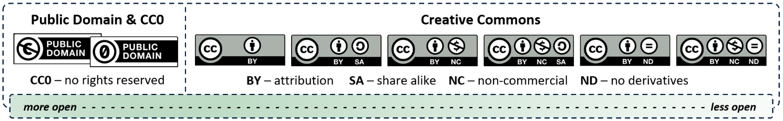

alt="An infographic showing the Creative Commons scale of openness. From more to less open, we have: Public Domain and CC0, CC BY, CC BY-SA, CC BY-NC, CC BY-NC-SA, CC BY-ND, CC BY-NC-ND."

### 1.2.6. Challenges for OERs

More restrictive licences can pose problems for OERs and limit their potential for the 5 R activities. The most problematic CC licence elements for OERs are:

|  |  |  |
| --- | --- | --- |
|  | **ND – No Derivatives** | The ND element prevents material from being *revised* or *remixed*. Students wouldn’t face an access barrier – one of the key benefits of OERs – but academics would have to work within the limitations of the licence.  When used for an open textbook, for example, an ND element still allows the book to be freely downloaded, retained, used in the classroom, and shared. Adapting or modifying the book, however, would not be permitted. This means that an academic couldn’t add course-specific content to the textbook, make changes to suit the Australian context, or update the content between semesters. |
|  | **NC – Non-Commercial** | Works that carry the NC element can be freely used for educational purposes. Any resultant resources should be freely available, however, so that access does not depend on tuition fees. In effect, NC limits how one may revise, remix, reuse, or redistribute. |

### 1.2.7. Creative Commons licences and the 5 R's

Take some time to inspect the following table, which outlines which Creative Commons licences enable each of the 5 R activities. Licences that work well for OERs are in white (the first five rows), and those that limit adaptation are in grey (last two rows).

|  |  |  |  |  |  |
| --- | --- | --- | --- | --- | --- |
|  | **Retain** | **Reuse** | **Revise** | **Remix** | **Redistribute** |
| **CC0 / public domain** | ✓ | ✓ | ✓ | ✓ | ✓ |
| **CC BY** | ✓ | ✓ | ✓ | ✓ | ✓ |
| **CC BY-SA** | ✓ | ✓ | same licence | same licence | ✓ |
| **CC BY-NC** | ✓ | ✓ | ✓ | ✓ | non-commercial |
| **CC BY-NC-SA** | ✓ | ✓ | same licence | same licence | non-commercial |
| **CC BY-ND** | ✓ | ✓ | not permitted | not permitted | ✓ |
| **CC BY-NC-ND** | ✓ | ✓ | not permitted | not permitted | non-commercial |

Table adapted from: Krysta McNutt, "Wiley's 5Rs and Creative Commons Licensing." [CC BY 4.0](https://creativecommons.org/licenses/by/4.0/). To view the full version, [visit the Google Drawing](https://docs.google.com/presentation/d/1Tk9sBhdIAKvhzxqjR9SeYn_dfctl7wXRfvcHZgj4sQo/edit#slide=id.p).

### 1.2.8. Copyright information and advice

For further information on copyright, the University’s [Copyright](https://copyright.unimelb.edu.au/) website is our go-to source. In particular, the following sections or pages might be of use to librarians and academics alike:

* [Copyright and teaching.](https://copyright.unimelb.edu.au/copyright-and-teaching)
* [Copyright and research.](https://copyright.unimelb.edu.au/copyright-and-research)
* [Guide: Requesting permissions from a copyright owner to reproduce material.](https://copyright.unimelb.edu.au/guides/requesting-permission-from-a-copyright-owner-to-reproduce-material)

Academics and others wanting to learn more about Creative Commons licence can read the [licence descriptions](https://creativecommons.org/licenses) online. Those looking for a suitable licence to apply to their own work can use Creative Commons’ [Choose a License](https://creativecommons.org/choose/) tool.

As we’ve seen, copyright and licencing can get complicated. The best place to go for advice on these matters is our [Copyright Office](https://copyright.unimelb.edu.au/contact).

### **Further resources & bibliography**

Descriptions of Creative Commons licences and elements were reproduced from: Creative Commons. (n.d.).*About the licenses.* <https://creativecommons.org/licenses/>.

Greatrix, M. [Martha Greatrix]. (2018,  September 7). *OER, The 5Rs of Open, and Creative Commons Licenses*[YouTube Video].  YouTube. <https://youtu.be/CnFCtP1pPrM>.

Vézina, B. (2020, April 21). Why Sharing Academic Publications Under “No Derivatives” Licenses is Misguided. *Creative Commons*. <https://creativecommons.org/2020/04/21/academic-publications-under-no-derivatives-licenses-is-misguided>.

## 1.3. Quiz

#### Question 1

A true OER allows a user to freely engage with the 5 R activities. These are: Retain, Reuse, \_\_\_\_\_, Remix, Redistribute. The missing word is…

* Revise *{CORRECT}*
* Recycle
* Reformat
* Reflect

*CORRECT:* That's right! The missing word was Revise, which reflects the user’s ability to change or adapt an OER according to their (or their class’s) needs. The 5 R activities are: Retain, Reuse, Revise, Remix, and Redistribute. See [1.1. OER, OEP, and the 5 R's](#_1.1._OER,_OEP,).

*INCORRECT:* The missing word was Revise, which reflects the user’s ability to change or adapt an OER according to their (or their class’s) needs. The 5 R activities are: Retain, Reuse, Revise, Remix, and Redistribute. See [1.1. OER, OEP, and the 5 R's](#_1.1._OER,_OEP,).

#### Question 2

Which of the following Creative Commons licences allows users to engage in all of the 5 R activities, so long as the creator is acknowledged and any adaptations are released under the same licence?

* CC BY (Creative Commons Attribution)
* CC BY-SA (Creative Commons Attribution-ShareAlike) *{CORRECT}*
* CC BY-NC (Creative Commons Attribution-NonCommercial)
* CC BY-ND (Creative Commons Attribution-NoDerivatives)

*CORRECT:* Spot on! A **CC BY-SA** licence, containing the **Attribution** and **Share Alike** elements, would allow users to engage in the 5 R activities, including revising and remixing, so long as the original creator is acknowledged and any derivative works are shared under the same CC BY-SA licence. See [1.2. Creative Commons licences](#_1.2._Creative_Commons).

*INCORRECT:* A **CC BY-SA** licence, containing the **Attribution** and **Share Alike** elements, would allow users to engage in the 5 R activities, including revising and remixing, so long as the original creator is acknowledged and any derivative works are shared under the same CC BY-SA licence. See [1.2. Creative Commons licences](#_1.2._Creative_Commons).

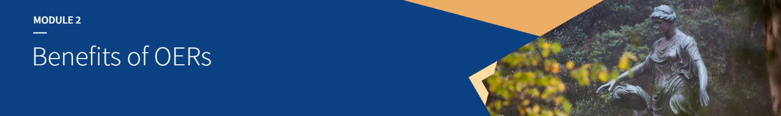

# Module 2: Benefits of OERs

## 2.0. Introduction

#### Learning outcomes

By the end of this module, you’ll be able to:

* Understand how OERs can contribute to social justice.
* Describe other benefits of OERs, including increased flexibility.

#### Time commitment

~ 20 minutes.

## 2.1. Social justice

OERs have the potential to transform education. They reduce financial barriers and enable greater representation of marginalised peoples and diverse voices. They also allow a flexibility in the teaching process that is not possible using traditional textbooks.

### 2.1.1. How OERs can contribute to social justice

OERs provide a level of social justice to education. The current for-profit model of educational publishing offers no such relief.

Dr Sarah Lambert (2018) identifies three main ways in which OERs provide social justice: *redistributive* justice, *recognitive* justice, or *representational* justice.

***Redistributive*** justice is the most long-standing principle of social justice and involves allocation of material or human resources towards those who by circumstance have less. ***Recognitive*** justice involves recognition and respect for cultural and gender difference, and ***representational*** justice involves equitable representation and political voice.

Let's explore each of these in some more depth, with some examples.

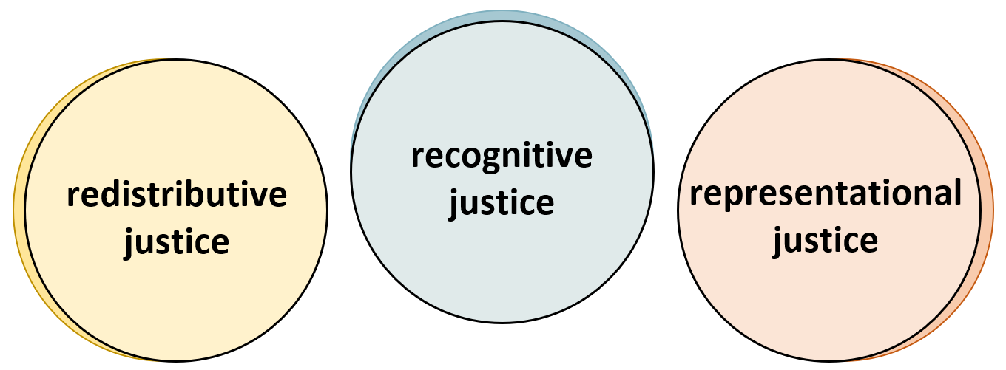

alt="Diagram showing three spheres side-by-side: redistributive justice, recognitive justice, and representational justice."

### 2.1.2. Redistributive justice

Like in the US, the cost of textbooks has increased in Australia, leaving many students struggling to afford them (Nagle & Vitez, 2020; Lambert & Fadel, 2022). OERs reduce the cost barrier to people from lower socioeconomic circumstances who struggle to afford educational materials.

In the past, students could avoid buying textbooks when libraries kept multiple copies of required texts for loan. In this new age of ebooks and online learning, however, publishers have been able to subvert traditional library models. Limits on simultaneous ebook users, inability to download content for offline reading, and cumbersome DRM make avoiding textbook costs increasingly difficult (Lambert & Fadel, 2022).

The COVID-19 pandemic has worsened the pressures on all student populations, especially those from existing underprivileged student populations. From food insecurity to precarious work, the pandemic has exacerbated existing economic challenges. The use of OERs has gone some way to lessening the burden faced by students (DeRosa, 2020).

### 2.1.3. Recognitive justice

OERs allow the recognition of groups and individuals often excluded from the academic sphere.

Textbooks by established experts often fail to incorporate knowledge and experiences from minority and underrepresented groups. However, OERs with more open Creative Common licences can be modified or expanded to foreground the work of under-represented people, including Indigenous Australians and LGBTQI+ individuals.

For example, textbooks in STEMM (Science, Technology, Engineering, Mathematics and Medicine), which have historically neglected women’s contributions in the fields, can benefit from examples that highlight women’s research and practice. Likewise, recognition of Indigenous knowledges, practices, and languages in OERs can also reduce the cultural and linguistic barriers often experienced by First Nations students (Funk & Guthadjaka, 2020).

### 2.1.4. Representational justice

Related to recognitive justice, representational justice allows marginalised groups to tell their own stories. Lambert and Fadel (2022) clarify the distinction between the two:

we think of *recognitive justice* as ensuring you can **see**diversity ... and *[representational] justice* as ensuring you can **hear**diverse points of view and knowledges.

The current academic publishing model, like higher education as a whole, tends to privilege the voices that have historically dominated scholarly discourse. The perspectives offered by these established experts, however, may not reflect the lived experience of a diverse and multicultural student cohort.

In their creation and adaptation, OERs can allow greater inclusion of underrepresented voices. Openly licensed OERs can be modified to suit different contexts and include different kinds of knowledge, enriching the resource with diverse perspectives.

Democratising the textbook creation process through OER models removes commercial, and sometimes even political, influences (Nusbaum, 2020).

Empowering marginalised communities to create and edit OERs facilitates social justice through greater representation. But greater representation can only occur by considering context and actively engaging with different communities.

### 2.1.5. Match the examples

**H5P: Justices (quiz) (CC BY-SA)**

[**https://unimelb.h5p.com/content/1291618628294169179**](https://unimelb.h5p.com/content/1291618628294169179)

### **Further resources & bibliography**

Colvard, N. B., Watson, C. E., & Park, H. (2018). The impact of open educational resources on various student success metrics. *International Journal of Teaching and Learning in Higher Education*, 30(2), 262-276. <https://eric.ed.gov/?id=EJ1184998>.

DeRosa, R. (2020). “Practitioner perspectives”: OER and a call for equity. *New England Journal of Higher Education*. <https://nebhe.org/journal/practitioner-perspectives-oer-and-a-call-for-equity/>.

Funk, J., & Guthadjaka, K. (2020). Indigenous authorship on open and digital platforms: Social justice processes and potential. *Journal of Interactive Media in Education, 2020*(1). <http://doi.org/10.5334/jime.560>.

Karakaya, K., & Karakaya, O. (2020). Framing the role of English in OER from a social justice perspective: A critical lens on the (dis)empowerment of non-English speaking communities. *Asian Journal of Distance Education, 15*(2), 175-190. <http://www.asianjde.com/ojs/index.php/AsianJDE/article/view/508>.

Lambert, S. R. (2018). Changing our (dis)course: A distinctive social justice aligned definition of open education. *Journal of Learning for Development, 5*(3), 225-244. <https://jl4d.org/index.php/ejl4d/article/view/290>.

Lambert, S. R., & Fadel, H. (2022).*Open textbooks and social justice: A national scoping study.*National Centre for Student Equity in Higher Education. <https://www.ncsehe.edu.au/publications/open-textbooks-social-justice/>.

Nagle, C., & Vitez, K. (2020). *Fixing the Broken Textbook Market*. 2nd ed. U.S. PIRG Education Fund. <https://studentpirgs.org/assets/uploads/2020/06/Fixing-the-Broken-Textbook-Market_June-2020_v2.pdf>.

Nusbaum, A. T. (2020). Who Gets to Wield Academic Mjolnir?: On Worthiness, Knowledge Curation, and Using the Power of the People to Diversify OER. *Journal of Interactive Media in Education, 2020*(1). <http://doi.org/10.5334/jime.559>.

## 2.2. Flexibility

OERs have potential to facilitate innovation in teaching practice. The ease with which many OERs can be edited and maintained gives educators the flexibility to enhance materials. Educational resources created in an openly licensed, digital environment can be vetted and reviewed by a broader community of experts, allowing greater accuracy and currency.

Let's explore some of the benefits of OERs' flexibility.

### 2.2.1. Continual improvement of OER content

As open digital resources, OERs can be easily edited and updated, without the educator having to find an alternative textbook or create a whole new resource. Freedom from fixed, unalterable resources allows educators greater freedom to contextualise, revise, or expand content to suit their curriculum.

For example, an OER could be:

* updated when new discoveries are made, or when new policies are introduced;
* revised or expanded in response to student feedback; or
* converted to new digital formats as required.

Although the prospect of adapting or creating an OER for the first time may be daunting, once adopted, OERs are easy to maintain and keep up to date.

### 2.2.2. Incorporating local perspectives

As we saw when we discussed social justice, existing textbooks may have an international focus and miss the local context. Canada and the US have a head start on the production and use of OERs, but their geographic and social contexts do not always translate well to Australia.

OERs can be revised to be made more relevant to local conditions. Resources that refer to overseas policy environments – for example: healthcare or financial systems – can be adapted to fit our own.

In line with representational justice, OERs can allow local voices to be heard. A case study of the Indigenous and Intercultural Health unit at La Trobe University, for example, showed the need for educational resources to be relevant to the targeted community. Ordinary health science programs offered were not gaining traction in Indigenous communities until Indigenous culture, language, and experiences were incorporated into the curriculum via an open-source platform (Hannon, Huggard, Orchard, & Stone, 2014).

### 2.2.3. Enhancing pedagogy

A study by Jung, Bauer & Heaps (2017) exploring faculty use of Open Stax textbooks reported that open textbooks better support student preparedness. They found that this, in turn, prompted faculty to increase their use of student-centred approaches, such as collaborative or active learning strategies, and lead them to use a flipped classroom approach.

OERs can also support active learning by allowing students to be involved in the creation and assessment of OERs, instead of just passively using them (Elder, 2021). After all, OERs with more open Creative Commons licences grant permission for all users, including students, to be involved in the 5 R activities: retain, reuse, revise, remix and redistribute (see [1.1. OER, OEP, and the 5 R's](#_OER,_OEP,_and)).

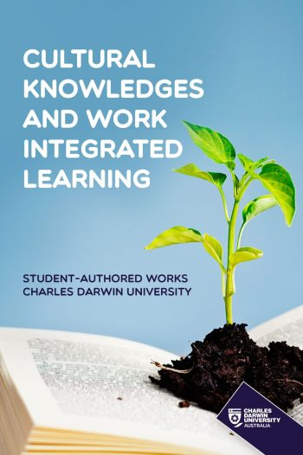For example, students could develop case studies which, with their permission, could be reused as OERs for other learners. The OER ebook [*Cultural Knowledges and Work Integrated Learning*](https://cduebooks.pressbooks.pub/cuc107/), is one such resource. Published on Pressbooks by Charles Darwin University under a CC BY-NC-ND licence, this book is an “iteratively compiled” collection of students' case studies on cultural capability. Further examples have recently been highlighted by Travis Wall for Pressbooks: [“Student-led OER to inspire and engage your class.”](https://pressbooks.com/2022/01/19/student-led-oer-to-inspire-and-engage-your-class/)

[Cultural Knowledges and Work Integrated Learning](https://cduebooks.pressbooks.pub/cuc107), Charles Darwin University. [CC BY-NC-ND 4.0](https://creativecommons.org/licenses/by-nc-nd/4.0/).

### 2.2.4. Consolidate your OER knowledge

Take a moment to watch this short video from the State University of Iowa on how OERs can benefit students and teachers alike. It provides a recap of what we've covered in these first two modules.

**YOUTUBE: “An Introduction to Open Educational Resources,” Abbey Elder, Iowa State University, 14 December 2017.**[**CC BY 4.0**](https://creativecommons.org/licenses/by/4.0/)**.**

[**https://www.youtube.com/watch?v=NtJmakm1-zc**](https://www.youtube.com/watch?v=NtJmakm1-zc)

### **Further resources & bibliography**

Bossu, C., Bull, D., & Brown, M. (2015). Enabling open education: A feasibility protocol for Australian higher education. In C. J. Bonk, M. M. Lee, T. C. Reeves, & T. H. Reynolds (Eds.), *MOOCs and Open Education Around the World*. Retrieved from <http://ebookcentral.proquest.com/lib/unimelb/detail.action?docID=2068916>.

Hannon, J., Huggard, S., Orchard, A., & Stone, N. (2014). OER in practice: Organisational change by bootstrapping. *RUSC: Universities and Knowledge Society Journal, 11*(3). <http://doi.org/10.7238/rusc.v11i3.2131>.

Jung, E., Bauer, C., & Heaps, A. (2017). Higher education faculty perceptions of open textbook adoption. *The International Review of Research in Open and Distributed Learning*, *18*(4). <https://doi.org/10.19173/irrodl.v18i4.3120>.

Nusbaum, A. T. (2020). Who Gets to Wield Academic Mjolnir?: On Worthiness, Knowledge Curation, and Using the Power of the People to Diversify OER. *Journal of Interactive Media in Education, 2020*(1). <http://doi.org/10.5334/jime.559>.

## 2.3. Quiz

#### Question 1

What three terms does Dr Sarah Lambert use to describe the ways that OERs contribute to social justice?

* Recognitive justice *{CORRECT}*
* Redistributive justice *{CORRECT}*
* Reputational justice
* Representational justice *{CORRECT}*
* Regressive justice

*CORRECT:* That’s right! Lambert identifies three types of social justice strengthened by OERs:

1. redistributive justice, in that all students and academics can access OERs without financial barriers;
2. recognitive justice, in that OERs can provide greater recognition of historically marginalised communities and individuals; and
3. representational justice, in that diverse voices, including those of marginalised communities, can be foregrounded.

See [2.1. Social justice](#_2.1._Social_justice).

*INCORRECT:* Not quite. Lambert identifies three types of social justice strengthened by OERs:

1. redistributive justice, in that all students and academics can access OERs without financial barriers;
2. recognitive justice, in that OERs can provide greater recognition of historically marginalised communities and individuals; and
3. representational justice, in that diverse voices, including those of marginalised communities, can be foregrounded.

See [2.1. Social justice](#_2.1._Social_justice).

#### Question 2

If an academic adopts an open textbook with a CC BY licence, which of the following could they do between semesters?

* Expand textbook content and add more examples, in light of past students’ performance
* Converted the text from HTML to EPUB and PDF, making all versions available to students
* Update economic data in the book to reflect the most recent data available
* All of the above *{CORRECT}*

*CORRECT:* Correct! As a true OER that allows revising and remixing, a CC BY textbook would allow an academic to undertake any of these activities. See [2.2. Flexibility](#_2.2._Flexibility).

*INCORRECT:* Actually, as a true OER that allows revising and remixing, a CC BY textbook would allow an academic to undertake any of these activities. See [2.2. Flexibility](#_2.2._Flexibility).

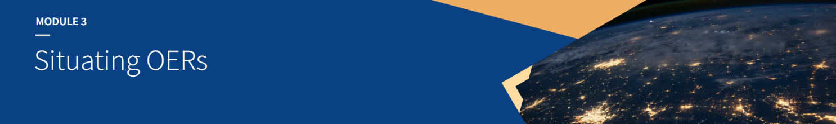

# Module 3: Situating OERs

## 3.0. Introduction

#### Learning outcomes

By the end of this module, you’ll be able to:

* Describe the relationship between OERs, open scholarship, open research, and open access.
* Recognise Australia’s place in the global OER context.

#### Time commitment

30-40 minutes.

## 3.1. OERs in the open scholarship ecosystem

### 3.1.1. Open scholarship

OERs are often seen as one branch of open scholarship. This umbrella term is used more or less interchangeably with *open science*.

The other branch of open scholarship is open research. In this model, we can recognise the familiar research/teaching divide.

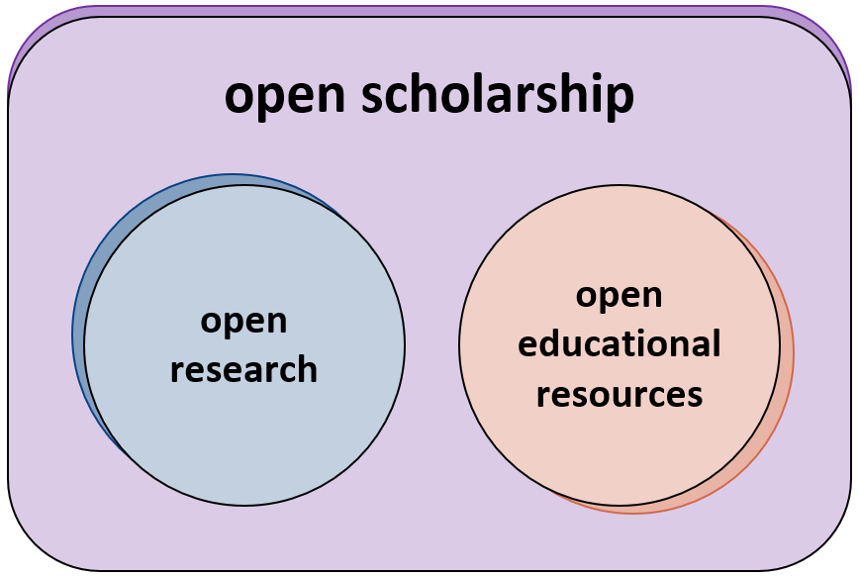

alt="Diagram showing open research and open educational resources as separate spheres under the open scholarship umbrella."

We can identify a lot of shared values and benefits of open scholarship as a whole, including:

#### Removing financial barriers

One of the key principles behind open scholarship is free access to information. The removal of paywalls and access fees is therefore central.

#### Benefiting academics and students around the world

Removing financial barriers benefits academics and students globally, including in developing countries. Students can access research and textbooks regardless of their wealth or that of their institutions. Likewise, researchers and educators can still access high-quality scholarship, even if their institutions can't afford subscription fees. All this allows truly global conversations.

#### Reaching a wider audience

Open scholarship makes quality information available to all. This includes the public, professionals and practitioners, and those writing public policy.

#### Informing others of your work

Opening up research and teaching practices, especially early on, allows academics to flag what they're working on. This can reduce the duplication of research or textbook writing.

#### Connecting with potential collaborators

By letting others know what they're working on, researchers can open up opportunities for collaboration. Local and international collaborations can greatly strengthen research and education quality.

#### Facilitating feedback and review

The more academics open up their scholarship and scholarly practices, the more feedback they can receive. Through open peer or community review, we can strengthen scholarship, fill gaps, and reduce errors. Such feedback and review are often facilitated by open platforms, servers, and repositories.

#### Demonstrating transparency and credibility

Choosing to open up any aspect of scholarship demonstrates a commitment to transparency, in turn offering greater credibility to our research. Likewise, making your work open to community review further demonstrates these key values.

Our [Open Scholarship](https://library.unimelb.edu.au/open-scholarship) website is a growing resource for all aspects of open scholarship.

### 3.1.2. Open research

Let's look at the open research side of open scholarship. Open research is a broad field covering all stages of the research lifecycle.

If you'd like to explore some of the different aspects of open research, click on the dark information icons in the image below. A text version is also available: [open-research.docx](#_Appendix_3:_Open).

Alternatively, if you'd like to delve in a bit deeper, you could watch the latest [Researcher@Library Open Research 101 webinar](https://vimeo.com/718970482/9f5fc9511e) (60 minutes).

**H5P: Open research (CC BY-SA)**

[**https://unimelb.h5p.com/content/1291605673053837669**](https://unimelb.h5p.com/content/1291605673053837669)

### 3.1.3. Relationships between open research and OERs

These two branches of open scholarship – open research and OERs – are not as separate as they may appear.

Open research feeds into OERs in many ways. Indeed, their potential uses as OERs are a strong argument for researchers making their work and outputs open. And vice versa, open education can contribute to open research.

Take a moment to explore these possible pathways between open research and OERs:

#### Reproducing open access publications in open textbooks

Textbooks and subject readers can be compiled from open access materials, including research articles and book chapters published open access or made open access in a repository.

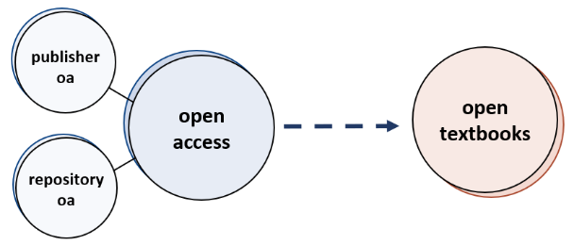

alt="Diagram showing open access publications (both publisher open access and repository open access) feeding into open textbooks."

#### Using open data for class activities and assignments

By using open data, students can gain experience working with real-world data sets. The 2015 (now the Australian Research Data Commons, ARDC) report [*Teaching with Research Data*](https://www.ands.org.au/__data/assets/pdf_file/0008/385019/teaching-with-research-data-report.pdf) examines nine case studies of universities using open research data in the classroom, including two examples from the University of Melbourne. The report notes that “unfettered access to data was seen as a key requirement in all of the nine case studies.” The open science advocacy group FOSTER also offers an open training module on this topic: [Use Open Data in Teaching](https://www.fosteropenscience.eu/node/2656).

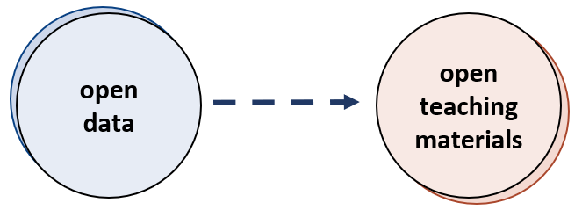

alt="Diagram showing open data feeding into open teaching materials."

#### Using open-source software and code in teaching

Just as open data can be a vital resource for classroom teaching, so can open code and software. Students studying IT, for example, can be provided with real-world code to work with, interpret, and manipulate. And students across a range of disciplines can be directed to open-source software to complete activities – everything from data analysis to creating multimedia presentations.

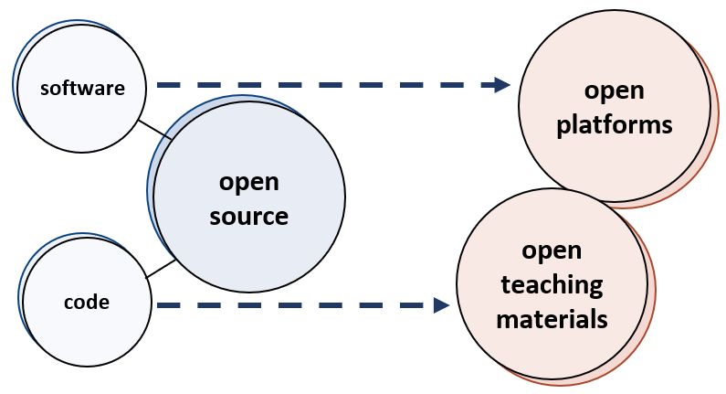

alt="Diagram showing open source software feeding into open platforms, and open source code feeding into open teaching materials."

#### Open NTROs (non-traditional research outputs) and open collections as sources of Creative Commons media for OERs

When developing OERs, having access to openly licenced reusable media is essential. There is significant overlap between the Creative Commons media collections often drawn on for OERs – both for illustrative and decorative purposes – and the open cultural collections and open NTROs produced by researchers. Openly licensing NTROs, such as images and recordings, and making them easily discoverable helps support the creation of OERs.

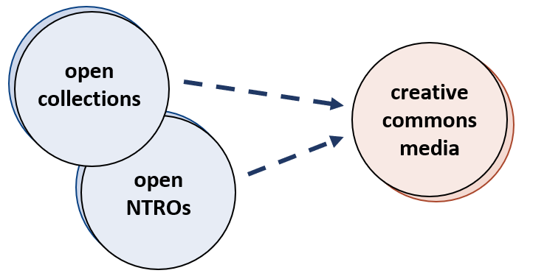

alt="Diagram showing open collections and open NTROs feeding into Creative Commons media."

#### Students contributing to citizen science projects or public engagement

The relationship between open research and OERs is not entirely one-way. For example, class assignments can require students to contribute to citizen science projects. Assessment tasks or extra-curricular activities can also get students practicing writing for a public audience. Students could then opt in to have high-quality work published on a suitable platform. An example of this is the University’s Science Communications program, which maintains a [Student Blog](https://blogs.unimelb.edu.au/science-communication/category/communicating-science-to-the-public/).

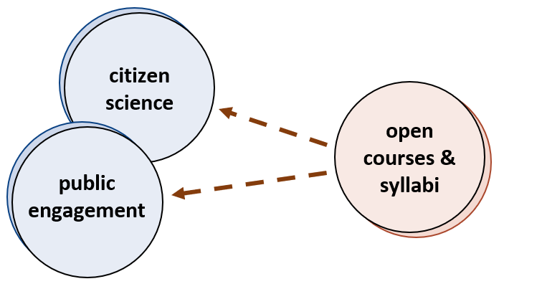

alt="Diagram showing open courses and syllabi feeding into citizen science."

OERs cannot be fully separated from open research activities. Open access publications often underpin open textbooks and other teaching materials. Open data and open-source code can be invaluable for providing students with real-world examples to work with. Open NTROs and cultural collections can be drawn on for the creation of engaging OERs. And syllabi can have students contribute to citizen science initiatives as a learning activity. For these reasons and many more, supporting open research practices is vital to supporting OERs, and vice versa.

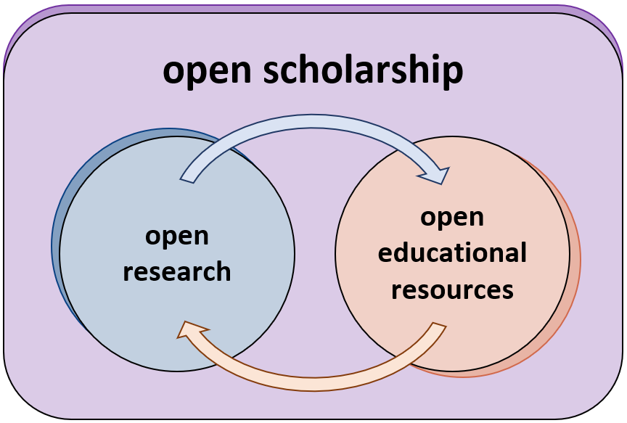

alt="Diagram showing open research feeding into open educational resources, and vice versa, all under the umbrella of open scholarship.

### **Further resources & bibliography**

Australian National Data Service (ANDS) (n.d.) *Data in education*.<https://www.ands.org.au/working-with-data/publishing-and-reusing-data/data-in-education>.

Bradley, J-C. (2006). Open Notebook Science. *Drexel CoAS E-Learning*. <https://drexel-coas-elearning.blogspot.com/2006/09/open-notebook-science.html>.

FOSTER. (2017). *Use open data in teaching*. <https://www.fosteropenscience.eu/node/2656>.

Knoth, P., & Pontika, N. (2015). Open Science Taxonomy (Version 3). figshare. <https://doi.org/10.6084/m9.figshare.1508606.v3>.

Ross-Hellauer T. (2017). What is open peer review? A systematic review. *F1000Research.* 6:588. <https://doi.org/10.12688/f1000research.11369.2>.

Science Communication at the University of Melbourne (n.d.) <https://blogs.unimelb.edu.au/science-communication/>.

University of Melbourne Library. (2022). *What is open research?* <https://unimelb.libguides.com/openresearch>.

University of Melbourne Library (n.d.). *Open scholarship.* <https://library.unimelb.edu.au/open-scholarship>.

University of Melbourne Library (n.d.). *Principles for open access to research outputs at Melbourne.*<https://library.unimelb.edu.au/open-scholarship/principles-on-open-access-to-research-outputs>.

## 3.2. The global context of OERs

### 3.2.1. The global benefits of OERs

On top of the benefits outlined in the previous module, OERs offer some important benefits to global education.

Perhaps most importantly, OERs can be used freely by institutions with limited financial resources, including those in developing countries, while opening up education to more students.

**H5P: Global Benefits of OERs (quiz) (CC BY-SA)**

[**https://unimelb.h5p.com/content/1291618569504865639**](https://unimelb.h5p.com/content/1291618569504865639)

### 3.2.2. The UNESCO OER Recommendation

These global benefits have led to UNESCO's advocacy for OERs as a means of overcoming inequality in education.

In 2012, UNESCO convened a World Open Educational Resources Congress in Paris. This resulted in the [2012 Paris OER Declaration](https://en.unesco.org/oer/paris-declaration), which “calls on governments worldwide to openly license publicly funded educational materials for public use.”

In 2019, the UNESCO OER Recommendation was adopted. It outlines five Areas of Action:

1. Building the capacity of stakeholders to create, access, re-use, adapt and redistribute OER.
2. Developing supportive policy for OER.
3. Encouraging inclusive and equitable quality OER.
4. Nurturing the creation of sustainability models for OER.
5. Promoting and reinforcing international cooperation in OER.

Through its recommendations, UNESCO hopes to make OERs the norm worldwide.

In March 2020, UNESCO launched the OER Dynamic Coalition to support the implementation of their recommendations.

You can find out more about UNESCO's OER initiatives on their [OER website](https://en.unesco.org/themes/building-knowledge-societies/oer).

**YOUTUBE: “Open Educators reflect on the UNESCO OER Action Area: Building Capacity,” Open Education Global, 25 September 2021.**[**CC BY 3.0**](https://creativecommons.org/licenses/by/3.0/)**.**

[**https://www.youtube.com/watch?v=AbDnAMXM738**](https://www.youtube.com/watch?v=AbDnAMXM738)

### 3.2.3. OER initiatives around the world

Beyond UNESCO’s work, other global initiatives have sought to increase awareness and uptake of OERs. Some highlights of worldwide OER advocacy include:

* [Open Education Global](https://www.oeglobal.org/) is a global non-profit that supports the development and implementation of open education around the world. One of their key areas of focus is OER, although they also advocate for MOOCs, open educational practices, and aspects of open research. Each year they coordinate [Open Education Week](https://www.oeglobal.org/activities/open-education-week/).
* [The OER World Map](https://oerworldmap.org/resource/) aims to be a space for anyone involved in open educational practices can share their experiences and initiatives. There are currently over 6,500 entries, including many detailing OER use around the world.

If you’d like to explore some major OER initiatives from around the world, click through the location markers on the map below. You can also explore the OER World Map linked above for a more granular view.

A text version of the interaction below is also available: [oers-around-the-world.docx](#_Appendix_4:_OERs)

**H5P: OER World Map (CC BY-SA)**

[**https://unimelb.h5p.com/content/1291610982945408679**](https://unimelb.h5p.com/content/1291610982945408679)

### 3.2.4. Australia’s place in the global OER landscape

Unfortunately, Australia has tended to lag behind in most aspects of open research, and this certainly applies to the OER landscape as well.

Australia lacks a national open agenda or vision for open scholarship, with no policies that would promote, support, or require any use of OERs. Thus Stagg et al. (2018) found that a “lack of policy levers has provided little incentive for Australian Higher Education institutions to explore OEP.”

There is some hope that this will change in the near future, however, with Chief Scientist Dr Cathy Foley’s work towards [An Australian Model for Open Access](https://oa2020.org/wp-content/uploads/POSTER_12_OpenAccessForAustralia_poster_DrCathyFoley.pdf). This model may have follow-on benefits in the OER space, since OER textbooks and other materials often draw from open access research.

Meanwhile, individual universities have led some significant OER initiatives. Open access academic books and textbooks have been published by a number of university presses or university libraries, including:

* [ANU Press](https://press.anu.edu.au/), the largest fully open access university press in the world.
* [UTS ePRESS](https://utsepress.lib.uts.edu.au/).
* The La Trobe University [eBureau](https://library.latrobe.edu.au/ebureau/" \t "_blank).
* Sydney University Press’s [Sydney Open Library](https://open.sydneyuniversitypress.com.au/).
* The University of Southern Queensland’s [Free and Open Textbooks](https://usq.pressbooks.pub/).

Other noteworthy Australian OER initiatives include:

* Led by Dr Sarah Lambert (Deakin University), the [Australian Open Textbooks Project](https://australianopentextbooks.edu.au/) has investigated open textbook use in Australia, with a focus on social justice. Their final report, [*Open Textbooks and Social Justice: A National Scoping Study*](https://www.ncsehe.edu.au/open-textbooks-diverse-learning-materials/), was published by the National Centre for Student Equity in Higher Education (NCSEHE) in February 2022.
* Some universities offer grants for the development of OERs. Examples include [Deakin University](https://dteach.deakin.edu.au/2021/06/30/deakin-launches-open-educational-resource-grant/) and the [University of Southern Queensland](https://usq.edu.au/learning-teaching/award-winning/oep-grants).
* The Australian Political Studies Association recently worked with Sydney University Press to develop an OER textbook, *Australian Politics and Policy*, which has both a [Senior Edition](https://open.sydneyuniversitypress.com.au/9781743328415.html) and a [Junior Edition](https://open.sydneyuniversitypress.com.au/9781743328439.html).
* In the university library context, OERs have been embraced by the [Digital Dexterity Community of Practice](https://digitaldexterity.edublogs.org/), an initiative by CAUL and CONZUL. Their OER Commons group, [Digital Dexterity Educators](https://www.oercommons.org/groups/digital-dexterity-educators/5554/), is open to all and hosts OERs focusing on digital literacy designed by members.
* CAUL’s [Enabling a Modern Curriculum Program](https://www.caul.edu.au/programs-projects/enabling-modern-curriculum), which was launched in late 2020 and focuses on OERs, is also gaining momentum. Take a look at their blog to find out more.



Enabling a Modern Curriculum blog banner, [Council of Australian University Librarians](http://moderncurriculum.caul.edu.au/), [CC BY 4.0](https://creativecommons.org/licenses/by/4.0).

### **Further resources & bibliography**

Agherdien, N. (2017). Towards pedagogical improvements in OER: repurposing for the South. *OE Global Conference 2017, Cape Town*.<https://conference.oeglobal.org/2017/presentation/towards-pedagogical-improvements-in-oer-repurposing-for-the-south/>.

Arinto, P.B., Hodgkinson-Williams, C., King, T., Cartmill, T., & Willmers, M. (2017). Research on Open Educational Resources for Development in the Global South: Project landscape. In Hodgkinson-Williams, C. & Arinto, P.B. (eds)., *Adoption and Impact of OER in the Global South*. Cape Town & Ottawa: African Minds, International Development Research Centre & Research on Open Educational Resources. <https://doi.org/10.25375/uct.10007162.v1>.

Commonwealth of Learning. (2022). *Open Educational Resources in the Commonwealth 2021.*<http://oasis.col.org/handle/11599/4009>.

De Oliveira Neto, J. D., Pete, J., Daryono & Cartmill, T. (2017). OER use in the Global South: A baseline survey of higher education instructors. In C. Hodgkinson-Williams & P. B. Arinto (Eds.), *Adoption and impact of OER in the Global South* (pp. 69–118).  Cape Town & Ottawa: African Minds, International Development Research Centre & Research on Open Educational Resources. <https://doi.org/10.25375/uct.10007174.v1>.

Schroeder, R. (2021).*It’s Time for Open Educational Resources.* Inside Higher Ed. <https://www.insidehighered.com/digital-learning/blogs/online-trending-now/it%E2%80%99s-time-open-educational-resources>.

Stagg, A., Nguyen, L., Bossu, C., Partridge, H., Funk, J., & Judith, K. (2018). Open Educational Practices in Australia: A First-phase National Audit of Higher Education. *The International Review of Research in Open and Distributed Learning*, *19*(3). 172–201. <https://doi.org/10.19173/irrodl.v19i3.3441>.

Tlili, A., Huang, R., Ting-Wen, C., Nascimbeni, F., & Burgos, D. (2019). Open educational resources and practices in China: A systematic literature review. *Sustainability, 11*(18), 4867. <http://dx.doi.org/10.3390/su11184867>.

Tlili, A., Jemni, M., Khribi, M. K., Huang, R., Chang, T.-W., & Liu, D. (2020). Current state of open educational resources in the Arab region: an investigation in 22 countries. *Smart Learning Environments, 7*(1). <https://doi.org/10.1186/s40561-020-00120-z>.

Tisoglu, S., Kursun, E., & Cagiltay, K. (2020). Open Educational Resources in Turkey. In *Current State of Open Educational Resources in the “Belt and Road” Countries* (pp. 213-235). <https://doi.org/10.1007/978-981-15-3040-1_12>.

Toledo, A. (2019). *Open Access and OER in Latin America: A survey of the policy landscape in Chile, Colombia and Uruguay*: University of Cape Town. <https://doi.org/10.25375/uct.10007183.v1>.

UNESCO. (2021). Malaysia adopts first national policy for inclusive Open Educational Resources. <https://en.unesco.org/news/malaysia-adopts-first-national-policy-inclusive-open-educational-resources>.

UNESCO. (2015). Philippines takes step towards a comprehensive policy for Open Educational Resources. <https://en.unesco.org/news/philippines-takes-step-towards-comprehensive-policy-open-educational-resources>.

Vollmer, T. (2011). Brazil introduces OER into federal legislation and adopts local government policy.  Retrieved from <https://creativecommons.org/2011/06/15/brazil-introduces-oer-into-federal-legislation-and-adopts-local-government-policy/>.

## 3.3. Quiz

#### Question 1

At the University of Melbourne, we see OERs as falling under the umbrella term...

* Open research
* Open access
* Open textbooks
* Open scholarship *{CORRECT}*

*CORRECT:* That's right! We see OERs as a kind of **open scholarship**, sitting alongside open research. We typically use the term “open access” to refer to traditional research publications, but it can also be applied to open textbooks, which are a kind of OER. See [3.1. OERs in the open scholarship ecosystem](#_3.1._OERs_in).

*INCORRECT:* Not quite. We see OERs as a kind of **open scholarship**, sitting alongside open research. We typically use the term “open access” to refer to traditional research publications, but it can also be applied to open textbooks, which are a kind of OER. See [3.1. OERs in the open scholarship ecosystem](#_3.1._OERs_in).

#### Question 2

UNESCO has played a major role in advocating for OER creation and adoption, seeing it as essential to overcoming global inequalities in education.

Match te dates below with their corresponding UNESCO OER milestones.

|  |  |
| --- | --- |
| 2012 | Paris OER Declaration is published |
| 2019 | OER Recommendation is adopted |
| 2020 | OER Dynamic Coalition is launched |

*CORRECT:* Well done! Here are some links to more information about each of these events:

2012: [Paris OER Declaration](https://en.unesco.org/oer/paris-declaration) is published

2019: [UNESCO OER Recommendation](https://www.unesco.org/en/communication-information/recommendation-oer) is adopted

2020: [UNESCO OER Dynamic Coalition](https://www.unesco.org/en/communication-information/open-solutions/open-educational-resources/oer-dynamic-coalition) is launched

See [3.2. The global context of OERs](#_3.2._The_global).

*INCORRECT:* Not quite. Here are some links to more information about each of these events:

2012: [Paris OER Declaration](https://en.unesco.org/oer/paris-declaration) is published

2019: [UNESCO OER Recommendation](https://www.unesco.org/en/communication-information/recommendation-oer) is adopted

2020: [UNESCO OER Dynamic Coalition](https://www.unesco.org/en/communication-information/open-solutions/open-educational-resources/oer-dynamic-coalition) is launched

See [3.2. The global context of OERs](#_3.2._The_global).

# Module 4: Find & Evaluate

## 4.0 Introduction

#### Learning outcomes

By the end of the module, you’ll be able to:

* Identify a range of recommended OER search tools and collections.
* Understand how to search EBSCO’s Faculty Select.
* Understand key criteria for evaluating OERs.
* Locate evaluation tools for assessing the suitability of OERs.

#### Time commitment

~30 minutes.

## 4.1 Finding OERs

This module lists some key OER search tools and collections. The focus here is on distinctly educational resources, with other open resources (such as Creative Commons images) being covered in [5.3. Practical tips for adapting or creating OERs](#_5.3._Practical_tips).

### 4.1.1. Advising academics

Where an academic searches for OERs will depend on the types of materials they need.

If the academic is looking for open textbooks, EBSCO’s Faculty Select may be a good place to start (limiting the search to OERs only). Alternatively, they could start with other OER search tools or go directly to open textbook collections. A broader range of OERs, including videos, course materials, and simulations, can be discovered through general and discipline specific OER collections, or OER search tools.

Searching OER collections is like searching any library database. Academics could be advised to follow the steps with which you’d be familiar:

1. Start searching with keywords related to your subject.
2. Begin broad, then narrow your search once you have an idea of the breadth of resources available.
3. Filter results using subject headings, publication dates, and other criteria.
4. Compile a list of relevant OERs.
5. Evaluate the options by searching tables of contents and descriptions.

### 4.1.2 OER search tools

There are numerous OER collections containing high quality, openly licenced educational materials. A good place to start a search is with OER search tools, which search across multiple repositories and aim to make the discovery of open content easier.

Prominent OER search tools include:

* [OASIS - SUNY’s Openly Available Sources Integrated Search](https://oasis.geneseo.edu/)  – A curated database drawn from 80 different sources.
* [The Mason OER Metafinder](https://oer.deepwebaccess.com/oer/desktop/en/search.html) – Searches simultaneous across 23 different sources of OERs.

### 4.1.3 OER collections

The following OER collections cover a range of resource formats and media types. They can be a good place for an academic to search for educational materials to adapt or remix as part of their course.

* [OER Commons](https://www.oercommons.org/hubs/OpenStax) – An open digital library of tens of thousands of OERs. Many different kinds of materials are covered, across a wide range of subject areas.
* [MERLOT](https://www.merlot.org/merlot/index.htm?action=find) – A curated collection of over 98,000 OERs from institutions and societies around the world.
* [LibreTexts](https://libretexts.org/) – A collection of open textbooks and learning objects covering a range of disciplines. There are currently about 400 textbooks on the platform.
* [Khan Academy](https://www.khanacademy.org/) – KA’s content experts develop educational videos and sort them into courses. Most content is released under CC BY-NC-SA licences and in multiple languages.

### 4.1.4 Discipline-specific OER collections

Academics might also find it worthwhile searching discipline-specific OER collections and get to know those in their area. Some examples include:

* [AMSER (Applied Math & Science Educational Repository)](https://amser.org/) – A portal of free educational resources for STEM disciplines. Not all resources are openly licensed, though – check the “Rights” field of licence terms.
* [COERLL (Center for Open Educational Resources and Language Learning, University of Texas at Austin)](https://www.coerll.utexas.edu/coerll/materials)– Produces and disseminates OERs such as online language courses, reference grammars, assessment tools, corpora, and more.
* [CORA (Community of Online Research Assignments)](https://www.projectcora.org/) – An open and collaborative space for faculty and librarians, focused on adapting and experimenting with research assignments to get students to engage with information resources in new ways.
* [Virtual Labs](https://virtuallabs.merlot.org/) – A collection of free virtual labs, experiments, and simulations, for STEMM disciplines. Many of the resources are open source but check licence terms before using or adapting.
* [Noba Project](https://nobaproject.com/) - This collection is an open psychology education initiative produced by the Diener Education Fund. Noba enables free access to open psychology textbooks and materials.

### 4.1.5 Open textbook collections

In post-secondary environments, open textbooks are one of the most common types of OER used to support learning.

A significant barrier to open textbook use is the perceived ease of finding traditional textbooks over open content. However, studies suggest that increased faculty awareness of the benefits of open textbooks – such as accessibility features and the potential to use innovative pedagogical approaches – support their adoption (Jung, Bauer & Heaps, 2017).

Some key open textbook collections and open access scholarly book collections include:

* [Open Textbook Library](https://open.umn.edu/opentextbooks) – A collection of over 1000 original open textbooks for higher education, all published under open licences that allow them to be used and adapted freely (No Derivatives licences are not permitted).
* [OpenStax](https://openstax.org/) – A high-quality, peer-reviewed collection of open textbooks. OpenStax features online highlighting, note-taking, and learning and teaching resources associated with each textbook. Some also include additional instructor resources, such as PowerPoint slides and associated resource hubs on OER Commons.
* [Pressbooks Directory](https://pressbooks.directory/) – A directory bringing together over 3,300 books published across over 110 Pressbooks networks. Not all are textbooks, per se, but all are educational or academic. The polished interface is easy to search and can be filtered by subject, licence, publisher, and interactivity. Several Australian universities publish using Pressbooks, so it can be a good source of local content.
* [DOAB (Directory of Open Access Books)](https://www.doabooks.org/) – A discovery service indexing over 51,500 peer-reviewed scholarly books, including textbooks.
* [OAPEN Library](https://www.oapen.org/) – A quality-controlled repository for hosting and disseminating peer-reviewed open access books, including open textbooks.
* [BCcampus OpenEd – B.C. Open Textbook Collection](https://open.bccampus.ca/) – A Canadian collection of almost 400 open textbooks for post-secondary education. The BCcampus OpenEd website also provides tools and advice for using, adopting, and creating open textbooks.

### 4.1.6 Open textbooks in Faculty Select (EBSCO)

The University of Melbourne has access to [Faculty Select (EBSCO).](https://library.unimelb.edu.au/contact_the_library/how-to-order-items-for-the-scholarly-services-collections/faculty-select) This resource offers eBooks that are available for purchase, as well as open textbook metadata gathered from various sources.

**YOUTUBE: "EBSCO Faculty Select," EBSCO Tutorials, 2 July 2019. ©EBSCO, 2019.**

[**https://www.youtube.com/watch?v=0IUIk0nX8n0**](https://www.youtube.com/watch?v=0IUIk0nX8n0)

Faculty Select streamlines access to quality OERs. Using the platform, academics and librarians can:

* Find and access quality OERs.
* Preview the title and/or request an access link.
* Save time searching and collating materials from multiple OER collections.

To find OERs in Faculty Select, limit your search to “OER Only” in the “Refine Results” sidebar.

alt="Screenshot of the Faculty Select interface, highlighting the "OER Only" tick box on the search results page."

Screenshot taken from EBSCO Faculty Select. ©EBSCO, 2022.

Note that if you do not limit your search results to “OER Only”, your search will return both open textbooks and DRM-free textbooks available for purchase. See [1.1. OER, OEP, and the 5 R's](#_OER,_OEP,_and) for details on this distinction.

Although items categorised as OERs are free to retain, reuse, and redistribute, some may not permit revising or remixing, due to CC BY-ND or CC BY-NC-ND licences. See [1.2. Creative Commons licences.](#_1.2._Creative_Commons)

The OER collections covered by Faculty Select include OpenStax, Open Textbook Library, OAPEN Library, B.C. Open Textbooks, and Milne Open Textbooks.

### **Further resources & bibliography**

Jung, E., Bauer, C., & Heaps, A. (2017). Higher education faculty perceptions of open textbook adoption. *The International Review of Research in Open and Distributed Learning, 18*(4). [https://doi.org/10.19173/irrodl.v18i4.3120](https://doi.org/10.19173/irrodl.v18i4.3120%20).

Lauri M. Aesoph and Josie Gray (eds.). (2018). *OER by Discipline Directory*. Victoria, BC: BCcampus. [https://opentextbc.ca/oerdiscipline/](https://opentextbc.ca/oerdiscipline/%20) (*updated as new resources are identified*).

EBSCO. (2021). EBSCO Faculty Select – Frequently Asked Questions. [https://connect.ebsco.com/s/article/EBSCO-Faculty-Select-Frequently-Asked-Questions](https://connect.ebsco.com/s/article/EBSCO-Faculty-Select-Frequently-Asked-Questions%20).

## 4.2. Evaluating OERs

This module lists some key OER search tools and collections. The focus here is on distinctly educational resources, with other open resources (such as Creative Commons images) being covered in [5.3. Practical tips for adapting or creating OERs](#_5.3._Practical_tips).

### 4.2.1. Considerations when selecting OERs

Before adopting, adapting, or remixing OERs, it’s important that the academic asks some critical questions to evaluate the resources. Librarians may play a role in encouraging academics to undertake such evaluations, prompting them to consider the OERs from different angles.

Below are some key areas of evaluation, along with the questions an academic should consider when selecting OERs:

#### Relevance

* Does the OER cover the topics you need covered?
* Is it relevant to the context being studied, or could it be adapted to be made relevant?

#### Audience

* Is the OER suitable for your student cohort, or was it developed for a more advanced, or more general, level?

#### Quality of content

* Is the educational content accurate, current, and of a high academic standard?
* Was it developed by qualified experts at a reputable institution?

#### Production quality

* Is the resource's production quality of a high standard?
* Is text appropriately formatted, are images and videos in high resolution, and is audio clear?
* If not, can you improve the quality of the material, or create a high-quality version?

#### Accessibility

* Is the OER accessible and inclusive of students from diverse backgrounds, or with disabilities or learning difficulties?
* For example, do images have captions or alt text? Are colour-blind-friendly diagrams used? Is the language accessible?
* If the OER is not accessible, can you adapt it to make it so? If not, you will need to find an accessible alternative.
* [Find out more about accessibility at the University of Melbourne.](https://www.unimelb.edu.au/accessibility)

#### Licensing

* Is the OER licensed in such a way that you can do what you need with it?
* If you plan to adapt the OER, for example, you'll need to avoid Creative Commons licences with ND (No Derivatives) elements.
* Keep in mind that the type of licence assigned to an open textbook, for example, will determine how it can be used as a course text.
* See [1.2. Creative Commons licences](#_1.2._Creative_Commons) and [5.2. Copyright, IP, and licensing OERs](#_5.2._Copyright,_IP,) for further guidance on licensing.

The video below provides some excellent guidance on how to evaluate OERs. Take a moment to watch it now.

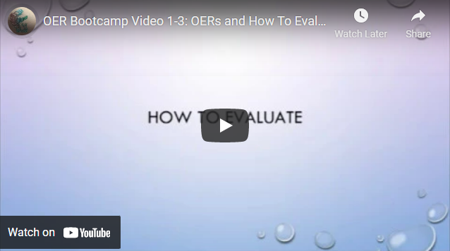

**YOUTUBE: "OER Bootcamp Video 1-3: OERs and How To Evaluate Them," Sarah Morehouse, 10 February 2018.**[**CC BY 3.0**](https://creativecommons.org/licenses/by/3.0/)**.**

[**https://www.youtube.com/watch?v=s2d0BxR5kic**](https://www.youtube.com/watch?v=s2d0BxR5kic)

### 4.2.2. Checklists and rubrics for OER evaluation

When evaluating OERs, it can be helpful to use a checklist or rubric. Here are some examples:

* [iRubric: Evaluating OER rubric](https://www.rcampus.com/rubricshowc.cfm?code=L9WC6X&sp=yes) (discussed in the video above)
* [University of Queensland – Evaluate OER](https://guides.library.uq.edu.au/how-to-find/open-educational-resources/evaluate)
* [Federation University – Evaluating OERs](https://libguides.federation.edu.au/c.php?g=892636&p=6418655)
* [BCcampus – Guide for Evaluating Open Education Resources](https://open.bccampus.ca/files/2014/07/Faculty-Guide-22-Apr-15.pdf)

## 4.3 Quiz

#### Question 1

You’re a librarian offering advice to an academic. They’re looking for openly licensed educational videos on climate change for their subject. Where might you suggest they begin their search?

* Faculty Select (EBSCO)
* OER search tools *{CORRECT}*
* Open textbook collections
* None of the above

*CORRECT:* That’s right! OER search tools can search multiple OER collections at once. They also cover different kinds of material, including educational videos. Open textbook collections and EBSCO’s Faculty Select, however, will only return results for textbooks. After trying OER metafinders, it might be worth trying other general or discipline-specific OER collections. See [4.1. Finding OERs](#_4.1_Finding_OERs).

*INCORRECT:* OER search tools can search multiple OER collections at once. They also cover different kinds of material, including educational videos. Open textbook collections and EBSCO’s Faculty Select, however, will only return results for textbooks. After trying OER metafinders, it might be worth trying other general or discipline-specific OER collections. See [4.1. Finding OERs.](#_4.1_Finding_OERs)

#### Question 2

The academic you were advising returns with an open textbook, which they found using Faculty Select and would like to use in their subject. They also hope to revise some elements of the textbook to better suit an Australian context, as well as add a chapter of their own.

The book they chose is:

Almiron, N., & Xifra, J. (Eds.). (2019). Climate Change Denial and Public Relations. Routledge. [https://doi.org/10.4324/9781351121798](https://doi.org/10.4324/9781351121798%20) (or view Faculty Select record)

They would like your advice on how to evaluate the suitability of the textbook. You decide to walk them through how to answer a few basic evaluation questions. What do you think would be the correct answer to the following question:

*Is the OER licensed in such a way that you could do what you need with it?*

*CORRECT:* That's correct. Under the book's CC BY-NC-ND licence, the academic would not be able to do what they needed - they could not make the revisions and alterations they'd indicated. They could still use the OER, but would not be able to change it in any way, and would have to release additional content separately. See [4.2. Evaluating OERs](#_4.2._Evaluating_OERs) for more evaluation criteria, and revisit [1.2. Creative Commons licences](#_1.2._Creative_Commons).

*INCORRECT:* The book's CC BY-NC-ND licence (Creative Commons Attribution-NonCommercial-NoDerivatives) is indicated on the publisher's website and in its Faculty Select record. Given this licence, the academic would not be able to do what they needed - they could not make the revisions and alterations they'd indicated. They could still use the OER, but would not be able to change it in any way, and would have to release additional content separately. [See 4.2. Evaluating OERs](#_4.2._Evaluating_OERs) for more evaluation criteria, and revisit [1.2. Creative Commons licences.](#_1.2._Creative_Commons)

# Module 5: Adapt & Create

## 5.0 Introduction

#### Learning outcomes:

By the end of the module, you’ll be able to:

* Describe and understand approaches for adapting or creating OERs.
* Locate tools that support adapting or creating OERs, and repositories for sourcing or sharing open content.
* Understand how copyright and licensing fit into the workflows for adapting or creating OERs.
* Identify tools to support licensing OERs.

#### Time commitment

~ 30-40 minutes.

## 5.1. The process of adapting or creating OERs

The University of Melbourne is still exploring workflows for publishing open textbooks and other OERs. In this module, we’ll be focusing on how to adapt existing OERs or create new ones, and share them on free open platforms.

### 5.1.1. Adopt, adapt, remix, or create?

There are several options for academics to choose from when it comes to using OERs in their course. According to Elder (2019), educators have four options:

* **adopt** an existing resource that suits the learning objectives of their course without making any changes to the content
* **adapt** a resource by customising some of the content, e.g., add local examples
* **remix** a variety of sources to create a new resource
* **author** and license a new resource, created from scratch using their own materials

Each option has different considerations, including suitability of the OER content and format, accessibility features, and the preparation time required.

### 5.1.2. Time commitment

A study by Jung, Bauer & Heaps (2017) found that 82% of participants spent the same amount of time or less preparing to teach their course using an open textbook. This indicates that adopting an OER does not necessarily lead to increased workload and may even reduce preparation time.

However, adopting an OER will often require some customisation of content to improve course alignment and ensure the material is tailored to support student learning. The educator may also wish to combine multiple OERs and remix them, or they may decide to create their own OER from scratch. Each of these involve different time commitments, as illustrated below.

alt="Diagram showing adopt, adapt, remix, and create - in that order, from less time intensive to more time intensive."

### 5.1.3. Planning for OER use

It is important to start with some planning before beginning the process of modifying an existing OER or creating a new one.

The following checklist, adapted from [*The OER Starter Kit*](https://iastate.pressbooks.pub/oerstarterkit/), can be used to support educators to prepare for an OER project (Elder, 2019):

* Is there an existing OER that can be adapted for use in my subject?
* Can my teaching materials be used to adapt an existing OER? Have I sought copyright approval to my teaching materials?
* Will I need to adopt additional materials (e.g. quizzes, images, videos) to remix with my own content?
* Have I only used openly licensed resources to adapt/remix my teaching materials or content?
* What type of licence will I assign for my new resource?
* How can I share my new resource so that it can be used by others?
* Where in the institution can I find support for creating an OER?

### 5.1.4. The OER creation process

The process for creating a new OER – whether from scratch, from remixing existing OERs, or from a mix of the two – involves several distinct stages.

The [CAUL OER Collective Publishing Workflow](https://caul.libguides.com/oer-collective-publishing-workflow) outlines seven stages for creating an open textbook: Initiate, Plan, Draft, Design, Review, Publish, and Evaluate. Their website also provides extensive guidance for authors and library staff about each stage.

alt="Diagram of the CAUL OER Collective Publishing Workflow. It shows, in a cycle: initiate, plan, draft, design, review, publish, and evaluate."

[Open Educational Resources Collective Workflow](https://caul.libguides.com/oer-collective-publishing-workflow) by [Council of Australians University Librarians](https://www.caul.edu.au/), [CC BY 4.0](https://creativecommons.org/licenses/by/4.0/).

Review the [7 Stages of the Workflow](https://caul.libguides.com/oer-collective-publishing-workflow) developed by CAUL for a detailed insight into the knowledge required and processes involved with publishing an open textbook.

For another visual representation of an OER project workflow, see the production process developed by Abbey Elder at Iowa State University:

alt="A detailed flowchart showing the production workflow for an OER. Major steps are: research, pre-production, design, development, and publication."

[A Production Workflow for OER Projects](https://docs.google.com/drawings/d/1Fn8ZnewHFLCqtwJaIPcajpbLMCH4jUkzk6KzzssPB44/edit) (2019) by Abbey Elder, Iowa State University. [CC BY 4.0](https://creativecommons.org/licenses/by/4.0/).

Advice or assistance may be required at different stages in the process of adapting or creating an OER. While the University of Melbourne does not currently have designated OER specialists, for local support, there are many sources of advice available including the Copyright Office, Librarians, Educational Technologists, and the Scholarly Communications team. These contacts, among others in the Scholarly Services team, can provide academics with guidance in finding, evaluating, creating, licensing and using OERs for teaching and learning.

### **Further resources & bibliography**

Elder, A.K. (2019). *The OER Starter Kit*. Ames, IA: Iowa State University Digital Press. <https://iastate.pressbooks.pub/oerstarterkit/>.

Jung, E., Bauer, C., & Heaps, A. (2017). Higher education faculty perceptions of open textbook adoption. *The International Review of Research in Open and Distributed Learning, 18*(4). <https://doi.org/10.19173/irrodl.v18i4.3120>.

## 5.2. Copyright, IP, and licensing OERs

### 5.2.1. Copyright, Intellectual Property, and publishing OERs at the University of Melbourne

Academics wishing to use their own teaching materials or research when creating or adapting an OER, such as an open textbook, will need to consider copyright and intellectual property (IP) throughout the process.

Relevant policies include the [University’s Intellectual Property (IP)](https://policy.unimelb.edu.au/MPF1320) policy and the [University of Melbourne statute](https://about.unimelb.edu.au/__data/assets/pdf_file/0031/19777/University-of-Melbourne-Statute-31Aug16-v02.pdf), which assert that the University owns the IP of teaching materials created by staff. The IP policy draws a distinction between Teaching Materials (of which the University holds copyright) and Scholarly Works (wherein the authors hold copyright):

#### Teaching materials

Teaching Materials means all versions, digital or otherwise, of information, documents and materials created or used for the purpose of teaching and education by the University, including the permitted adaptation or incorporation of the scholarship, learning or research of the relevant member of academic Staff, Honorary Appointee, Visiting Personnel or Student for that purpose. Teaching Materials exclude Scholarly Works.

Teaching Materials include, but are not limited to:

1. lecture notes that are made available to students;
2. computer-generated presentations;
3. course guides;
4. overhead projector notes;
5. examination scripts;
6. examination marking guides;
7. course databases;
8. websites; and
9. multimedia-based courseware

#### Scholarly Works

Scholarly Works means any article, book, musical composition, thesis, creative writing or like publication or any digital or electronic version of these works that contains material based on the creator’s scholarship, learning or research. It does not include work that is Teaching Material or any other work required to be disclosed under section 13(6)(b) of the University of Melbourne Statute.

For example, an academic who intends to publish an open textbook using their subject’s teaching materials would need to seek approval from the University. Requests to use University-owned copyright materials can be submitted to the [Copyright Office Permission Service](https://copyright.unimelb.edu.au/services/permissions-service).

In contrast, materials classified as “Scholarly Works” can be freely used in creating OERs in any format. As we progress with OER as an institution, further policy development will be needed in this space.

Supporting academics with copyright questions in the context of OER is complex, due to the wide variety of OER types. As always, the best place to go for copyright advice is our [Copyright Office](https://copyright.unimelb.edu.au/contact).

### 5.2.2. Avoiding third-party copyright infringement

When adapting, remixing or creating a new OER, such as an open textbook, it is the author’s responsibility to ensure that third-party copyright is not infringed. This includes images, multimedia, data, and text. All third-party material must be checked to ensure their licences allow for adaptation and sharing (see [1.2. Creative Commons licences](#_1.2._Creative_Commons)).

If materials are copyrighted with all rights reserved, the author must seek permission from the copyright holder to adapt or reproduce those materials. Guidance about seeking permission to avoid third party copyright infringement can be found on the Copyright Office’s website: [Requesting permission from a copyright owner to reproduce material.](https://copyright.unimelb.edu.au/guides/requesting-permission-from-a-copyright-owner-to-reproduce-material)

### 5.2.3. Using Indigenous cultural and intellectual property (ICIP)

Indigenous cultural and intellectual property (ICIP) refers to the right of Indigenous Australians to protect their cultural heritage, including all aspects of art, knowledge systems, and culture (Dr Terri Janke and Company, 2022). When planning to include Indigenous content in OERs, it is important to be cognisant of ICIP and to respect the rights of Indigenous individuals and communities to be consulted and provide consent.

It is crucial for non-Indigenous individuals to appropriately seek Indigenous permissions to use or disseminate Indigenous knowledge. The following sources provide guidance and information about Indigenous Protocols:

* The Australia Council for the Arts’ [Protocols for Using First Nations Cultural and Intellectual Property in the Arts](https://australiacouncil.gov.au/investment-and-development/protocols-and-resources/protocols-for-using-first-nations-cultural-and-intellectual-property-in-the-arts).
* Oxfam Australia’s [Aboriginal and Torres Strait Islander Cultural Protocols (PDF](https://www.oxfam.org.au/wp-content/uploads/2015/11/2015-74-ATSI-Cultural-Protocols-update_WEB.pdf)).
* [*True Tracks*](https://cat2.lib.unimelb.edu.au/record=b7750071~S30), by Indigenous lawyer Dr. Terri Janke, provides information about the legal protection of Indigenous art, cultures and knowledge.

Be aware that Indigenous cultural IP may not fit into traditional areas of copyright and reuse. It’s best to seek out help from those have expertise in this area– see the [Indigenous Knowledges Research Guide](https://unimelb.libguides.com/c.php?g=932536&p=6741079) for local contacts.

**YOUTUBE: “Indigenous Cultural Intellectual Property: Arts Law's Artists in the Black Service,” Arts Law / Artists in the Black, 8 September 2016. ©Arts Law, 2016.**

[**https://www.youtube.com/watch?v=hISy0D05zO4**](https://www.youtube.com/watch?v=hISy0D05zO4)

### 5.2.4. Licensing your OERs

OERs can take many different forms, but they should always strive to fulfil the 5 R’s (see [1.1. OER, OEP, and the 5 R's](#_OER,_OEP,_and)) to best support teaching and learning. For this reason, licensing should be considered throughout all stages of adapting or creating OERs.

If modifying an existing OER, then one must determine if the licence of the work allows it to be adapted or remixed. The educator must also ensure any content being added to an existing OER has a licence that allows for those materials to be shared or adapted.

Finally, the licence selected for a new OER will determine how a resource can be used by others. Creative Commons licences are best suited for this purpose, and the official [Creative Commons licence chooser](https://creativecommons.org/choose/) can be used for tailored advice on which licence best suits the creator’s needs.

Which licence you choose, however, will be influenced by the licences of the third-party material you include. Here, [the Creative Commons Compatibility Wizard](https://web.archive.org/web/20070928134756/http:/creativecommons.org.tw/licwiz/english.html) is a very useful tool. Simply select the licences of works being included in the OER, and compatible licences for the finished work will be highlighted.

alt="Screenshot: CC Licenses Compatibility Wizard. Rows are CC licences of used works; columns indicate compatible licences."

The [Creative Commons Compatibility Wizard](https://web.archive.org/web/20070928134756/http:/creativecommons.org.tw/licwiz/english.html) indicates what licences can be applied to a finished work, based on the licences used for the components it includes. It is open source using the [MIT](https://web.archive.org/web/20070926223208/http:/www.opensource.org/licenses/mit-license.php) license.

### **Further resources & bibliography**

Dr Terri Janke and Company. (2019). *Protocols for using First Nations cultural and intellectual property in the arts.* <https://australiacouncil.gov.au/investment-and-development/protocols-and-resources/protocols-for-using-first-nations-cultural-and-intellectual-property-in-the-arts>

Dr Terri Janke and Company. (2022). *Indigenous cultural and intellectual property (ICIP).* <https://www.terrijanke.com.au/icip>

Janke, T. (2021). *True tracks: Respecting Indigenous knowledge and culture*. NewSouth Publishing. <http://cat.lib.unimelb.edu.au/record=b7750071~S30>

University of Melbourne. (2020). *Intellectual Property Policy (MPF1320)*. <https://policy.unimelb.edu.au/MPF1320>.

## 5.3. Practical tips for adapting or creating OERs

To finish this course, we’re going to look at some practical tips and advice that can be offered to academics for the creation of OERs. We’ll cover some of the tools, repositories, and platforms it would be worth being familiar with when providing support in the OER space.

### 5.3.1. Tools for creating OERs

The following free tools enable educators to build, modify, or share OERs:

* [MERLOT (Create materials with Content Builder):](https://info.merlot.org/merlothelp/Content_Builder_Welcome.htm) The MERLOT Content Builder is a free website development tool. It is accessible by logged-in members from the MERLOT home page by clicking the Add menu at the top of the page and selecting Create Material with Content Builder.
* [OpenAuthor (OER Commons):](https://www.oercommons.org/authoring-overview) OpenAuthor supports educators who want to build and share OERs such as courses, units, lessons, activities and presentations on their own.
* [OpenStax Hub](https://www.oercommons.org/hubs/OpenStax): The OpenStax Community Hub on OER Commons supports undergraduate teaching and learning by collecting community generated resources related to OpenStax textbooks.
* [GitBook](https://www.gitbook.com/): This open-source tool allows you to create a textbook in Markdown (simple markup language) and is hosted in the GitHub repository.
* [Ink Scape](https://inkscape.org/): This vector graphic editor application is an open-source tool used for editing PDFs and creating artistic and technical drawings.
* [TED ED Content builder tool:](https://ed.ted.com/) TED-Ed is a “lesson creator” platform that enables instructors to create flipped classroom style activities.
* [WP OER Plugin](https://wordpress.org/plugins/wp-oer/#:~:text=WP%20OER%20is%20a%20free,repository%20on%20any%20WordPress%20website.): WP OER is a free plugin which allows you to create your own open educational resource repository on any WordPress website

### 5.3.2. Sourcing materials to enhance or enrich OERs

In the previous module we focused on how to find open educational content, like textbooks and course materials, that is ready to use and openly licensed. But when creating or adapting OERs, you might also like to include other media to either increase engagement or communicate ideas.

There is a range of repositories that enable you to find open media content such as images, video, or assessment material, that is either in the public domain or that has a Creative Commons licence, which can be used in OERs.

The repositories and search engines below may help academics source open materials to use in their OERs.

#### Images

* [Pexels](https://www.pexels.com/)
* [Flickr: Creative Commons](https://www.flickr.com/creativecommons/)
* [Wikimedia commons](https://commons.wikimedia.org/wiki/Category:Images)
* [Google Images Advanced Search](https://www.google.com/advanced_image_search) – scroll to the "usage rights" menu and select "free to use and share" to retrieve openly licensed images.

#### Videos

* [Pexels videos](https://www.pexels.com/@free-videos/)
* [Wikimedia Commons Videos](https://commons.wikimedia.org/wiki/Category:Videos)
* Platforms like YouTube and Vimeo contain many openly licenced videos, although most are all rights reserved. Check the licence terms of videos before using them as OERs.

#### Other general resources

* [Internet Archive: Digital Library of Free & Borrowable Books, Movies, Music & Wayback Machine](https://archive.org/)
* [Openverse](https://wordpress.org/openverse/?referrer=creativecommons.org) – for various media, all under Creative Commons licences or in the public domain.

### 5.3.3. Accessibility is essential

When adopting an OER for use in their subject, academics should be aware of methods for enhancing accessibility for all students, particularly those with diverse learning needs. Coolidge, Doner & Robertson (2015) emphasise that open materials should be inclusive to all learners:

The focus of many open textbook projects is to provide access to education at low or no cost. But what does access mean? If the materials are not accessible for each and every student, do they fulfill the mandate to deliver fully open textbooks?

In the context of open textbooks, the authors suggest that electronic resources can be designed with accessibility in mind by using the checklist of features:

* resources are optimised for people who use screen-reader technology
* content can be navigated using a keyboard
* links, headings, and tables are formatted to work with screen readers
* images have alt text, captions, or descriptive tags
* information is not communicated by colour without other markers being present, e.g., differing patterns
* there is an option to increase font size

Optimising the accessibility of open content is critical for enhancing the usability for learners with diverse needs, including students with cognitive, visual or auditory disabilities.

Watch the brief video below, from the Centre for Teaching, Learning and Technology at the University of British Colombia, to learn more about how accessible OERs can support social inclusion.

**H5P (interactive video): Open dialogues: open education and accessibility (CC BY-SA)**

[**https://unimelb.h5p.com/content/1291618781106029009**](https://unimelb.h5p.com/content/1291618781106029009)

--------------------

**BASED ON THE YOUTUBE VIDEO: "Open Dialogues: Open education and accessibility,"  
University of British Columbia, 29 July 2017.**[**CC BY 3.0**](https://creativecommons.org/licenses/by/3.0/legalcode)**.**

[**https://www.youtube.com/watch?v=KcvYG-rkO-Y**](https://www.youtube.com/watch?v=KcvYG-rkO-Y)

There is a range of free tools available online that can be used to check for readability to ensure that fonts and colours used in an OER are accessible to those with visual or learning disabilities. See, for example:

* [WAVE® Web Accessibility Evaluation Tool](https://wave.webaim.org/)
* [WebAim color contrast checker](https://webaim.org/resources/contrastchecker/)
* [ContrastChecker.com](https://contrastchecker.com/)

Elder (2019) also recommends that OERs use dyslexic-friendly fonts, such as Arial, Century Gothic, Open Sans or Verdana.

### 5.3.4. Platforms for sharing OERs

Some of the same platforms that enable you to source OERs also allow you to share them with others, for example, OER Commons.

Depending on the type of OER you are using, there are different repositories that are best suited for sharing, some suggestions include:

#### For OERs of any kind

* [OER Commons](https://www.oercommons.org) (“Add OER” section)

#### For images and video

* [Flickr](https://www.flickr.com/creativecommons/) (Creative Commons)
* [Wikimedia Commons](https://commons.wikimedia.org/wiki/Main_Page)
* Platforms like YouTube and Vimeo can also be used, just be sure to use clear open licences for your work. Note that these are commercial platforms (and show ads) so might not be suitable for Creative Commons material with Non-Commercial requirements.

#### For software and code

* [GitHub](https://github.com/)

#### Melbourne.figshare

* The University’s data repository, [Melbourne.figshare](https://melbourne.figshare.com/), allows staff to share all kinds of materials, including presentations, multimedia, rubrics, and assessment tasks.

### 5.3.5. Consolidate your knowledge

For an overview of the OER production process, take a moment to watch the video below. It recaps how you can find OER content, adapt open resources, and assign a Creative Commons licence.

**YOUTUBE: “**[**Creating OER and Combining Licenses Part 1**](https://youtu.be/0LxD7xAcY3k)**,”  
The Orange Grove Repository, 5 September 2012.**[**CC BY-SA 3.0**](https://creativecommons.org/licenses/by-sa/3.0/)**.**

[**https://www.youtube.com/watch?v=0LxD7xAcY3k**](https://www.youtube.com/watch?v=0LxD7xAcY3k)

### **Further resources & bibliography**

Aesoph, L.M. (2018). *Self-publishing guide*. BCcampus. <https://opentextbc.ca/selfpublishguide>

Coolidge, A., Doner, S., Robertson, T., & Gray, J. (2018). *Accessibility toolkit – 2nd edition*. BCcampus. <https://opentextbc.ca/accessibilitytoo>

Elder, A.K. (2019). *The OER Starter Kit.* Ames, IA: Iowa State University Digital Press. <https://iastate.pressbooks.pub/oerstarterkit/>

Open Washington. (2018). Module 9: Accessibility. *How to use Open Educational Resources*. <https://www.openwa.org/module-9/>

Stagg, A., Martin, N., Wattiaux, C., Heck, T. (2018). *Creating OER (Postcard format for Higher Education).* OER Commons. <https://www.oercommons.org/authoring/25364-creating-oer-postcard-format-for-higher-education/view>.

## 5.4. Quiz

#### Question 1

An academic is creating a new OER by remixing several existing OERs. They’ve included chapters from open textbooks with CC BY-NC and CC BY-NC-SA licences, a CC BY journal article, and some images that are in the public domain. How should they licence their resulting OER?

* They could use any Creative Commons licence allowing the 5 R activities
* They should use a CC BY-NC licence
* They should use a CC BY-NC-SA licence *{CORRECT}*
* They must release the OER as All Rights Reserve

*CORRECT:* That's correct. The licence used for an adapted or remixed OER will depend on the licences of the materials included. Public domain content can be used in any way, and CC BY content can be remixed and redistributed under any Creative Commons licence (except for CC0, which does not require attribution). If CC BY-NC materials are used, the derivative OER must also be NC, to prevent the original work being used for commercial purposes. The key licence here is CC BY-NC-SA, which requires the derivative work – the academic’s remixed OER – to be shared under a CC BY-NC-SA licence. The [Creative Commons Licenses Compatibility Wizard](https://web.archive.org/web/20070928134756/http:/creativecommons.org.tw/licwiz/english.html) can help here. See [5.2. Copyright, IP, and licensing OERs](#_5.2._Copyright,_IP,).

*INCORRECT:* The licence used for an adapted or remixed OER will depend on the licences of the materials included. Public domain content can be used in any way, and CC BY content can be remixed and redistributed under any Creative Commons licence (except for CC0, which does not require attribution). If CC BY-NC materials are used, the derivative OER must also be NC, to prevent the original work being used for commercial purposes. The key licence here is CC BY-NC-SA, which requires the derivative work – the academic’s remixed OER – to be shared under a CC BY-NC-SA licence. The [Creative Commons Licenses Compatibility Wizard](https://web.archive.org/web/20070928134756/http:/creativecommons.org.tw/licwiz/english.html) can help here. See [5.2. Copyright, IP, and licensing OERs](#_5.2._Copyright,_IP,)

#### Question 2

The University owns the intellectual property (IP) of teaching materials created by staff

* True *{CORRECT}*
* False

*CORRECT:* Correct! The University’s IP policy states that the University holds the copyright of work considered "Teaching Materials." However, the author holds the copyright of "Scholarly Works," such as articles, books, musical compositions, theses, or creative writing. See [5.2. Copyright, IP, and licensing OERs](#_5.2._Copyright,_IP,) for details and definitions.

*INCORRECT:* The University’s IP policy states that the University holds the copyright of work considered "Teaching Materials." However, the author holds the copyright of "Scholarly Works," such as articles, books, musical compositions, theses, or creative writing. See [5.2. Copyright, IP, and licensing OERs](#_5.2._Copyright,_IP,) for details and definitions

#### Question 3

Choose the correct word to fill in the blanks: **author, adopt, remix, adapt**

There are several options available for using an OER for teaching and learning purposes. An academic may choose to **[A]** an existing resource that aligns with their course without making changes to the content. Alternatively, they may choose to **[B]** a resource by customising the content or **[C]** a variety of sources to create a new resource. Finally, an educator may **[D]** a new resource from scratch using their own materials.

*ANSWER:* A = adopt ; B = adapt ; C = remix ; D = author

*CORRECT:* Correct!

*INCORRECT:* Review the options for OER use described at the start of [5.1. The process of adapting or creating OERs](#_5.1._The_process).

# Continue your learning

Elder, A.K. (2019). *The OER Starter Kit.* Ames, IA: Iowa State University Digital Press. <https://iastate.pressbooks.pub/oerstarterkit/>

ABSTRACT: This starter kit has been created to provide instructors with an introduction to the use and creation of open educational resources (OER). The text is broken into five sections: Getting Started, Copyright, Finding OER, Teaching with OER, and Creating OER. Although some chapters contain more advanced content, the starter kit is primarily intended for users who are entirely new to Open Education. CC BY.

Elder, A. [Abbey Elder]. (2017 December 14). *An introduction to open educational resources*. [YouTube Video]. <https://youtu.be/NtJmakm1-zc>

DESCRIPTION: This playlist brings together Abby Elder’s excellent videos on OERs created for Iowa State University. Across 15 short videos, you can start to explore different aspects of OERs, including finding and using OERs, understanding copyright, how to advocate for OERs, and the role of academic libraries in supporting OERs.

Stagg, A., Martin, N., Wattiaux, C., Heck, T. (2018). *Creating OER (Postcard format for Higher Education).* OER Commons. <https://www.oercommons.org/authoring/25364-creating-oer-postcard-format-for-higher-education/view>

CREATOR'S DESCRIPTION: Originally designed by Alexander Schnücker für Arbeitsstelle Hochschuldidaktik der Universität Siegen, these postcard-sized resources have been translated into English, and contextualised for Australia. The cards are broken into Theory, Practice, Examples, and Resources, and introduce OER to new practitioners whilst also providing examples and tools for anyone to use. This resource is used to raise staff awareness, to act as a 'ready reference' for practitioners, and as an aid for OER workshops designed to engage staff with OER in their discipline.

Stagg, A., & Power, E. (2017). *Open Educational Practice (OEP).* ANU Coffee Courses. <https://anuonline.weblogs.anu.edu.au/projects/open-educational-practice-oep/>

DESCRIPTION: This open ‘Coffee Course’, published under a CC BY (Links to an external site.) licence by ANY and developed by Adrian Stagg and Emma Power, explores OEP through six posts. It could be an excellent resource for academics wanting to integrate OERs and OEP into their teaching, or for Liaison Librarians wanting to dig a bit deeper. The posts, which each take 10-15 minutes to work through, cover:

1. [What kind of open do you want?](https://anuonline.weblogs.anu.edu.au/2017/03/27/open-educational-practice-day-1-what-kind-of-open-do-you-want/)
2. [Open Educational Resources: giving content for free.](https://anuonline.weblogs.anu.edu.au/2017/03/28/open-educational-practice-day-2-giving-content-for-free/)
3. [Research as an Open Educational Resource: expanding impact?](https://anuonline.weblogs.anu.edu.au/2017/03/29/open-educational-practice-day-3-research-as-oer/)
4. ‘[I’m not allowed to do that to a textbook!’ Discovering and using OER.](https://anuonline.weblogs.anu.edu.au/2017/03/30/open-educational-practice-day-4-discovering-and-reusing-oer/)
5. [Join the Dark Side: we have openness.](https://anuonline.weblogs.anu.edu.au/2017/03/31/open-educational-practice-day-5-join-the-dark-side/)
6. [Conclusion.](https://anuonline.weblogs.anu.edu.au/2017/04/13/open-educational-practice-final-thoughts-and-conclusion/)

SUNY Empire State College. (2020). *Get Up to Speed with OER*. Retrieved from <https://subjectguides.esc.edu/oeruptospeed>

DESCRIPTION: This in-depth self-paced tutorial was produced by Sarah Morehouse and released under a CC BY (Links to an external site.) licence. It covers similar topics to those explored in this course, but goes into more detail in certain areas, such as creating and adapting OERs (including creating images, recording and editing audio, and so on). It might be a helpful resource to share with academics who are interested in OERs.

# Appendix 1: The 5 R’s of OER (infographic)

### **Retain**

Find, save, and use OER content.

*Download what you need. Keep it on your devices.*

### **Reuse**

Use OER content as it exists currently.

*Put it to use as often as you need.*

### **Revise**

Adapt, adjust and modify existing OER content.

*Make small- or large-scale changes to suit your needs.*

### **Remix**

Combine multiple pieces to make something new.

*Blend existing material and add in your own touches.*

### **Redistribute**

Share your OER with others.

*Release your revisions and remixes into the community.*

CC BY licence mark.

adapted from: “[5 Rs of OER](https://courses.lumenlearning.com/suny-oercommunitycourse-understandingoer/chapter/defining-oer/)” infographic created by [SUNY OER Services](https://oer.suny.edu/) and  
licensed under a [Creative Commons Attribution 4.0 International License](https://creativecommons.org/licenses/by/4.0/).

# Appendix 2: Explore the licences (H5P interactive)

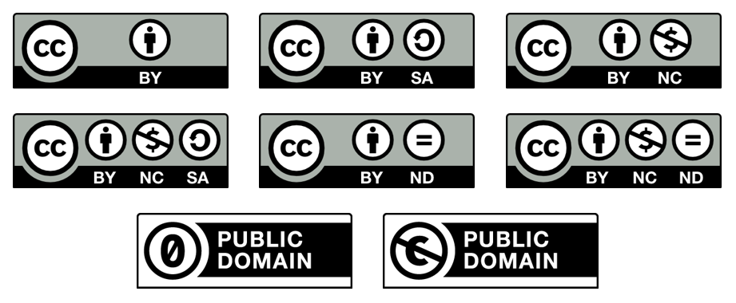

### **CC BY – Creative Commons Attribution**

Allows reusers to distribute, remix, adapt, and build upon the material in any medium or format, so long as attribution is given to the creator. It allows for commercial use.

### **CC BY-SA – Creative Commons Attribution-ShareAlike**

Allows reusers to distribute, remix, adapt, and build upon the material in any medium or format, so long as attribution is given to the creator. It allows for commercial use.

If you remix, adapt or build upon the material, you must license the modified material under identical terms.

### **CC BY-NC – Creative Commons Attribution-NonCommercial**

Allows reusers to distribute, remix, adapt, and build upon the material in any medium or format for non-commercial purposes only, and only so long as attribution is given to the creator.

### **CC BY-NC-SA – Creative Commons Attribution-NonCommercial-ShareAlike**

Allows reusers to distribute, remix, adapt, and build upon the material in any medium or format for non-commercial purposes only, and only so long as attribution is given to the creator.

If you remix, adapt or build upon the material, you must license the modified material under identical terms.

### **CC BY-ND – Creative Commons Attribution-NoDerivatives**

Allows reusers to copy and distribute the material in any medium or format in unadapted form only, and only so long as attribution is given to the creator. It allows for commercial use.

### **CC BY-NC-ND – Creative Commons Attribution-NonCommercial-NoDerivatives**

Allows reusers to copy and distribute the material in any medium or format in unadapted form only, for non-commercial purposes only, and only so long as attribution is given to the creator.

### **CCØ – Creative Commons Public Domain Dedication**

This allows works to be made available in the Public Domain where creators have waived the copyright of their work.

It means there are no licensing restrictions so that anyone can use, reuse, revise, remix or redistribute without attribution given to the creator.

### **Public Domain Mark**

This mark can be used if you have identified a work that is free of known copyright restrictions. Creative Commons does not recommend this tool for works that are restricted by copyright laws in one or more jurisdictions.

CC BY licence mark.Creative Commons and Public Domain marks and licence summaries created by [Creative Commons](https://creativecommons.org/licenses/) and licensed under a [Creative Commons Attribution 4.0 International License](https://creativecommons.org/licenses/by/4.0/). Icons by [The Noun Project](https://thenounproject.com/).

# Appendix 3: Open research (H5P interactive)

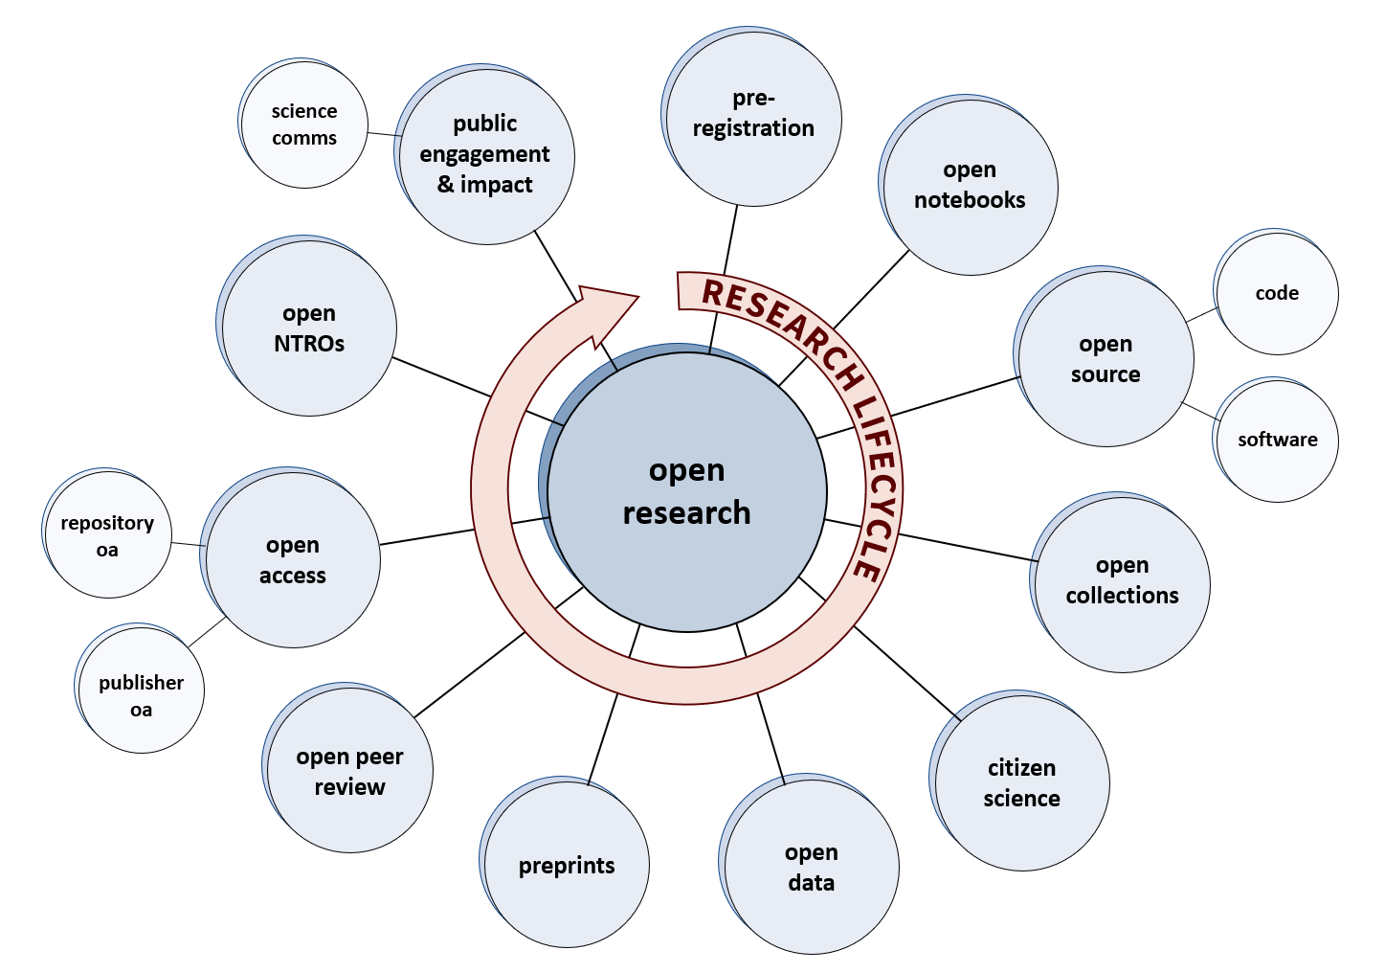

### **Preregistration**

Publicly registering a study or trial before data collection and analysis is growing more common. Preregistration allows greater transparency and reproducibility. It also means researchers can let others know what you’re working on, reducing the duplication of research.

Preregistration of certain clinical trials is also required by [Australia’s National Statement on Ethical Conduct in Human Research (3.1.7)](https://www.nhmrc.gov.au/about-us/publications/national-statement-ethical-conduct-human-research-2007-updated-2018#toc__438) and the International Committee of Medical Journal Editors.

Many journals, especially in STEMM disciplines, now accept [Registered Reports](https://www.cos.io/initiatives/registered-reports). In such cases, study designs are peer reviewed and published before research is conducted, with in-principle acceptance being offered to final articles regardless of study outcomes. Registered Reports can thus help reduce publication bias.

### **Open notebooks**

Researchers who embrace open notebooks make their research notes and records publicly available. This can be done either as notes are recorded or once the project is complete, although the former offers more transparency. Such materials may include lab books and other notebooks, and raw and processed data. Principles of “as open as possible” apply, as some de-identification may be necessary.

Drexel University (USA) researchers pioneered these ideas as Open Notebook Science. Fundamentally, in Open Notebook Science “it is essential that all of the information available to the researchers to make their conclusions is equally available to the rest of the world. Basically, no insider information” (Bradley, 2006).

### **Open-source code & software**

Researchers working on code and developing software can share these under open-source licences. Many of these licences rely on “copyleft” principles, which are akin to the Creative Commons Share-Alike element. Open-source licences are detailed at [Open Source Initiative](https://opensource.org/) website. Creative Commons licences can also be used in most cases.

Code and software can be shared through [Melbourne.figshare](https://melbourne.figshare.com/), or through specialised platforms such as GitHub or GitLab. Many aspects of open research rely on open infrastructure – open-source software developed to advance the open research agenda. For more on this, see the [OpenInfra Foundation](https://openinfra.dev/) and [Invest in Open Infrastructure](https://investinopen.org/) websites.

### **Open collections**

Although the term “open collections” can refer to many things – collections of data, of research outputs, and so on – it often refers to open cultural collections. Think, for example, of the images, books, and ephemera digitised by state and national libraries. Most of these collections are in the public domain, copyright permitting.

Examples include [SLV’s popular digitised collections](https://www.slv.vic.gov.au/search-discover/popular-digitised-collections), [TROVE’s newspapers and gazettes](https://trove.nla.gov.au/newspaper/), and our own [Digitised Collections](https://digitised-collections.unimelb.edu.au/). Such open collections are vital to many areas of research, especially in the humanities.

### **Citizen science**

“Citizen science” occurs when amateur scientists and other members of the public participate in the research process. This usually involves the collection, and sometimes analysis, of data through open platforms. Initiatives may originate with amateur scientists themselves, or with research institutes or universities.

In Australia, major citizen science initiatives include bushfire recovery projects and biodiversity tracking. For more on citizen science in Australia, see the [Australian Citizen Science Association](https://citizenscience.org.au/) website and [CSIRO’s citizen science programs](https://www.csiro.au/en/education/get-involved/citizen-science).

### **Open data**

Funders and institutions often encourage an “as open as possible, as closed as necessary” approach to research data. This accepts that not all data can be fully open (due to privacy and confidentiality, for example). In such cases, de-identified datasets can usually be shared.

Planning for open data should occur early on in a research project, as permissions may need to be sought. Many journals now require data to be open when publishing research articles.

There are many data sharing platforms available, including [melbourne.figshare](https://melbourne.figshare.com/) for UoM researchers. Also see [Managing Data @Melbourne](https://library.unimelb.edu.au/Digital-Scholarship/training_and_outreach/data).

### **Preprints**

A preprint is a scholarly paper that has been made available online *before* peer review has taken place.

Sharing is usually done on preprint servers, either multidisciplinary or subject specific. Such platforms usually allow authors to receive feedback on their work and upload revised versions. If the paper is then submitted to a journal, peer reviewed, and published, the author can update the preprint record to link to the final version.

While preprint sharing is now common in many disciplines, it has been gaining momentum across all disciplines in recent years. There are also ongoing efforts to [strengthen preprint reviews and feedback](https://scholarlykitchen.sspnet.org/2022/02/28/guest-post-preprint-feedback-is-here-lets-make-it-constructive-and-fast/), and to more fully integrate preprint sharing into publication workflows.

### **Open peer review**

Approaches to, and definitions of, open peer review vary greatly. Ross-Hellauer (2017) suggests we understand open peer review as “an umbrella term for a number of overlapping ways that peer review models can be adapted in line with the aims of Open Science, including making reviewer and author identities open, publishing review reports and enabling greater participation in the peer review process.”

For an example of open peer review in practice, see [Ross-Hellauer’s article on F1000 Research](https://doi.org/10.12688/f1000research.11369.2), which discloses reviewer identities, reviewer reports, and earlier versions of the article.

### **Open access**

Open access (OA) is the term applied to traditional research outputs that have been made open to all. Such outputs may include journal articles, monographs, and book chapters. Although the term is sometimes applied to other outputs, such as data, it is most often associated with peer-reviewed research publications.

There are two main pathways to open access: through publishers, and through repositories.

### **Publisher OA**

Publisher open access (OA) is where the journal or book publisher releases the work as open access. Authors typically retain copyright, with the publisher releasing the work under a Creative Commons licence.

OA publishing may involve a fee – an article or book processing charge (APC/BPC). Most fully OA journals do not levy APCs, being supported instead by institutions, societies, or organisations. Hybrid journals, however, always levy APCs and their costs can be very high.

The University of Melbourne now has a number of [open access publishing agreements](https://library.unimelb.edu.au/open-scholarship/open-access-publishing-agreements), which can allow authors to avoid APCs.

### **Repository OA**

Repository open access (OA) usually involves the peer-reviewed Author Accepted Manuscript (AAM) of a publication being made open access in a repository. Publishers often require an embargo period of 12-36 months.

At the University of Melbourne, repository OA can be done using [Minerva Access](https://minerva-access.unimelb.edu.au/), our institutional repository. The Minerva Access team checks copyright and publisher policies before making anything open access. They also manage all required embargo periods.

Subject repositories and public digital archives, like PubMed Central or Zenodo, can also be used for this purpose.

### **Open NTROs**

For most digital non-traditional research outputs (NTROs), the best pathway to open is through Creative Commons licences. However, copyright can be very complex for some outputs, such as films or live performances. In such cases, the “as open as possible” principle usually applies.

For non-digital NTROs, such as sculptures or paintings, our existing notions of “open access” run into problems. Here, “as open as possible” may mean providing Creative Commons photographs of the object, or a digitised exhibition guide.

### **Public engagement and impact**

Public engagement is an important end point for many research projects. Truly *open* engagement, though, would be more than just making information freely available online – it would mean using open licences, such as Creative Commons licences, to allow the public to share, reuse, and perhaps even adapt the content to suit their needs.

A multi-disciplinary example of this is [The Conversation](https://theconversation.com/au), which publishes articles by academics aimed at a general audience. Articles are released under a CC BY-ND licence, which allows the work to be freely shared and republished, so long as the original author and source are acknowledged and its content isn’t changed.

### **Science communications**

Open licences can also help improve reach and impact in fields like science communications and public health information. For example, the New Zealand researcher Dr Siouxsie Wiles has worked with cartoonist Toby Morris to create [a growing collection of infographics and animations](https://thespinoff.co.nz/media/07-09-2021/the-great-toby-morris-siouxsie-wiles-covid-19-omnibus) to communicate public health information relating to the COVID-19 pandemic. These were all released under CC BY-SA licences, meaning that others can reuse and adapt them, so long as the creators are acknowledged and the resulting works are likewise openly licenced. This has led to Wiles and Morris’s creations being picked up, adapted, and used by public health agencies around the world.

“[Open Research](https://unimelb.h5p.com/content/1291605673053837669),” University of Melbourne, released under a [Creative Commons Attribution-ShareAlike 4.0 International License](https://creativecommons.org/licenses/by-sa/4.0/).

# Appendix 4: OERs around the world (H5P interactive)

### **Africa**

In 2008, the not-for-profit open learning organisation [Saide](https://www.saide.org.za/) established [OER Africa](https://www.oerafrica.org/) to advocate for, and support, OER uptake across the continent.

Najma Agherdien (2017), a learning designer at Saide, notes that “the current local educational landscape” includes a “demand for equitable access to free, quality education for all.” This, he explains, “makes open education and the provision of quality OER particularly critical.” The freedom to adapt high-quality educational materials from leading international institutions for local contexts, and provide them freely to students, helps overcome some of the barriers faced by higher education providers in Africa.

### **Canada**

In British Columbia, the government’s [BCcampus Open Textbook Project](https://sparcopen.org/our-work/innovator/bccampus/) been creating OERs since 2012. They are now recognised as a world leader in the field, with over 380 of their open textbooks now being used around the world.

In 2012, three Canadian provinces (British Columbia, Alberta, and Saskatchewan) also signed a memorandum of understanding to support the development, sharing, and use of OERs (Stagg et al., 2018).

### **China**

Following the 2003 MIT OpenCourseWare conference in Beijing, the non-profit China Open Resources for Education was founded to support OER development and adoption (Tlili et al., 2019).

The uptake of OERs in China has not been well tracked, but there has been a notable uptake of open courses. The <XuetangX> platform, launched by Tsinghua University in 2013, is China’s leading MOOC platform, providing free access to over 3,000 courses.

### **Europe**

The European Commission has led several OER initiatives, including the [Open Education Framework](https://ec.europa.eu/jrc/en/open-education) and [EPALE (Electronic Platform for Adult Education in Europe)](https://unimelbcloud.sharepoint.com/teams/BuildingStaffCapabilityinOERs/Shared%20Documents/General/Modules/foregrounds%20OERs). The EU-sponsored [European Network for Catalysing Open Resources in Education (encore+)](https://encoreproject.eu/) is a strong and active advocate of OER policy, uptake, and sharing.

In Central and Eastern Europe, the [Open Education Policy Network](https://oerpolicy.eu/) organises regional collaborations to strengthen OER policies and the open education ecosystem.

### **India**

There has been a strong uptake of OERs in India, with initiatives and programs being supported at the government level. There is a great need for OERs that reduce financial barriers, as India has one of the lowest levels of GDP per capita in the world (de Oliveira Neto et al., 2017).

Notable projects include [Project OSCAR](http://oscar.iitb.ac.in/oscarHome.do) (Open Source Courseware Animations Repository) from ITT Bombay, the [Open Education Project](https://in.okfn.org/open-education/) of the Open Knowledge Foundation in India, the [National Repository of Open Educational Resources](http://nroer.gov.in/), and the government’s [National Programme on Technology Enhanced Learning](https://nptel.ac.in/).

### **United Kingdom**

The UK not-for-profit organisation [Jisc](https://www.jisc.ac.uk/) has funded several major university OER projects, including “[Open education](https://www.jisc.ac.uk/rd/projects/open-education)” (2009-2012) and “[Institution as e-textbook publisher](https://www.jisc.ac.uk/rd/projects/institution-as-e-textbook-publisher)” (2014-2018).

More recently, the [UK Open Textbooks](https://ukopentextbooks.org/uk-open-textbooks/uk-open-textbooks-report/) project sought to advocate for OER uptake at universities across the UK, but as with the Jisc projects, funding was limited and the project ended in 2019.

### **United States of America**

Between 2008 and 2016, the US Department of Labor invested 2 billion USD to support the creation and uptake of OERs in community colleges (Stagg et al., 2018).

Investment in OERs has continued, with access to textbooks being of increasing concern given the financial disadvantages often experienced by US students (Schroeder, 2021).

### **North America**

SPARC (the Scholarly Publishing and Academic Resources Coalition) is a US-based organisation advocating for open research and open education. Their [Connect OER](https://sparcopen.org/our-work/connect-oer/) platform gathers information on OER initiatives and resources from universities and colleges across North America.

The [2018-2019 SPARC annual report](https://doi.org/10.31229/osf.io/dvmfn) provides a fascinating snapshot of OER activities and uptake across 132 institutions.

### **Latin America**

Argentina, Peru and Mexico have all passed legislation creating obligations for the open access publishing of scientific research, with repositories and other portals also being created by individual institutions and consortiums, such as [SciELO](https://scielo.org/en/) and [LA Referencia](https://www.lareferencia.info/en/) (Toledo, 2019).

In the wake of the open access movement, a push for OERs followed. A study from 2013 revealed that “in Brazil and other parts of South America, the average annual cost of textbooks to students is over 50% of the annual minimum wage” (Arinto et al., 2017, p. 9). This may be why Brazil, in 2011, passed legislation to fund OER production (Vollmer, 2011).

In 2012, Colombia adopted the National Strategy for Digital Open Educational Resources (Recursos Educativos Digitales Abiertos, or REDA), which establishes a roadmap for a national OER system (Toledo, 2019). Other innovations have come from individual institutions. See, for example, [Eduteka](https://eduteka.icesi.edu.co/articulos/quienes), an OER portal created by Icesi University in Cali, Colombia.

### **East and South-East Asia**

The Malaysian Department of Higher Education has adopted a national policy for the use of OERs based on the UNESCO Recommendation in consultation with 20 public universities and various civil society groups (UNESCO, 2021).

The cost of importing textbooks to countries like the Philippines is prohibitive to many students, who rely on photocopying to access materials (Arinto et al., 2017). In 2015, a National Workshop on the Development of Open Educational Resources (OER) Policies was organised to try to advance OER uptake and coordination (UNESCO, 2015).

Thailand and Indonesia have yet to develop national policies on OER, but there have been tentative steps taken by individual institutions. See, for example, [Thailand Cyber University’s use of OER](http://imlf.mobi/presentations/Anuchai.pdf) and, in Indonesia, [Universitas Terbuka’s OER portal](http://www.ut.ac.id/OER/index.html).

### **Middle East / Western Asia**

Saudi Arabia, Kuwait, Qatar, Bahrain, and Oman are all developing, or have already developed, national OER policies. Some other states, like Jordan, have developed policies in conjunction with universities and other institutions. In other states and regions, which may have less wealthy economies or be suffering under political instability, such as Lebanon and Palestine, OER policies and initiatives are solely in the hands of individual institutions, with no government involvement (Tlili et al., 2020).

In 2004, as the open access movement gained momentum, researchers from Turkey, Europe, and the US, started a Turkish OCW (Open Courseware) project, translating MIT’s OER and OCW materials into Turkish. This led to the establishment of a [National Open Course Materials Consortium in the Turkish Academy of Sciences (TÜBA)](https://www.tuba.gov.tr/en/activity-projects/academy-projects/open-course-materials-project) in 2006, which has focused on translating OERs into Turkish and creating new Turkish OERs. Nonetheless, most of the activity in the OER space in Turkey has been driven by individual universities and academics who have undertaken their own OER projects (Tisoglu, Kursun & Cagiltay, 2020).



“[OER World Map](https://unimelb.h5p.com/content/1291610982945408679),” University of Melbourne, released under a [Creative Commons Attribution-ShareAlike 4.0 International License](https://creativecommons.org/licenses/by-sa/4.0/)