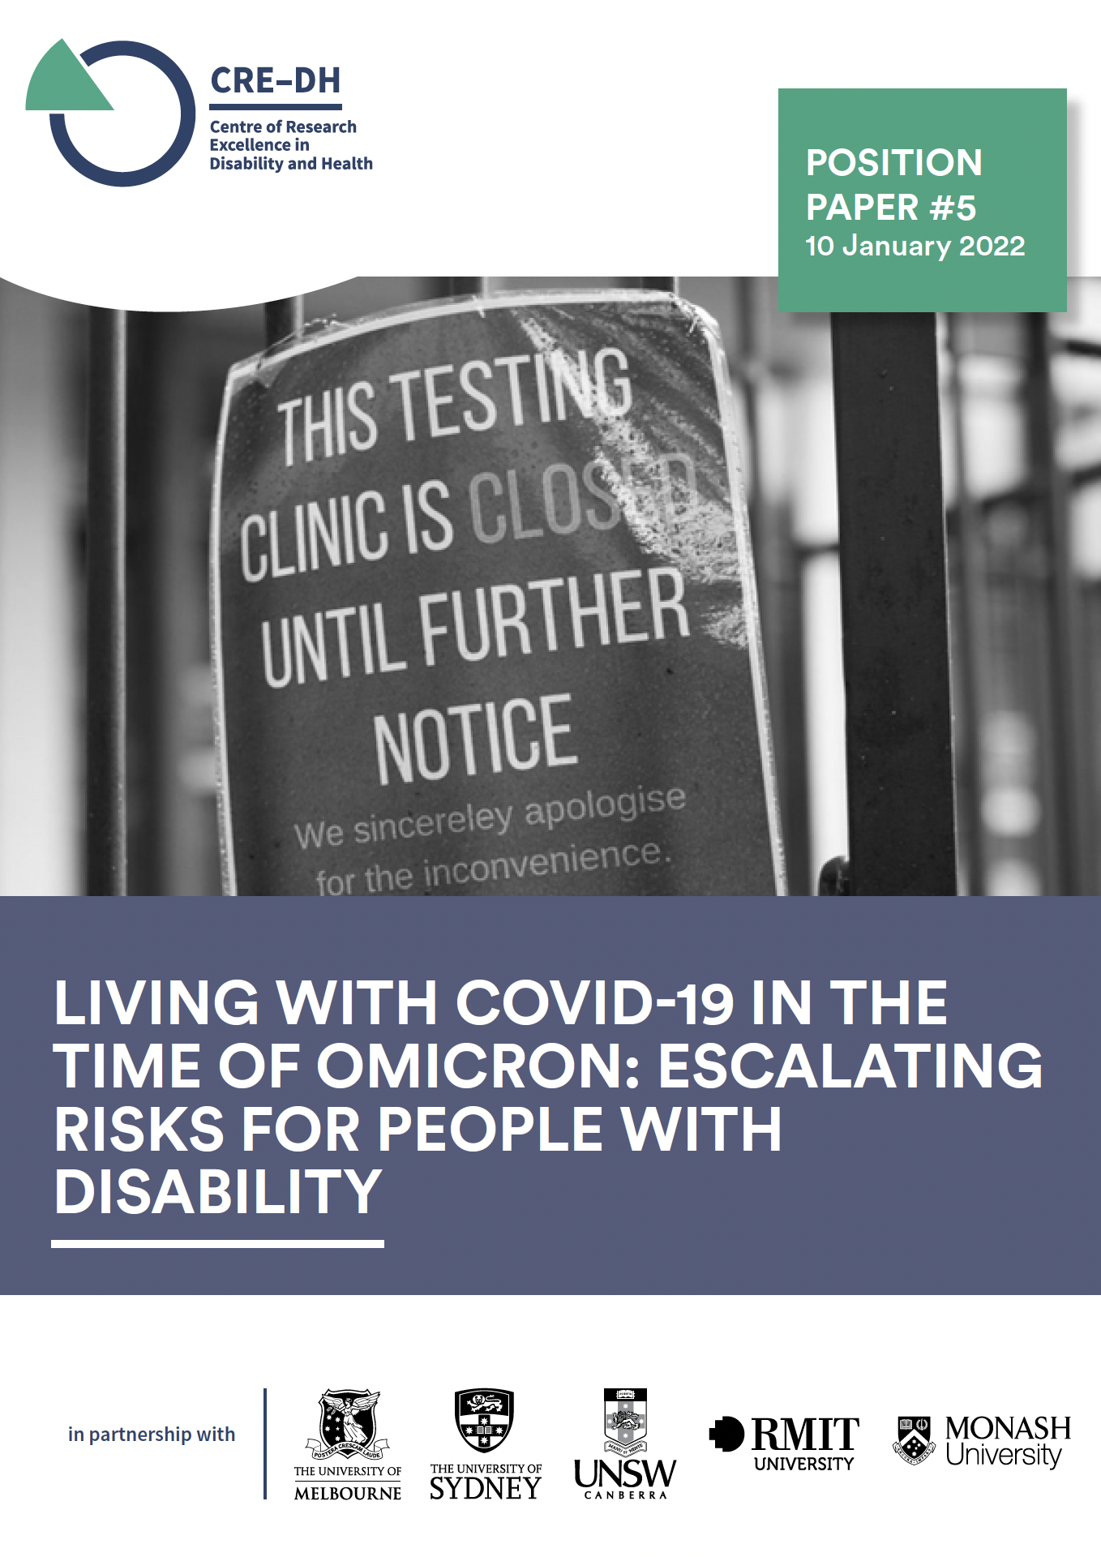

Two years into the COVID-19 pandemic we have reached the most dangerous time yet for people with disability. While Australia fared well for the first two years of the pandemic, we have reached a critical juncture. Without urgent action we will see major adverse impacts for people with disability and their families, including death.

There are now unprecedented levels of infection in Australia because of the high transmissibility of Omicron. This has resulted in major staff shortages in health and disability services.

Right now, people with disability are at high risk of not getting essential supports for ordinary daily activities from eating to assistance with personal hygiene. They are also at very high risk of being infected with COVID-19 from workers and their household members, especially if they and/or their workers and household members are not fully vaccinated or have not received booster doses.

The Centre of Research Excellence in Disability and Health makes urgent recommendations in relation to health care, disability supports, vaccination and monitoring to reduce the risk for people with disability in this current situation.

COVID-19 and COVID-19-related health care and planning

The health system is under significant pressure with furloughing of staff due to COVID-19 infection or as close contacts. More people with disability with COVID-19 will need to be cared for where they live rather than in hospital. This is also critical where hospitals have moved to mixed wards, such as in ACT, where positive and non-positive people are placed together – increasing the risk of exposure and transmission.

Health system pressures are impacting vaccination capacity and COVID-19 PCR testing, with some people with disability experiencing 7 day waiting times on results. There is limited supply of Rapid Antigen Tests, which are essential for ‘screening’ workers before they provide support.

We call on governments across Australia to ensure that people with disability receive essential health care and that they are protected from COVID-19 infection.

- Clear guidance to people with disability, families, services, and support workers on how to monitor people with COVID-19 at home including accessible information and self-care kits (e.g., oximeters, thermometers) potentially extending the Disability Liaison Officer model in Victoria to do this
- Continuation of telehealth for primary and specialist care for all health care without restriction to non-bulk billed services or geographic location of provider or patient
- Prioritisation when processing PCR tests, ensuring people with disability who are at high risk receive results within an acceptable timeframe
- Individualised emergency COVID-19 plans for all people with disability that can be enacted if they are COVID-19 positive
- Re-establishment of disability COVID-19 health professional expert panel to provide advice to other health care professionals supporting people with disability who are COVID-19 positive
- Ensure all people supporting people with disability – disability support workers, families, and carers – report RAT positive results for individuals with disability to link to monitoring at home and any changes in health condition or health advice.

Disability services and support workers

Just like health care, disability services are facing staff shortages which is having an impact of the people’s capacity to access essential supports.

- Immediately establish surge workforce capacity for people with disability or their families and carers to access in an emergency by recruiting students in allied health, nursing, and medicine and maintaining and extending temporary visa measures
- Where practicable, mandate and fund the use of TGA approved respirator masks (N95/P2) for workers supporting people with disability and organise fit testing of workers and training in their use
- Priority and free access to TGA approved Rapid Antigen Tests for workers, and guidelines on frequency of use in various risk settings (e.g., residential care, community)
- Priority access and processing of PCR tests for disability support workers who are symptomatic or close contacts
- Paid pandemic leave for workers who have COVID-19 like symptoms, are COVID-19 positive, or are required to isolate
- Restrict worker movement, particularly between homes, to reduce transmission risk and compensate workers and services where appropriate
- Provide immediate guidance and funding for services and people with disability to reduce transmission risk through ventilation adopting the recommendations of OzSAGE on Safe Indoor Air
- Guidelines for people with disability in accessible formats on what to do if they or someone they are living with are COVID-19 positive
- Do not allow or force non-symptomatic COVID-19 positive workers back to work, except for when they are supporting COVID-19 positive people with disability
- Do not allow or force workers who are isolating as close contacts back into the workforce.

Vaccination

Vaccination remains central to the prevention and control of COVID-19 pandemic and reducing risk for those most likely to be severely affected. With limited health care capacity nationally to deliver vaccines it is critical people with disability are prioritised. We recommend:
- Intensive outreach to people with disability who have not been vaccinated and substitute decision-makers to ensure they are vaccinated, noting that 16% of people with disability in residential settings have not had two doses of the vaccine
- Contact all people with disability and workers due for booster or third doses and organise appointments immediately where needed
- Mandate booster or third doses for disability support workers
- Prioritise access to vaccination for clinically vulnerable 5- to 11-year-olds and boosters or third doses for 12- to-17-year-olds with disability.

Monitoring

In this rapidly changing situation, it is critical that we collect data on COVID-19 infections, hospitalisations, and deaths among people with disability.

- RATs should be regarded as positive and reportable to the NDIS Quality and Safeguards Commission recognising that these will be an undercount.
- Transparent reporting on numbers of positive COVID cases and deaths of people with disability
- Link disability data to infection, hospitalisation, and death data to establish a better picture of the true situation.

Implementation of recommendations
Our recommendations for health care and disability services and supports require extensive coordination across the State and Territory and Commonwealth government agencies responsible for disability and health. Cooperation and coordination are essential to ensure timely distribution of free RATs and PPE to people with disability and services; outreach to services and people with disability to ensure optimal COVID-19 and non-COVID-19 health care; and the provision of accessible information through multiple channels, especially community and locally based and accessed information points.

We have found throughout the pandemic that responsibility for disability has fallen between government silos (health and disability), and agencies (National Disability Insurance Agency and the NDIS Quality and Safeguards Commission). There is a need for clear decisions regarding who holds responsibility for implementing different actions to ensure the health and safety of people with disability during the pandemic.

Data also needs to be shared across agencies, with the necessary privacy provisions, to enable outreach and coordination of public health responses to COVID-19.

The Disability Gateway should continue to provide a single point of contact for information related to COVID-19.

Authors
Professor Anne Kavanagh, Chair in Disability and Health, Melbourne School of Population and
Global Health, University of Melbourne; Co-Director CRE-DH
Professor Gwynnyth Llewellyn, Centre of Disability Research and Policy, University of Sydney; Co-Director CRE-DH
Professor Helen Dickinson, Public Service Research, UNSW; Chief Investigator CRE-DH
Professor Gemma Carey, Research Director, Centre for Social Impact, UNSW; Chief
Investigator CRE-DH
Dr George Taleporos, Disability Rights Advocate; Policy Manager, Summer Foundation

Contact details
Professor Anne Kavanagh
Chair in Disability and Health, Melbourne School of Population and Global Health,
The University of Melbourne
a.kavanagh@unimelb.edu.au
www.credh.org.au

