The Cascade of Care: How HIV data models shape understanding of “monitoring and evaluation”, and “surveillance and survey”.

Contributors: Contributors are listed in alphabetical order, and their contributions indicated according to the CRediT framework (https://casrai.org/credit/)
Name | CRediT
Amalia Handayani | Writing – review & editing
Ben Hegarty | Conceptualization, research, writing – various sections, writing – review and editing
Priyanka Pillai | Writing – review & editing
Kristal Spreadborough | Conceptualization, Project administration, Writing – original draft, Writing – review & editing

* Handayani, A., Hegarty, B., Pillai, P., Spreadborough, K. (2021) The Cascade of Care: How data models shape understanding of “monitoring and evaluation”, and “surveillance and survey”. DOI: https://doi.org/10.26188/14784783
*Authors listed in alphabetical order

Abstract
This paper sets up the context in which the Cascade of Care is applied to HIV prevention in the Indonesian context. The Cascade of Care, hence forth referred to as the cascade, is a component of the broader Continuum of Care which is focused on the process from being at risk of HIV through to HIV prevention.
This paper first outlines the cascade as a data model, which is a core component of providing policy makers and funders a high-level picture of progress towards HIV prevention. The paper considers the implications of the 90/90/90 approach to HIV prevention - “90% of all persons living with HIV (PLHIV) are aware of their HIV status, 90% of all people who know their status are receiving antiretroviral therapy (ART), and 90% of those on ART are virally suppressed”.
The paper then considers two main components required to supply data to the cascade. First, monitoring and evaluation which emphasises that data should be used to drive decisions is examined. Second, surveillance and survey is considered which are the tools by which this data is collected. Throughout the paper, consideration is given to the purpose of the cascade and how the cascade shapes conceptualisation of these key terms. This paper provides a critique of how the cascade provides the appearance of a standard of HIV treatment and the broader implications of this.

1 Context
Data about the HIV epidemic – both modelling and the collection of epidemiological information – has expanded, as political momentum to “end AIDS” has spurred the expansion of medical and information technologies to test, treat and track the epidemic. For example, in its 2016 report, the World Health Organization emphasised the collection and use of data as a key strategy for implementing tailored responses to the HIV epidemic (World Health Organization, 2016, pp. 28 - 30). As the report outlines, “Quality data are required to measure service access, service uptake, populations covered, quality and acceptability along the entire continuum of HIV services” (p. 29). These and other international measurements focused on data collection broadly draw on the concept of a “continuum of HIV services” generally and the “HIV care cascade” specifically.
The continuum of HIV services and the HIV care cascade provide the model through which indicators for monitoring the HIV response to the epidemic globally are drawn. The HIV care cascade, or cascade of care (hereafter called the cascade), is a data model used as an international standard across international development funds, especially global mechanisms like the Global Fund. Given its widespread adoption and use, the cascade is defined differently in each context, as are the principles of “monitoring and evaluation” (M&E) and “surveillance and survey” which underpin the collection of data that is used to establish the cascade of care. This paper outlines how definitions of “monitoring and evaluation” (M&E) and “surveillance and survey” are influenced by the cascade. It focuses specifically on the application of these models to the Indonesian context. First, an examination of the cascade data models is undertaken. Then, how the principles of M&E, and surveillance and survey are defined within these contexts is outlined. Finally, this paper concludes with a discussion of the working definitions of these principles. In this way, this paper sets out some preliminary or working definitions that will be important in a study of Indonesian HIV data infrastructures.

2 The Cascade of Care
The cascade is a data model designed to simplify the representation of data relating to HIV prevention. It does this by focusing on specific components of the broader continuum of care. For example, Figure 1 shows the relationship between the World Health Organisation’s broader continuum of care and the elements included in the cascade. The cascade is focused on data collected to support the assessment of outputs and outcomes related to HIV care. However, how these outputs and outcomes are conceptualised differs across different data models. This section looks at the use of the cascade as a data model by two major international organisations which address the HIV epidemic: the World Health Organisation and the United States-government funded “Linkages” program. It then considers how these models shape the discourse around Indonesia’s HIV related outputs and outcomes.
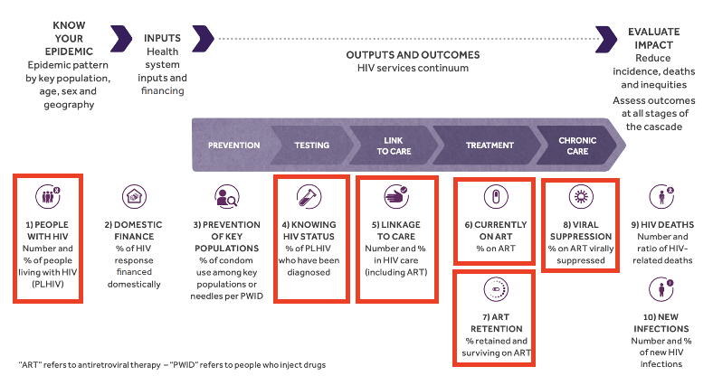
Figure 1. The HIV response across one “continuum” of HIV services. The elements relating to the HIV Care Cascade are indicated in red boxes. Figure adapted from World Health Organization, 2016, p. 30.

2.1 The World Health Organisation
The World Health Organisation’s conceptualisation of the cascade was introduced by the Joint United Nations Programme on HIV/AIDS (UNAIDS) in 2014. Since around this time, the Programme has focused the bulk of policy and funding towards the elimination of HIV. It sets out this aim by using a version of the cascade, simplified into three parts: “90% of all persons living with HIV (PLHIV) are aware of their HIV status, 90% of all people who know their status are receiving antiretroviral therapy (ART), and 90% of those on ART are virally suppressed” (UNAIDS, 2014). Thus, viral suppression is the ultimate indicator of success in the cascade model. These three measures form the basis of the cascade data model, which is typically represented as a bar graph (sometimes with additional steps) across both policy and research settings. The data model may include between three to six measures; however, it is the three categories of diagnosis, treatment, and suppression that underpin the 90/90/90 target. Figure 2 shows some examples of the cascade data model represented with varying numbers of measures.
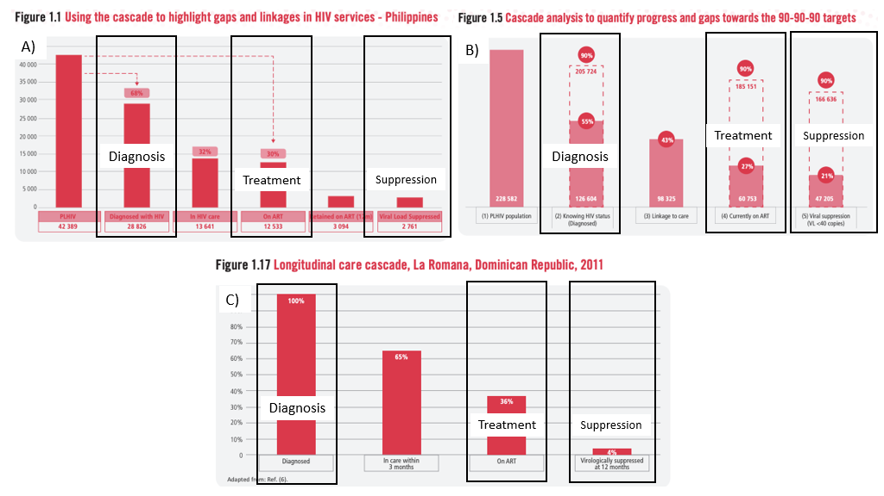
Figure 2. Examples of the World Health Organisation cascade data model. The three key indicators of diagnosis, treatment and suppression are shown in boxes in each of the models. Figure adapted from World Health Organization, 2018.

2.2 Linkages (United States development aid funded programs)
The cascade model used by the Linkages program (funded by the United States through its international development agency, USAID) is similarly based on the 90/90/90 targets. In a large number of developing countries around the world, including Indonesia, the Linkages program funds HIV services specifically for key populations (those at greater risk of infection, incorporating people who inject drugs, men who have sex with men, transgender persons, sex workers and prisoners). This model links two realms of HIV programs often characterised as separate – prevention and treatment – together, thus placing all “key populations” (regardless of HIV status) into its purview. It nevertheless separates out indicators which are related to prevention, and those related to care and treatment as prevention. As shown in Figure 3, the 90/90/90 target, however, spans both. Whereas the World Health Organisation cascade data model is often used at the national and global funder level, the Linkages cascade is here directed at “on the ground” staff and community organisations (FHI 360/LINKAGES, 2017, p. 3).
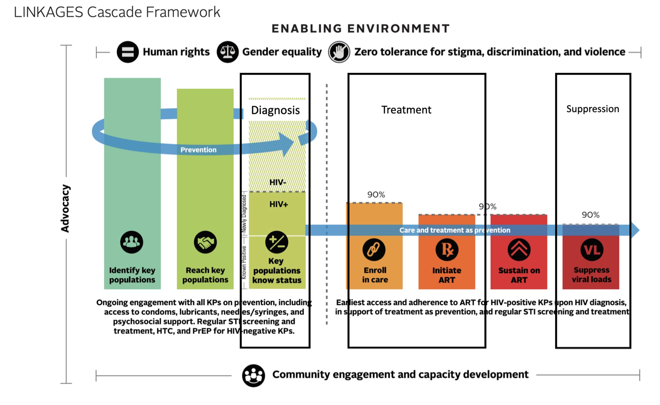
Figure 3. Examples of the Linkages cascade data model. The three key indicators of diagnosis, treatment and suppression are shown in boxes in each of the models. Figure adapted from FHI 360/LINKAGES, 2017, p. 2.

A central aspect of the Linkages cascade is identifying where “leakages” occur. That is, points where individuals discontinue treatment. This is often referred to as “lost to follow up”. Figure 4 shows the Linkages “leaky pipe” where individuals are identified as being “lost to follow up” and how this relates to the stages of the cascade data model. One key goal of the broader Linkages program (including both the cascade data model and the leaky pipe framework) is to standardise “programs based on proven, high-quality interventions from other countries.” (FHI 360/LINKAGES, 2017, p. 3). In this context, broader program aims and the cascade – a model with its roots in biomedical care –become closely linked (see, for example, FHI 360/LINKAGES, 2017, Figure 4, p. 4).

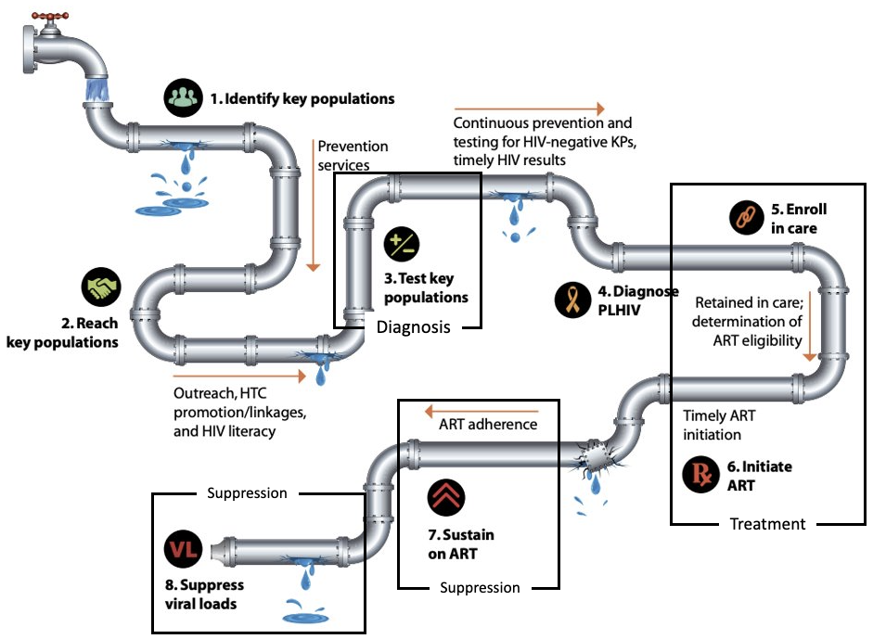
Figure 4. Examples of the “Leaky pipe” framework within the Linkages cascade data model. The stages of the cascade are indicated in black boxes. Figure adapted from United States Agency for International Development (USAID), 2015, p. 2.

2.3 The Indonesian Context
In Indonesia – the focus of our study – UNAIDS Data 2017 reported the following cascade indicators: only 35% of people have knowledge of their status among all people living with HIV; 36% of people living with HIV who know their status are on treatment; and 13% of all people living with HIV are on treatment (Evidence to Action, 2021). Adding to the complexity is that many of the total numbers are premised on estimates that are based on epidemiological models (which are in turn tied to targets). Thus, the latest total number of people living with HIV in Indonesia that is cited in this report – 640,000 – is an estimate. Nevertheless, by the 90/90/90 standards which underpin cascade data models, Indonesia has a long way to go in “ending AIDS.” (Evidence to Action, 2021). (Evidence to Action, 2021). Adding to the complexity is that many of the total numbers are premised on estimates that are based on epidemiological models (which are in turn tied to targets). Thus, the latest total number of people living with HIV in Indonesia that is cited in this report – 640,000 – is an estimate. Nevertheless, by the 90/90/90 standards which underpin cascade data models, Indonesia has a long way to go in “ending AIDS.” (Evidence to Action, 2021). Adding to the complexity is that many of the total numbers are premised on estimates that are based on epidemiological models (which are in turn tied to targets). Thus, the latest total number of people living with HIV in Indonesia that is cited in this report – 640,000 – is an estimate. Nevertheless, by the 90/90/90 standards which underpin cascade data models, Indonesia has a long way to go in “ending AIDS.”.
Since the introduction of the cascade concept into Indonesian HIV policy in 2012, in 2018 the Ministry of Health rolled out a “test and treat” program (meaning that specific at-risk populations are able to access treatment regardless of other existing diagnostic criteria) on the national level (Lazuardi, 2019). As Elan Lazuardi (2019) points out, the cascade has radically shaped the meanings associated with “HIV care” across its various steps in Indonesia. Yet there is little known about processes of data collection and infrastructures that support such a model in the Indonesian context. Specifically, there is no clear understanding about how data is collected, how it could be made more effective, and the potential for its misuse. As a result, despite calls for greater amounts of data to feed the cascade data model, it is not clear how accurate current data collection processes are or whether management of it is robust. For this reason, research is needed which interrogates the principles which underpin these data models so that we might better understand how much of the Indonesian HIV picture is represented in current cascades. To do this, however, first a shared understanding of these principles must be reached. (Lazuardi, 2019). As Elan Lazuardi (2019) points out, the cascade has radically shaped the meanings associated with “HIV care” across its various steps. Yet there is little known about processes of data collection and infrastructures that support such a model in the Indonesian context. Specifically, there is no clear understanding about how data is collected, how it could be made more effective, and the potential for its misuse. As a result, despite calls for greater amounts of data to feed the cascade data model, it is not clear how accurate current data collection processes are or whether management of it is robust. For this reason, research is needed which interrogates the principles which underpin these data models so that we might better understand how much of the Indonesian HIV picture is represented in current cascades. To do this, however, first a shared understanding of these principles must be reached.
One area in which there is a need to better understand how the Indonesian context is represented in the current cascade models is most evident is in their use for evaluating the effectiveness of Indonesia’s HIV response. One assessment, funded by the World Health Organization, of HIV services for “key populations” (KP) (those groups considered more vulnerable to HIV infection, the focus of the Linkages program, as mentioned earlier) identified several issues with data collection in Indonesia (Falkenberry et al., 2018). The findings of this assessment included an inconsistent use of unique identifier codes (UIC) (which facilitate anonymity) across agencies (NGO and state), collecting extraneous data, recording personal/potentially identifying data on forms, extensive duplication in clinical data, and inadequate technical lab capacity for viral load (VL) testing which is increasingly understood as the “end point” of the cascade of care.
In other accounts the very measure of aspects of the cascade are altered due to a lack of available data. For example, recent research into Indonesia’s “test and treat” policy launched in 2014, found that the “viral load” component of the cascade (the last 90) is exchanged for “proxy” data of “Lost to Follow Up” (individuals whose data shows they do not continue in treatment) or “retained in care” (people who continue to take treatment and attend routine checkups) (Tarigan et al., 2020). This highlights an important definitional aspect of the cascade; although it may differ both in the presentation and the data used (e.g. retained in care rather than suppressed viral load), what matters is its presentation as a universal model.
Despite its presentation as a universal model, the “cascade” is, however, used differently in different settings. This is particularly so given that Indonesia relies on international funding/donors for a significant proportion of its budget to tackle HIV/AIDS (although this has shifted towards greater domestic spending over the years, see Evidence to Action, 2021). This speaks to the fact that specific meaning of “cascade” depends on audience for the data as measured against a specific indicator. For example, a local NGO will understand the cascade insomuch that it is concerned with meeting outreach targets so that it can continue to receive funding. The government ministry of health is concerned with reporting to the coordinating ministry which then can report to international donors. It is possible, moreover, that the ministry of health uses cascade data to evaluate the performance of individual clinics (though this is not clear). The Indonesian government may also use cascade data to report on progress towards international development targets. Sometimes the data used across all of these settings is the same, sometimes it is different. It is across these different contexts that the meanings of concepts like M&E and “cascade of care” take their meaning.

3 Monitoring and Evaluation
“Evaluation” is defined by UNAIDS as “the systematic collection of information about the activities, characteristics and outcomes of a specific programme to determine its merit or worth” (UNAIDS, n.d., p. 14). “Monitoring” appears to refer to the collection of data for evaluating program performance: e.g. “serosurveillance, behavioural surveys, routine programme monitoring” (UNAIDS, n.d., 47). Figure 5 is a visualisation of the process of M&E. Although it has different outcomes and processes to surveillance, the “cascade logic” is applied here too; eight “public health questions” are organised visually into the three “cascade steps” of “diagnosis (know your status),” “treatment (retained in care),” and “suppression.” Thus, M&E is imagined to correspond to steps undertaken to achieve suppression of viral load at a population level. Although M&E as shown in Figure 5 is focused on different outputs and outcomes to the cascade data models discussed above, it is a model that is premised on the collection of data. Because of this, the M&E framework lends itself to the cascade data models. For example, in answer to the question “What is the problem?” the response from policymakers thinking through the cascade is likely to be, “not enough people on ARTs” and related problem of “not enough HIV+ people are virally suppressed” or “we don’t know how many people are on ARTs and virally suppressed.” In this way, M&E activities can be recast to fit the indicators of the cascade data model; in other words, it encourages policymakers to adopt treatment as prevention (a biomedical model) as core to their efforts. (UNAIDS, n.d., p. 14). “Monitoring” appears to refer to the collection of data for evaluating program performance: e.g. “serosurveillance, behavioural surveys, routine programme monitoring” (UNAIDS, n.d., 47). Figure 5 is a visualisation of the process of M&E. Although it has different outcomes and processes to surveillance, the “cascade logic” is applied here too; eight “public health questions” are organised visually into the three “cascade steps” of “diagnosis (know your status),” “treatment (retained in care),” and “suppression.” Thus, M&E is imagined to correspond to steps undertaken to achieve suppression of viral load at a population level. Although M&E as shown in Figure 5 is focused on different outputs and outcomes to the cascade data models discussed above, it is a model that is premised on the collection of data. Because of this, the M&E framework lends itself to the cascade data models. For example, in answer to the question “What is the problem?” the response from policymakers thinking through the cascade is likely to be, “not enough people on ARTs” and related problem of “not enough HIV+ people are virally suppressed” or “we don’t know how many people are on ARTs and virally suppressed.” In this way, M&E activities can be recast to fit the indicators of the cascade data model; in other words, it encourages policymakers to adopt treatment as prevention (a biomedical model) as core to their efforts.
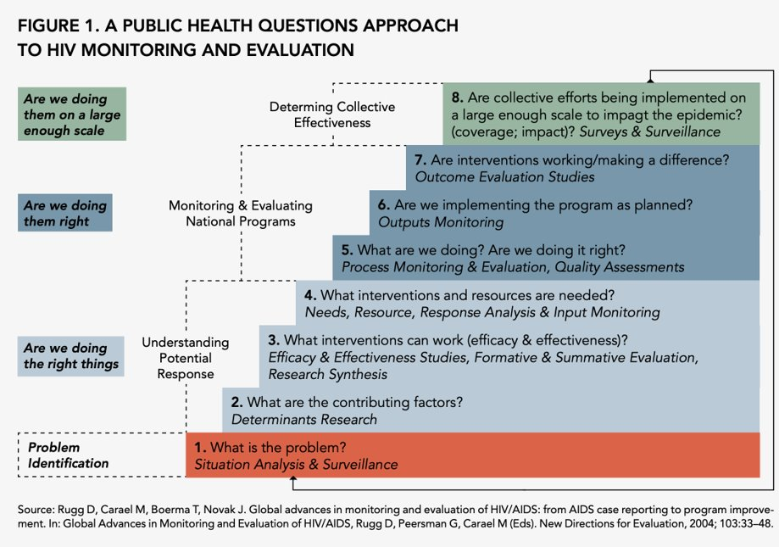
Figure 5. The M&E framework overlaid with the three key indicators of the cascade data model. Figure from UNAIDS, n.d., p. 16.UNAIDS, n.d., p. 16.UNAIDS, n.d., p. 16.

The impact of the processes of M&E of the HIV epidemic has changed over time (and indeed, the emergence of M&E as a priority in data collection about HIV), but can be characterised broadly as a move towards a cascade model. Measuring progress in terms of the cascade has been the case since the widespread adoption of “treatment as prevention,” an approach centered on the concept that the widespread rollout of effective treatment could also serve as a form of prevention. Social scientists have critiqued this heralding increasing biomedicalisation of the way that HIV is understood and addressed (away from community-driven and socially complex models) (Kippax & Stephenson, 2019). This also shapes how M&E takes place; indeed, ART initiation in the aid of suppression of viral load – also known as undetectable viral load – is the key indicator where the process can be determined as a success (see for example as displayed in Figure 3 above – the USAID (2015) model for evaluating the programs it funds for treatment and prevention as a continuum).
More fully defined, the cascade approach to M&E sees treated HIV as an end point of processes of a series of steps through which a patient moves: from testing, diagnosis, linked and accessing treatment, and retention in treatment. Each of these steps serves in a sense as an aim for "undetectable viral load" that is, viral suppression so that a person is theoretically unable to infect anyone else. This is driven through a political emphasis on of "treatment as prevention" (i.e., undetectable viral load, or treatment, to stop further transmission, or prevention). A critique of the "cascade" is thus that it defines "HIV care" narrowly in terms of a goal of viral suppression/treated HIV (for these critiques see, Paparini & Rhodes, 2016). Cascade of care and related concern of treatment as prevention, as a form of M&E, shapes public health surveillance and allocation of resources, particularly towards those “out of care” or not virally suppressed (n.b. in an age of PrEP this takes on meaning of similar biomedicalisation of prevention targets for HIV negative populations through emergence of prophylactic for "key populations") (see Molldrem, 2020). In the present document we can also see how the definition of M&E is influenced by the cascade, especially the Linkages cascade, which operates at the level of M&E of outreach workers in the field albeit implicitly (program coverage and HIV testing = prevention; HIV CARE for key populations = cascade of care, with ART access key goal). Figure 6 shows “sample monitoring indicators” for non-governmental organisations funded to undertake outreach. These organisations are encouraged to understand and report on their own activities through a version of the cascade.
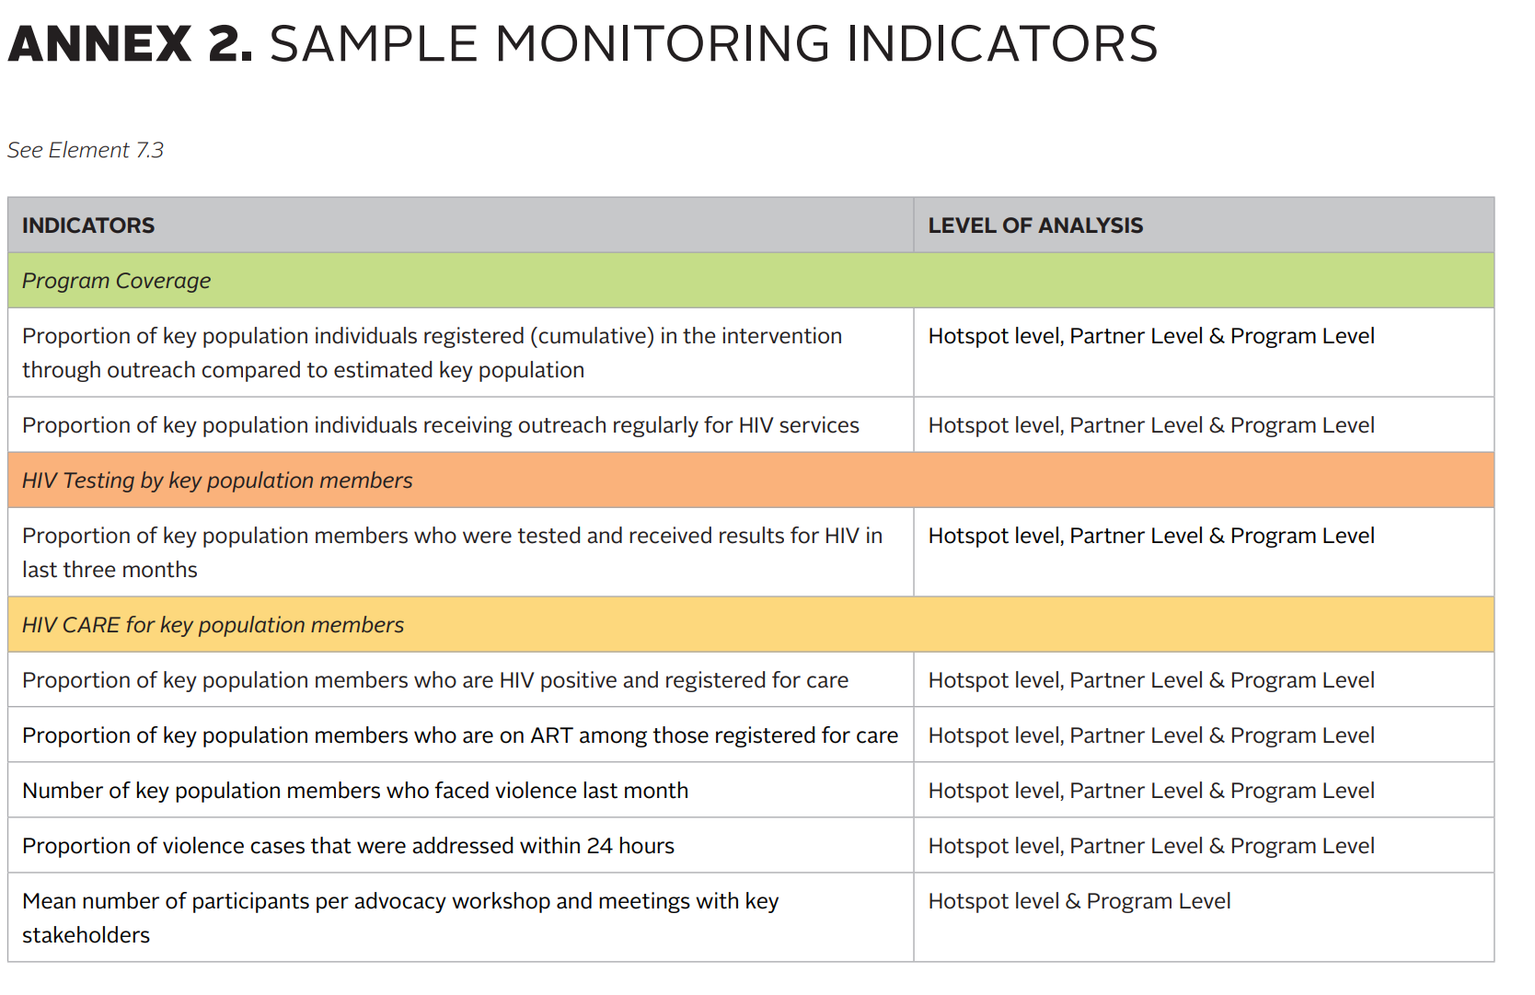
Figure 6. The sample monitoring indicators used by LINKAGES. Figure from FHI 360/LINKAGES, 2017, p. 83.

4 “Surveillance” and “Survey”
According to the US CDC baseline template training module for public health personnel surveillance is defined as: "[the] ongoing, systematic collection, analysis, and interpretation of health-related data essential to planning, implementation, and evaluation of public health practice, closely integrated with the timely dissemination of these data to those responsible for prevention and control," (Centers for Disease Control and Prevention, 2018, para. 1). The UNAIDS/WHO Working Group on global HIV/AIDS and STI Surveillance adds the following to this definition, describing surveillance in one report as, “early-warning systems for the detection of changes in diseases or patterns, which allow for the necessary interventions to be put into practice to prevent new infections” (2003, p. 71). While surveillance is complex, and there are many different methods, surveillance for HIV at the broadest level relies on the collection of various kinds of data about the population. Surveillance incorporates data from routine reporting including case reporting (requiring an understanding of the total number of tests undertaken, the number who test positive, the number who enrol in care and so on) and sentinel surveillance (focused on periodic testing and behavioural surveys among at risk populations). An important feature of models of HIV surveillance is that it focuses on tracking the epidemic by collecting behavioural and biological data about specific at-risk populations rather than the population as a whole. This is shown in Figure 7.
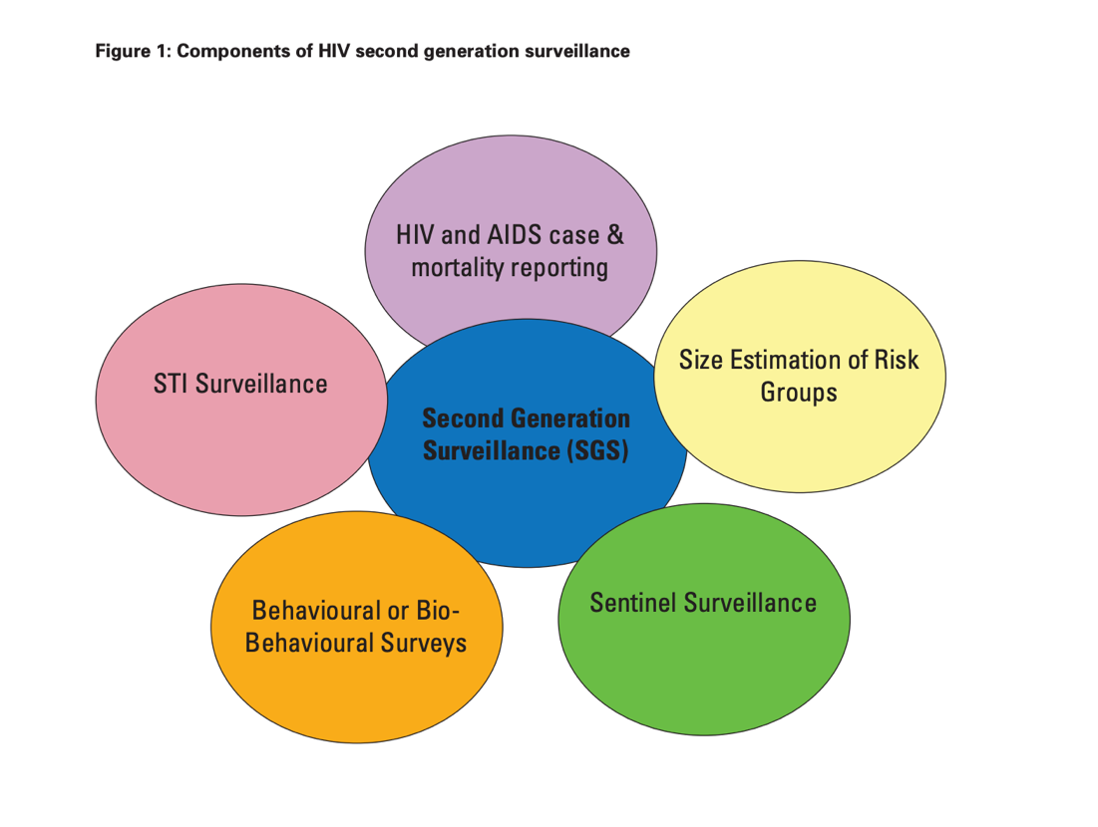
Figure 7: Overview of data included in “second generation surveillance.” Figure from (World Health Organization, 2013, section 1.1).
Using this definition, surveillance is an important part of the data collection mechanisms that make the M&E discussed above possible. In their guide to surveillance published in 2013, the World Health Organization describe the close relationship between surveillance and M&E in HIV programs as follows:
“Countries have gained experience in when and how data collection activities for surveillance and monitoring and evaluation (M&E) can be designed so that they are complementary (5). These data collection activities have some overlaps. 1) The main objective of surveillance is to track how the epidemic in a country is changing. 2) The main objective of M&E is to track how effectively programmes are responding to the epidemic, and whether the outcomes and outputs correspond to the activities planned.” (World Health Organization, 2013, section 1.3).
Because of the lack of clarity about data collection practices in Indonesia as discussed above, there is little research about how surveillance is defined relative to the cascade model in Indonesia. For this reason, this section draws on the authors understanding of surveillance in this context based on informal conversations and a preliminary review of some of the grey literature on the topic. It does appear that most of the data collections that comprise the methods outlined as “second generation surveillance” are used in Indonesia. This information appears to be collected and stored in “SIHA” (the Indonesian HIV/AIDS Online Data System) in a systematic manner, including HIV and STI case reporting, size estimation of key populations and sentinel surveillance. Included in SIHA are instances of data collection that can be classed as perhaps more traditional forms of “public health surveillance” (although the difference between M&E and “surveillance” is not really clear from the definition provided by the World Health Organization, 2013). Each of these methods of data collection have their own techniques and standard, yet all require in some way data collected on the basis of “high risk” (and to the relationship between risk and sexuality in particular).
Although not the only one, a method of data collection that informs the M&E used to report to the cascade is the periodic biological and behavioural surveys of key populations through the Behavioural and Biological Survey (IBBS). These surveys are undertaken approximately once every three years and involve a large logistical effort encompassing many organisations and fieldworkers which collect various kinds of biological data. The IBBS is one example of the kinds of surveillance data collected in Indonesia. The Indonesian IBBS undertaken in 2013gathered HIV data about populations that overlap with but are not exactly the same as the “key populations” outlined earlier (Ministry of Health 2013). In the summary slides of the 2013 IBBS in Indonesia, these “risk groups” have been defined as:
  - Wanita Pekerja Seks Langsung (WPSL) [direct female sex workers]
  - Wanita Pekerja Seks Tidak Langsung (WPSTL) [indirect female sex workers]
  - Pria Berisiko Tinggi (Pria Risti) [high risk men],
  - Penasun [people who inject drugs],
  - Waria [transgender women],
  - Lelaki Seks dengan Lelaki (LSL) [men who have sex with men]”
  - Remaja [young people] (Ministry of Health 2013, slide 9).
A common feature of surveillance across programs is therefore its focus on “risk” — defined both as practices and as categories that tend to be tied to types of persons — although who is included and what counts as risk shifts across different documents, manuals and reports, and from year to year. While outside of the scope of this paper, the categories for evaluating and measuring risk are moreover not uniformly applied. As a result, one might have “MSM (men who have sex with men)/Gay” at one point, “homosexual” at another, and “male sex worker” at yet another. Moreover, the concept of risk itself is used in different ways; it is used to describe practices “risky anal sex” (anal seks berisiko) and types of persons defined as “risk groups” (kelompok berisiko). In doing so it is possible that such forms of categorisation established through processes of data collection may come to equate groups of people with “risky behaviour” (or undertaking sexual practices that are risky). A better understanding of the relationship between data collection about such “risk hierarchies” in Indonesia and how such information is or is not being used in M&E of programs is needed.
The authors of this paper have discussed the meanings of “surveillance” and related processes of M&E, and identified many points of overlap. Although the term “surveillance” has ominous and negative connotations we do not necessarily contest its value in public health responses to HIV. However, we do suggest the need for a better understanding of the meanings and practices associated with both surveillance and M&E at a time of increasing data literacy around notions of personal privacy, and (perhaps paradoxically) its increased opacity. In the Indonesian context, where there has been increasing stigma directed at all non-marital sexuality and steps taken towards criminalising same-sex sexuality in particular, methods associated with HIV surveillance (e.g., testing, prevention activities) have been transformed into the troubling exposure of individuals within key populations in the media (Wijaya 2020). To be clear, we are not saying that Ministry of Health surveillance has been deliberately leaked. Rather, we identify that a localised understanding of surveillance (of sexuality) is overlaid with the increased emphasis on data collection as a function of M&E as required for the cascade model to work. The cascade model is often used as a measure of progress towards targets by international funders, and increasingly by the national government. Community based organisations are often required to undertake extensive data collection (what could be understood as surveillance and survey) to feed these models. This may result in people living with HIV being required to provide sensitive personal information. In this way, practices of data collection outlined (surveillance and survey and M&E) become associated with metrics that may not always result in the best outcomes for HIV prevention and treatment. A better understanding of what data is collected, how it is collected, and how it is used as part of combined efforts for “surveillance” and “M&E” (increasingly collapsed under the cascade model) is required.

5 Conclusion
This paper has explored how the cascade – the dominant model for reporting data relating to HIV globally – shapes understandings of M&E and surveillance and survey. While M&E is generally well defined in the relevant literature, the definition of public health surveillance and survey is less clear. Regardless, how these terms are understood is tied to their context. Both Linkages and the World Health Organization emphasise a biomedical reading of these terms, and tie their usage strongly to approaches conceptualised as treatment as prevention. This is the case when M&E and surveillance and survey are applied to the Indonesian context.
The cascade plays a significant role in the Indonesian HIV context for a variety of reasons, especially due to the reporting obligations of organizations to international funders. Because the desired “end goal” for funding stakeholders is viral suppression, M&E is seen as a tool for tracking biomedical markers. However, M&E can be used much more broadly to track progress on a range of other measures, including quality of life and attitudes towards people living with HIV. The dominant use of the cascade places constraints on the use of M&E, meaning data about the experiences of people living with HIV and their place within community is marginalised. This may have important implications for understanding the socio-cultural factors for HIV prevention.
Although less clearly defined, the cascade similarly shapes understandings of surveillance and survey. It is through surveillance and survey that data required to feed the cascade is gathered, and therefore progress towards HIV prevention tracked. Although designed to provide a clear summary of HIV data, surveillance and survey data presented through the cascade may also result in an oversimplified, biomedical picture of the complex, socio-cultural challenges surrounding HIV prevention. This is especially the case in Indonesia where proxy surveillance and survey data is sometimes used in the cascade in place of required indicators such as viral suppression. Additionally, surveillance and survey is predominantly carried out on key populations, however, who these key populations are as a group and whether individuals meet the criteria for inclusion differs between and within cascade models. Additionally, surveillance and survey within the cascade focuses on key populations considered to be at risk of contracting HIV and also collects sensitive data relating to these groups that might place them at risk of discrimination. Thus, surveillance and survey within the cascade reinforces ideas of “risky people” and “risky data” that may place barriers to individuals accessing treatment.
The goal of this paper was to explore how the cascade shapes our understanding of concepts central to current discourse around HIV treatment and prevention, specifically in the Indonesian context. In doing so, we aimed to provide a shared understanding of how common terms like M&E and Surveillance and Survey are conceptualised in this space. This shared understanding is important for future work seeking to understand the implications of models like the cascade on how people living with HIV are positioned within data models and for considering alternative approaches to the collection and use of HIV data.

References
Butt, L. (2011). Can You Keep a Secret? Pretences of Confidentiality in HIV/AIDS Counseling and Treatment in Eastern Indonesia. Medical Anthropology, 30(3). https://doi.org/10.1080/01459740.2011.560585
Centers for Disease Control and Prevention. (2018, November 15). Introduction to Public Health Surveillance. https://www.cdc.gov/training/publichealth101/surveillance.html
Evidence to Action. (2021). Country Profiles, Indonesia. https://www.aidsdatahub.org/country-profiles/indonesia
Falkenberry, H., McCallum, L., Sebayang, M., Burrows, D., & Parsons, D. (2018). Assessment of HIV Service Packages for Key Populations in Indonesia. https://hivpreventioncoalition.unaids.org/wp-content/uploads/2018/09/Indonesia-KP-Country-Report-19-September-2018.pdf
FHI 360. (2020). Monitoring Guide and Toolkit for HIV Prevention, Diagnosis, Treatment, and Care Programs with Key Populations. https://www.fhi360.org/sites/default/files/media/documents/resource-linkages-monitoring-tools.pdf
FHI 360/LINKAGES. (2017). Key Population Program Implementation Guide. https://www.fhi360.org/sites/default/files/media/documents/resource-linkages-implementation-guide.pdf
Hegarty, B. (2021). Reconstructing LGBT through Images in Indonesia: Criminal Spectacle as Visual Power. Indonesia and the Malay World, Under Review.
Kippax, S., & Stephenson, N. (2019). Socialising the Biomedical Turn in HIV Prevention. Anthem Press.
Lazuardi, E. (2019). Navigating the social dynamics of HIV care: A qualitative study in urban Indonesia in the era of scaled-up testing and treatment. record http://handle.unsw.edu.au/1959.4/68979
Ministry of Health. (2013). Fact Sheet Integrated Biological and Behavioural Survey (IBBS): High Risk Group in Indonesia. http://www.slideshare.net/ditkeswa/finalstbp-totaldraft13-januari1.
Molldrem, S. (2020). How to build an HIV out of care watch list: Remaking HIV surveillance in the era of treatment as prevention. First Monday. https://doi.org/10.5210/fm.v25i10.10295
Paparini, S., & Rhodes, T. (2016). The biopolitics of engagement and the HIV cascade of care: a synthesis of the literature on patient citizenship and antiretroviral therapy. Critical Public Health, 26(5). https://doi.org/10.1080/09581596.2016.1140127
Samuels, A. (2020). Strategies of silence in an age of transparency: Navigating HIV and visibility in Aceh, Indonesia. History and Anthropology. https://doi.org/10.1080/02757206.2020.1830384
Tarigan, Y. N., Woodman, R. J., Miller, E. R., Wisaksana, R., Wignall, F. S., & Ward, P. R. (2020). Changes in the HIV continuum of care following expanded access to HIV testing and treatment in Indonesia: A retrospective population-based cohort study. PLOS ONE, 15(9). https://doi.org/10.1371/journal.pone.0239041
UNAIDS. (n.d.). A National Evaluation Agenda for HIV UNAIDS. Retrieved June 9, 2021, from https://files.unaids.org/en/media/unaids/contentassets/documents/document/2010/9_3-National-Eval-Agenda-MEF.pdf
UNAIDS. (2014). 90-90-90: An ambitious treatment target to help end the AIDS epidemic. https://www.unaids.org/sites/default/files/media_asset/90-90-90_en.pdf
UNAIDS/WHO Working Group on Global HIV/AIDS and STI Surveillance. (2000). Guidelines for Second Generation HIV Surveillance. https://www.who.int/hiv/pub/surveillance/en/cds_edc_2000_5.pdf
UNAIDS/WHO Working Group on Global HIV/AIDS and STI Surveillance. (2003). Guidelines for conducting HIV sentinel serosurveys among pregnant women and other groups. https://www.who.int/hiv/pub/surveillance/en/ancguidelines.pdf
United States Agency for International Development (USAID). (2015). LINKAGES HIV Cascade Framework for Key Populations. https://www.clac.cab/portfolio-item/linkages-hiv-cascade-framework-key-populations
World Health Organization. (n.d.). Second Generation Surveillance for HIV/AIDS. Retrieved June 9, 2021, from https://www.who.int/hiv/topics/surveillance/2ndgen/en/
World Health Organization. (2013). Guidelines for Second Generation HIV Surveillance. https://www.ncbi.nlm.nih.gov/books/NBK158982/
World Health Organization. (2016). Global health sector strategy on HIV: 2016-2021. https://www.who.int/publications/i/item/WHO-HIV-2016.05
World Health Organization. (2018). HIV strategic information for impact: cascade data use manual: to identify gaps in HIV and health services for programme improvement: user manual. World Health Organization. https://apps.who.int/iris/handle/10665/273119
World Health Organization. (2021). The UNAIDS/WHO Working Group on global HIV/AIDS and STI Surveillance. https://www.who.int/hiv/strategic/surveillance/workinggroup/en/
World Health Orginization, UNICEF, & UNAIDS. (2011). A Guide on Indicators for Monitoring and Reporting on the Health Sector Response to HIV/AIDS.

Indonesian HIV treatment and prevention are funded through a mix of national programs (primarily through the health budget) and internationally funded programs (especially but not only the United States, and the Global Fund).
In In its overview of the Linkages cascade, readers are invited to imagine the cascade as a “leaky pipe” where water is lost at various points of connection: “These weak linkages among programs can be thought of as a leaky pipe along the continuum of HIV services (Figure 1). Outreach programs often refer [Key Populations] KP members to HIV testing and counselling (HTC), yet a large segment of those reached never actually go for an HIV test. If KP members do obtain an HIV test, those who are HIV negative may only test once or infrequently, despite ongoing risk. Those diagnosed HIV positive may leave the testing site without a referral to care and treatment. Loss-to follow-up for KPs is very common across the continuum in many settings, contributing to a significant and preventable burden of HIV morbidity and mortality” (United States Agency for International Development (USAID), 2015, p. 2).(United States Agency for International Development (USAID), 2015, p. 2). .
Key populations tend to be the same across international agencies, but will differ as they are translated into national contexts. This might be at the level of translation into Indonesian (e.g. waria or transpuan for transgender woman, LSL for MSM) or it might involve the wholesale addition of specific groups, like PMKS or disadvantaged people, in the earlier phases of the epidemic in Indonesia. See FHI 360, 2020, p. 113 for a definition of USAID-recognised key populations.
Indicators differ according to relationship, for an example see the earlier 2011 HIV data and indicators for evaluating the health sector response World Health Orginization et al., 2011. The “cascade” of care is not mentioned, but “universal access to ART” is (the latter is basically a requirement for the former).
Details of the surveillance working group are at (World Health Organization, 2021). Since 2002, modified surveillance guidelines have been rolled out in partnership with national health agencies globally, known as “second generation” surveillance (World Health Organization, n.d.). The World health Organization outlines the five goals of “second generation” surveillance: “Better understanding of trends over time; Better understanding of the behaviours driving the epidemic in a country; Surveillance more focused on sub-populations at highest risk of infection; Flexible surveillance that moves with the needs and state of the epidemic; Better use of surveillance data to increase understanding and to plan prevention and care” (UNAIDS/WHO Working Group on Global HIV/AIDS and STI Surveillance, 2000, p. 2). This document outlines the shift in surveillance, from “post-facto” measuring of the impact on the general population, to forms of surveillance which are focused on at risk populations and can be fed back into decision making processes.
The UNAIDS/WHO Working Group on Global HIV/AIDS and STI Surveillance (2000, p. 19) indicators for surveillance are: “1. Biological indicators; HIV prevalence; STI prevalence; TB prevalence; Number of adult AIDS cases; Number of paediatric AIDS cases. 2. Behavioural indicators; Sex with a non-regular partner in the last 12 months; Condom use at last sex with a non-regular partner; Youth: age at first sex; Drug injectors: Reported sharing of unclean injecting equipment; Sex workers: Reported number of clients in the last week. 3. Sociodemographic indicators; Age; Sex; Socioeconomic and educational status; An indicator of residency or migration status; Parity (for antenatal sites); Marital status.”
For a discussion of the methods used to select various “proxy populations” for HIV surveillance see World Health Organization, 2013, p. 10. In Indonesia, “high risk man” - selected through sampling at locations like truck stops and at ports - is a proxy for “clients of female sex workers.”
For example, following now commonplace raids on sex on premises venues for men who have sex with men, police will commonly release or leak HIV test results of participants (Hegarty, 2021). Various problems with confidentiality protocols have been observed by anthropologists in different parts of Indonesia (Butt, 2011; Samuels, 2020).

