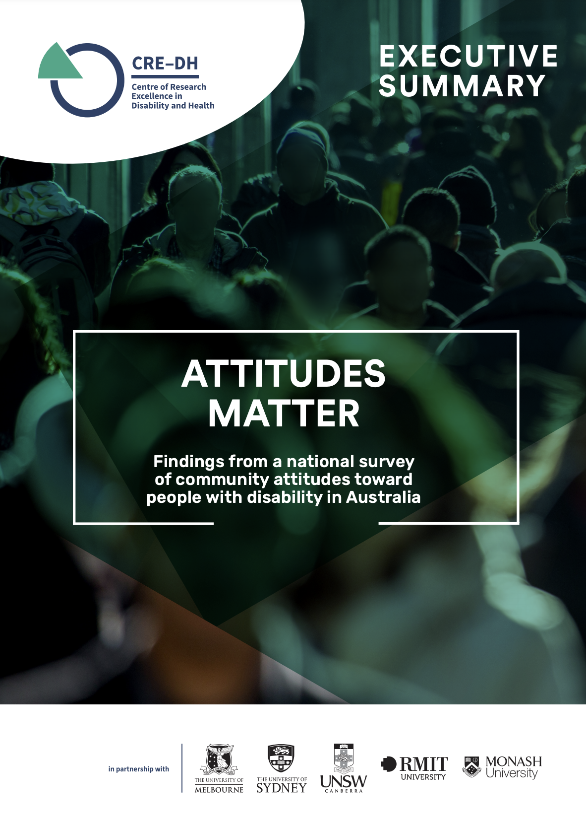

Acknowledgements
We sincerely thank the many representatives from across the Australian disability advocacy sector who provided input into the survey design. We would particularly like to acknowledge and extend our thanks to AMAZE for sharing their experiences on their survey ‘Australia’s Attitudes and Behaviours towards Autism’^{[1]}. We also thank the Life in Australia members for sharing their thoughts with us.
Suggested citation
Bollier AM, Sutherland G, Krnjacki L, Kasidis V, Katsikis G, Ozge J & Kavanagh AM. (2021). Attitudes Matter: Findings from a national survey of community attitudes toward people with disability in Australia. Centre of Research Excellence in Disability and Health, The University of Melbourne. https://doi.org/10.26188/15176013
Published August 2021
ISBN 978 0 7340 5602 3
© The University of Melbourne
The project was funded by the Hallmark Disability Initiative at the University of Melbourne, the Victorian Department of Health and Human Services, the Centre of Research Excellence in Disability and Health (CRE-DH), and the Disability and Health Unit, Melbourne School of Population and Global Health at The University of Melbourne.
Contact information
Centre of Research Excellence in Disability and Health (CRE-DH), Disability and Health Unit
Melbourne School of Population and Global Health
The University of Melbourne
Parkville VIC 3001
Telephone +61 3 8344 0717
Email cre-dh@unimelb.edu.au
Website https://credh.org.au
https://credh.org.au/projects/community-attitudes-towards-people-with-disability/
Twitter @DisabilityHlth

Executive Summary

Why Attitudes Matter
Attitudes can have a significant impact on the lives of people with disability. Attitudes are related to disability-based discrimination and social exclusion, which in turn impact the health and wellbeing of people with disability. Disability advocates in Australia have pushed for action to improve community attitudes for years, with the aim of achieving a more equitable and inclusive society for people with disability.
The survey
This study is the first national survey on attitudes toward people with disability in Australia. Over 2,000 people from across Australia participated in the Community Attitudes Survey in 2018. The survey asked respondents about their individual or personally held attitudes, as well as society or community perceptions about people with disability.
Summary of findings
Negative and positive attitudes
Most respondents reported positive attitudes toward people with disability. Only a minority reported overtly negative attitudes. For example, 86% agreed that adults with disability should get to have a say about who they live with (positive), while 20% agreed that employers should be allowed to refuse to hire people with disability (negative).
Mistreatment and social exclusion
Many respondents were aware of the harmful and exclusionary ways that people in the community treat people with disability. For example, 42% agreed that people with disability are ignored, 63% agreed that people tend to become impatient with people with disability, and fewer than half (42%) thought workplaces were accepting of people with disability.
Seeing people with disability as exploitable
Sixty-three percent of respondents agreed that people with disability are easier to exploit than people without disability. This view may reflect deeply ingrained stereotypes about vulnerability, incapacity and/ or weakness. While it may sound protective, stereotypical perceptions of people with disability as exploitable could be used to limit opportunities for choice and self-determination.

Uncertainty around people with disability
Seventy-eight percent of respondents agreed that people without disability are unsure how to act toward people with disability. While some actions toward people with disability are overtly discriminatory, other types of harm—such as asking inappropriate questions or ‘helping’ without being asked—may stem from a lack of understanding, which in turn leads to discomfort or uncertainty in interactions with people with disability. Regardless of a person’s intentions, acting based on uncertainty can have adverse impacts for people with disability.
Neutral responses
Across the survey it was common for respondents to choose the neutral response option—that is, selecting ‘neither agree nor disagree’ in response to statements about attitudes. For example, 34% neither agreed nor disagreed with the statement ‘people with disability should not raise children.’
Neutral attitudes are important to understand in greater depth. While we do not know why some people responding to this survey chose neutral responses, it is possible that those who give neutral responses hold negative attitudes but were reluctant to report their true opinion because they do not believe it is socially acceptable (in research, this is referred to as ‘social desirability bias’). At a population level, understanding shared characteristics of those who hold neutral attitudes may help identify this group for the purpose of targeted action to shift their attitudes in a positive direction [2].
Recommendations
The United Nations Convention on the Rights of People with Disabilities (UNCRPD) declares full and active participation in society as a fundamental right of people with disability [3]. With negative attitudes and consequent discriminatory behaviors known to be a key limiting factor to full participation, the results of this survey indicate that Australia still has a long way to go in meeting its obligations. Investing in strategies to improve community attitudes towards people with disability is also critical for realising the aspirations of the new National Disability Strategy [4].
We recommend, therefore, an ambitious agenda for all levels of government to invest in co-designed interventions that are targeted to those sectors and life domains that are identified by people with disability as impacting on participation and inclusion (e.g. work, education, community). Consideration should be given to multi-level interventions (structural, organisational, and individual) and should draw on currently available evidence regarding the effectiveness of interventions and rigorously evaluated so they can be monitored and improved upon.

People with disability report experiencing discrimination and prejudice in their day-to-day life which excludes them from many domains of life including work, school, accessing services and the community.

Background
Understanding disability
The United Nations Convention on the Rights of Persons with Disability (UNCRPD) describes disability as ‘long-term physical, mental, intellectual or sensory impairments which in interactions with various barriers may hinder their full and effective participation in society on an equal basis with others’[3]. In other words, it is not simply having an impairment or impairments that is disabling, but the interaction of impairment(s) with barriers to participation in society. For example, in workplaces, many people with disability find it difficult to access buildings, travel on public transport or ask for adjustable workstations due to a lack of accessible equipment and infrastructure.
Attitudes and ableism
Attitudes can act as a barrier to social participation for people with disability. Fundamentally, attitudes are assessments or evaluations of people, places, things or ideas, particularly those that persist over time—whether at the individual or societal level [2, 5].
Attitudes are closely related to disability-based prejudice and discrimination, also known as ableism. Ableism can be directed toward anyone who is considered to have a disability, no matter what type of condition or impairment they have [2].
Attitudes toward people with disability take a range of forms. For example, they can be:
- Limiting and devaluing
- Paternalistic and protective
- Hostile and demonising
- Benevolent and glorifying
- Neutral, or a mix of positive and negative attitudes (ambivalent)

All these types of attitudes influence how people act toward people with disability. However, positive attitudes do not necessarily bring about inclusive behaviours, practices or policies. While it is difficult to tease out exactly how attitudes translate to social inclusion of people with disability—or, conversely, to discrimination against people with disability—it is clear that attitudes play an important role.
Previous research suggests that, despite considerable diversity among people with disability, there is a set of global attitudes and stereotypes that are commonly applied to people with disability regardless of the type of impairment they have. These global attitudes contribute to our understanding of the collective oppression of people with disability in society[2].
It is for this reason that this Community Attitudes Survey sought to examine global attitudes toward people with disability, rather than attitudes related to people with specific types of impairments.
A human rights perspective
Australia is a signatory to the UNCPRD. Article 1 of the UNCPRD states ‘The purpose of the present Convention is to promote, protect and ensure the full and equal enjoyment of all human rights and fundamental freedoms by all persons with disabilities, and to promote respect for their inherent dignity’[3]. Negative attitudes, stereotypes and prejudices create barriers to the full participation of people with disability in society. Changing attitudes is critical to Australia achieving its obligations under the UNCPRD.
Why do we need a national survey on attitudes to disability?
Research on attitudes to disability is not new; studies go back many decades. In addition, community members with disability and their advocates have shared stories on how attitudes have impacted their lives[6]. Until now, no study has collected data on community attitudes towards disability from a nationally representative sample in Australia. The Community Attitudes Survey represents a key step in documenting current attitudes towards people with disability in Australia, providing information about where policy efforts might be targeted for greatest effect. These data can also be used as a baseline from which to track progress towards a more inclusive society.

About the Survey

The Attitudes Matter Survey builds on previous research and reports on attitudes toward people with disability in Australia [7, 8]. It makes two important and new contributions to research on attitudes:
- It is the first population-level representative survey, which means that the findings can be applied to the general Australian population
- The survey was developed by people with disability who were employed as co-researchers on the project team; questions thus tap into attitudes that are salient in the lives of people with disability in Australia.

The survey examines both personally held and societal attitudes toward people with disability. This includes personal feelings and behaviours toward people with disability, as well as perceptions of how people with disability are treated by others in the community.
An inclusive approach to survey development
This survey was developed through collaboration between academic researchers at the University of Melbourne and three co-researchers with disability. Co-researchers helped design a survey that was relevant to the lives of people with disability in Australia. The team worked across all aspects of the research, including:
- Reviewing existing instruments and previous surveys on attitudes to disability to identify potential survey questions
- Identifying attitudes that were most relevant to measure in the Australian context
- Conducting stakeholder interviews with leading disability advocates to guide survey development
- Drafting and finalising the survey
- Interpreting and disseminating survey findings

The co-researchers conducted ten stakeholder interviews face-to-face or by online video or audio. The interviews were recorded and transcribed. Stakeholders’ contributions helped ensure the survey was useful to the disability advocacy sector. Advocates suggested ideas that we had not considered and helped us refine questions to be more understandable or relevant. Many also commented on their own experiences of attitudes. Where relevant, we have interspersed their comments with the survey results presented in this report.

People with disability who provided input into this survey spoke about attitudes as interconnected to the inclusion of people with disability in all aspects of society. They described attitudes toward people with disability as inextricably linked to issues such as accessibility in public spaces, discrimination in the workplace, and abuse and neglect. The variety of questions in the survey, focusing not just on personal attitudes but on behavioural and structural/institutional manifestations, reflects some of these interconnections.

Survey content
Based on what people with disability have said about experiences of discrimination in previous research, and on the lived experiences of co-researchers and stakeholders we interviewed, questions were developed to target different attitudes or behaviours (e.g. paternalistic, benevolent, devaluing) across a range of domains (e.g. personal life, work, education, community). Where possible, we used existing instruments such as the Attitudes to Disability Scale, developed by the World Health Organization Quality of Life - Disabilities (WHOQOL-DIS) Group[9].
Survey methods
Survey respondents were members of the Life in Australia panel, a probability-based panel managed by the Social Research Centre (SRC) based in Melbourne. The Life in Australia panel was originally recruited in October-November 2016 through random sampling to maximise representativeness of the Australian population (see: https://www.srcentre. com.au/our-research#life-in-aus).
In April 2018, all 2,908 active panel members were invited to take part in this survey and of these, 2,069 (71%) participated. Most respondents completed the survey online (87%), with the remaining completing by telephone (13%). Socio-demographic characteristics of the sample are shown in Appendix A.
Approach to analysis¹
We generated descriptive statistics of survey responses. Findings for each survey question are reported as percentages out of 100, which represent the proportion of total respondents. Only a small number of people did not respond to questions; these individuals were excluded from the analytic sample.
All survey questions were worded as agree-disagree statements with 5 response options; strongly disagree, disagree, neither agree nor disagree, agree, strongly agree. For this report we recategorised these into three groups; (1) disagree (strongly disagree and disagree), (2) neutral (neither agree nor disagree), and (3) agree (strongly agree or agree).
To ensure the survey sample was representative of the Australian population we applied survey weights developed by the SRC.

_____________
- Previously, our group reported on research for the Victorian government using the same survey questionnaire with a sample of Victorian residents [10]. The current report uses data from that same project, but this sample included respondents from all Australian States and Territories. Unlike the Victorian report, these results represent attitudes of people across Australia.

Results

In this section we highlight key findings. Results are organised into four sections:

- Common beliefs
- Attitudes about personal lives
- Behaviours toward people with disability
- Inclusion of people with disability

A guide to interpreting results
This survey captured community attitudes through different lenses. Sometimes we asked respondents about their own attitudes. Other times, we asked them about their perceptions of broader community attitudes or behaviours. We have reflected these below in the results.

1. Common beliefs

These statements reflect respondents’ own attitudes.

Low expectations
20% of respondents agreed that people should not expect too much from people with disability.

Perceived exploitability
63% of respondents agreed that people with disability are easier to take advantage of, exploit or treat badly.

Future prospects
23% of respondents agreed that people with disability have less to look forward to than others.

5% agreed that people with disability should not be optimistic about their future.
‘Burden’ stereotypes
9% of respondents agreed that people with disability are a burden on society.

25% agreed that people with disability are a burden on their families.

The following statement reflects a perception of other people:

The ‘hero’ narrative
63% of respondents agreed that people are inspired by people with disability.

- Attitudes about personal lives

These statements reflect respondents’ own attitudes.

Talking about sex
6% of respondents agreed that sex should not be discussed with people with disability.
Choice of housemates
86% of respondents agreed that adults with disability should get to have a say about who they live with.

The following statement reflects a perception of other people.

The right to raise children
16% of respondents agreed with the statement, ‘People believe that people with disability should not raise children.’

- Behaviours toward people with disability

The following statements reflect a perception of other people.

People are unsure how to act
78% of respondents agreed that people are unsure how to act toward people with disability.

Impatience with people with disability
63% of respondents agreed that people tend to become impatient with people with disability.

Making fun of disabilities
61% of respondents agreed that people often make fun of disabilities.

Ignoring people with disability
42% of respondents agreed that people ignore people with disability.

Treating people with disability like they have no feelings

41% of respondents agreed that people treat people with disability as if they have no feelings.

- Inclusion of people with disability
The following statements reflect respondents’ own attitudes.
Employing people with disability
20% of respondents agreed that employers should be allowed to refuse to hire people with disability.

Segregation in education
13% of respondents agreed with the statement, ‘Children with disability should only be educated in special schools.’

Making friends
55% of respondents agreed that people with disability find it harder than others to make new friends.

Getting involved in society
55% of respondents agreed that people with disability have problems getting involved in society.

The following statements reflect perceptions of other people.

School and workplace inclusiveness

61% of respondents agreed that schools are accepting of children with disability.

42% agreed that workplaces are accepting of people with disability.

References

[1] Jones S, Akram M, Murphy M, Myers P, Vickers N. Australia’s Attitudes & Behaviours towards Autism; and Experiences of Autistic People and their Families: Autism and Education Research Report for AMAZE. Melbourne; 2018.
[2] Nario-Redmond MR. Ableism: the causes and consequences of disability prejudice. Hoboken, NJ: Wiley-Blackwell; 2020.
[3] United Nations. Convention on the Rights of Persons With Disabilities (CRPD): resolution adopted by the General Assembly, 2007.
[4] Australian Government Department of Social Services. 2010-2020 National Disability Strategy.
[5] Eagly AH, Chaiken S. The psychology of attitudes. Fort Worth: Harcourt Brace Jovanovich; 1993.
[6] National People with Disabilities and Carer Council. Shut Out: The Experience of People with Disabilities and their Families in Australia - National Disability Strategy Consultation Report. Canberra: Commonwealth of Australia; 2009.
[7] Scope. Scope 1 in 4 Poll information sheet. Melbourne; 2011.
[8] Thompson D, Fisher K, Purcal C, Deeming C, Sawrikar P. Community Attitudes to People with Disability: Scoping Project. Sydney: Australian Department of Families, Housing, Community Services and Indigenous Affairs; 2012.
[9] Power MJ, Green AM, Group W-D. The Attitudes to Disability Scale (ADS): development and psychometric properties. J Intellect Disabil Res 2010;54(9):860-74.
[10] Bollier AM, Krnjacki L, Kavanagh A, Kasidis V, Katsikis G, Ozge J. Survey of Community Attitudes toward People with Disability: A report for the Victorian Department of Health and Human Services. Melbourne: Disability & Health Unit, Centre for Health Equity, University of Melbourne; 2018.
[11] Emerson E, Milner A, Aitken Z, Krnjacki L, Vaughan C, Llewellyn G, et al. Overt acts of perceived discrimination reported by British working-age adults with and without disability. J Public Health (Oxf). 2021 Apr 12;43(1):e16-e23.10.1093/pubmed/fdz093.
[12] Kavanagh A, Priest N, Emerson E, Milner A, King T. Gender, parental education, and experiences of bullying victimization by Australian adolescents with and without a disability. Childcare Health Dev 2018;44(2):332-41.
[13] King T, Aitken Z, Milner A, Emerson E, Priest N, Karahalios A, et al. To what extent is the association between disability and mental health in adolescents mediated by bullying? A causal mediation analysis. Int J Epidemiol 2018;47(5):1402-13.
[14] Australian Government Department of Social Services. National Disability Strategy – Position Paper. Canberra; 2020.

Further Information

Emerson E. How attitudes disable. Up Close Podcast, 28 June 2017 https://pursuit.unimelb.edu.au/podcasts/how-attitudes-disable

Kavanagh A. Disabling Abelism. Eavesdrop on Experts Podcast, 23 May 2017. https://pursuit.unimelb.edu.au/podcasts/disabling-ableism

King T & Kavanagh A. Disabled teens suffering the mental health effects of bullying. The Conversation, 10 August 2018. https://theconversation.com/disabled-teens-suffering-the-mental-health-effects-of-bullying-101186

Kavanagh AM, Priest N, Emerson E, Milner A & King T. Gender, parental education and experiences of bullying victimization by Australian adolescents with and without a disability. Child Care Health Dev 2018; 44(2) 332-341. 10.1111/cch.12545

Jones S, Akram M, Murphy N, Myers P & Vicker N. Australian autism and attitudes report, 2018 26 September: https://www.amaze.org.au/wp-content/uploads/2019/06/Education-Community-Attitudes-and-Lived-Experiences-Research-Report_FINAL.pdf

____________

Contact information
Centre of Research Excellence in Disability and Health (CRE-DH_
The University of Melbourne
Parkville VIC 3001
Telephone: +61 8344 0717
Email: cre-dh@unimelb.edu.au
Website: https://credh.org.au/
Twitter: @DisabilityHtlh

