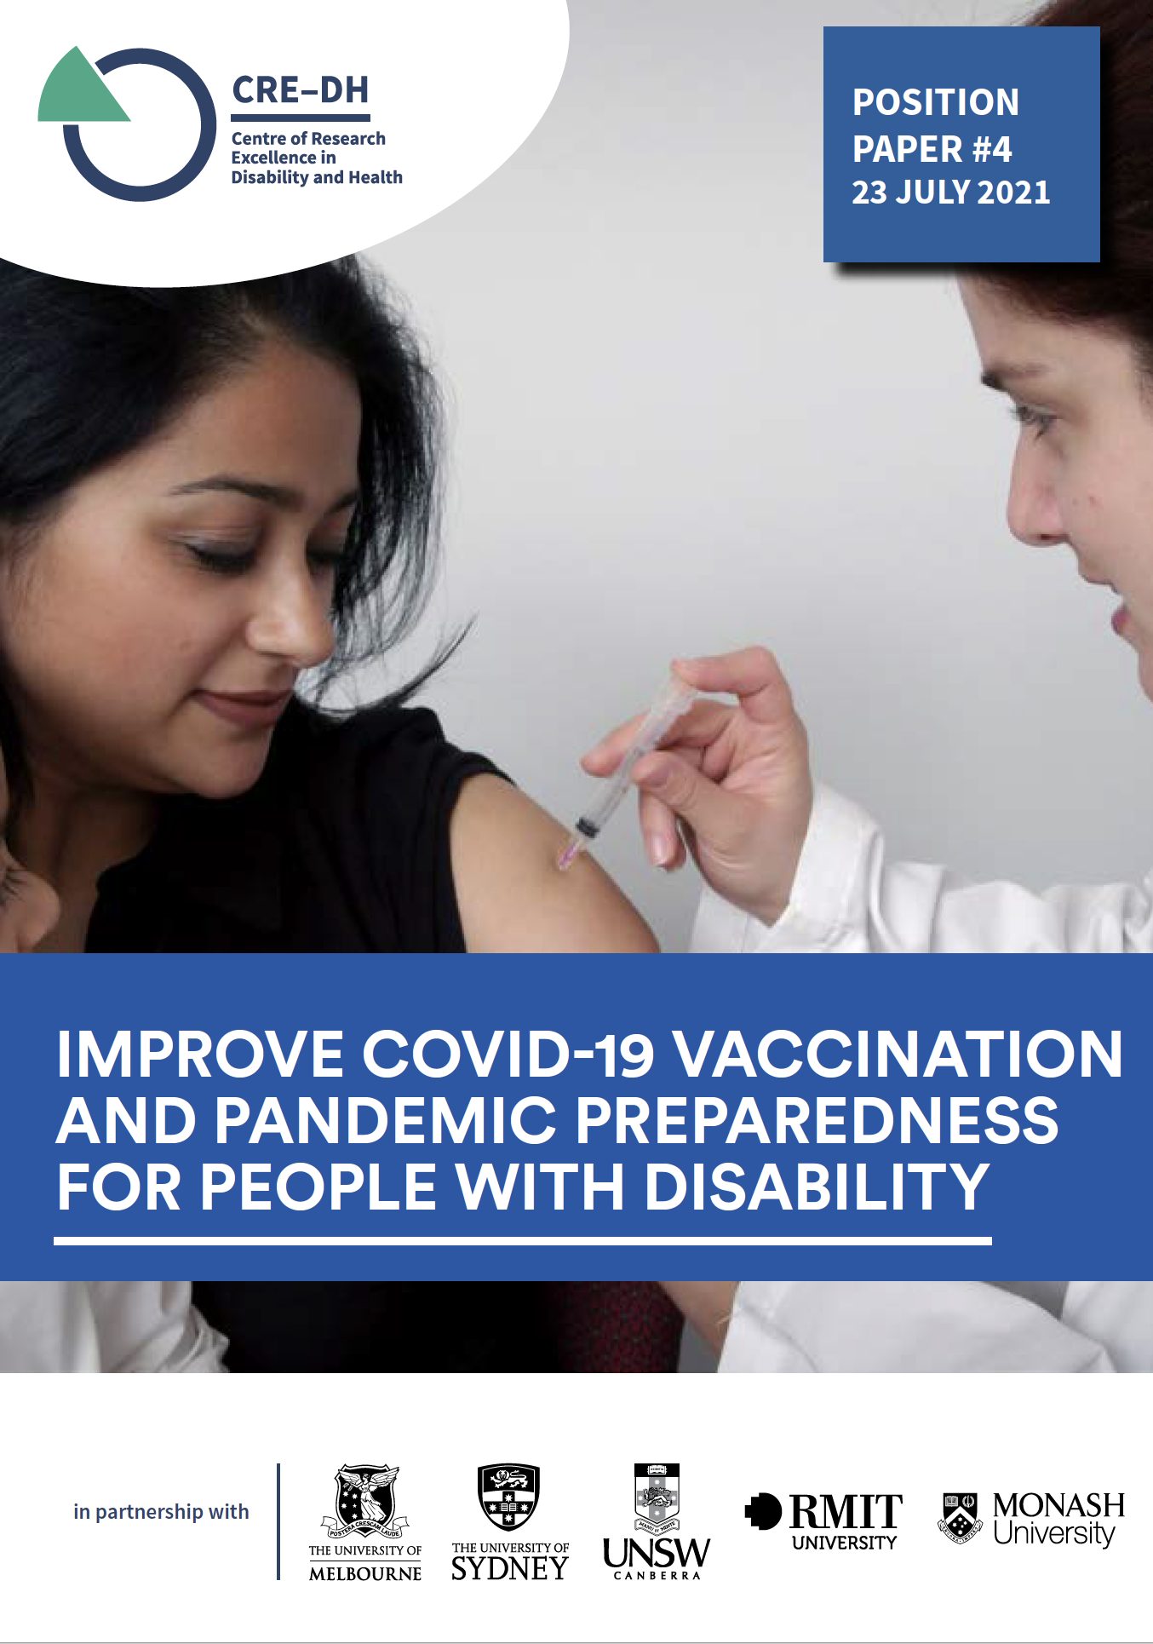



**State and Federal governments need to act now to ramp up vaccination among people with disability, improve pandemic preparedness, and implement best practice responses to outbreaks in disability group homes.**

COVID-19 vaccination is the cornerstone of the global strategy to control the COVID-19 pandemic. In January 2021, the Commonwealth government [prioritised](https://www.health.gov.au/resources/publications/covid-19-vaccination-australias-covid-19-vaccine-national-roll-out-strategy) access to COVID-19 vaccines for people with disability living in group homes and people with chronic physical and mental health conditions – which many people with disability have. They also prioritised access to disability support workers.

People with disability living in groups homes, and the workers who support them, were prioritised in Phase 1a – the highest priority group. There have been many reports of people with disability having difficulty accessing the vaccine, particularly those in [group homes](https://www.abc.net.au/news/2021-07-15/disability-advocates-call-for-a-quicker-vaccine/13447226). While data on vaccination seems to be available for people with disability and workers, it is rarely publicly reported. On [July 22](https://www.afr.com/politics/federal/atagi-shake-up-not-connected-to-vaccine-advice-pm-20210722-p58c2n), the Australian Financial Review reported that 31% of NDIS participants had had just one vaccine dose and half of those living in disability residential settings had had one dose. A much lower proportion have been fully vaccinated – just 19% of residents as of [July 1](https://www.theguardian.com/world/2021/jul/01/hit-and-miss-less-than-one-in-five-australians-in-disability-care-vaccinated-against-covid-19). On [July 8](https://www.abc.net.au/news/2021-07-08/ndis-minister-covid-vaccine-mandatory-disability-care-worker/100276708), Minister Reynolds reported 36% of workers had received one dose of the vaccine.

The [Centre of Research Excellence in Disability and Health](https://credh.org.au/projects/covid-19-and-people-with-disability-in-australia/), funded by the National Health and Medical Research Council, has previously drawn attention to the risk of COVID-19 among people with disability and the potential for outbreaks in [congregate settings](https://pursuit.unimelb.edu.au/articles/protecting-people-with-disability-during-the-pandemic) such as group homes, something that was realised in Victoria’s second wave when outbreaks were reported in more than [50 group homes](https://www.abc.net.au/news/2020-08-07/fears-coronavirus-spreading-disability-group-home-care-victoria/12535692). Our [qualitative research](https://credh.org.au/projects/covid-19-and-people-with-disability-in-australia/impact-of-covid-19-on-disability-support-workers/) with services and workers following services second wave revealed worrying problems including lack of training and confidence in the use of Personal Protective Equipment with online training being insufficient; poor communications between government, services, workers and residents; lack of understanding of disability residential settings with aged-care responses being applied; and, significant impacts on the mental health of residents.

Our survey of disability support workers conducted in September and October in 2020 found that only half of workers felt comfortable supporting someone who had COVID-19 and many wanting more training including hands on training. Our work has also revealed problems with vaccine hesitancy among disability support [workers](https://credh.org.au/dsw-vaccine/) related to concerns about safety and efficacy and relatively low levels of understanding of the importance of vaccination in preventing COVID-19 infection and disease. We highlighted the importance of tailored, co-designed strategies to improve communications to increase vaccine uptake among people with disability and disability support workers. This hasn’t happened.

We’d hoped that further outbreaks in group homes would be averted with widespread vaccination of people with disability and workers, yet our fears that this would not be the case have been realised with COVID-19 infections reported among partially [vaccinated residents and workers at a group home](https://www.abc.net.au/news/2021-07-22/five-people-in-disability-service-group-home-covid-positive/100314092) in Sydney.

**Three issues need urgent action:**

1. Rapid escalation of vaccination of people with disability and disability support workers
2. Ensuring people with disability, services, and workers are prepared for outbreaks
3. Implementing best practice responses to outbreaks in group homes

**Vaccination recommendations**

* Urgent in-reach to disability residential settings to vaccinate residents and staff
* Urgent in-reach to people with disability who are unable to leave their home for vaccination
* Promote disability accessible vaccination hubs, and communicate to people with disability that hubs are accessible
* Co-design tailored vaccination plans for people with disability who may require specialised responses to enable vaccination (e.g., those who experience extreme anxiety around vaccination who, in rare circumstances, may require sedation)
* Prioritise appointments for people with disability and disability support workers through state-run vaccination hubs, general practitioners, and pharmacies
* Provide financial incentives for workers to be vaccinated including paid leave
* Finalise and implement the disability vaccination strategy being developed by the [Commonwealth government](https://www.ndiscommission.gov.au/coronavirus-vaccine-information-people-disability)
* Report data on disability vaccination uptake among people with disability and workers by jurisdiction at least weekly
* Prioritise use of the Pfizer vaccine for people with disability and workers to ensure rapid vaccine coverage

**Preparedness for outbreaks**

* Support services to develop [pandemic preparedness plans](https://www.health.nsw.gov.au/Infectious/covid-19/Pages/iap-disability-residential-outbreak-management.aspx) which recognise the importance of aerosol transmission
* NDIS Quality and Safeguards Commission actively audit pandemic preparedness plans for service providing support in disability residential settings
* NDIA ensure bulk access to PPE, if required, that does not have to be claimed from participant plans
* Tailored individual pandemic response plans for people with disability, particularly those in residential settings
* Mandatory training of workers in use of PPE and infection control, including in-reach training where possible
* Paid pandemic leave for workers to prevent them going to work when they are sick
* Regular and priority testing of workers that is easily accessible
* Reduce disability support worker mobility – restrict workers to only working in one group home
* Compensate workers when they lose shifts due to restricted mobility

**Managing outbreaks**

* Availability of appropriately trained health staff to support disability workers in COVID-19 positive settings
* Tailored responses for residents in disability group homes (e.g., separating COVID-19 positive and negative residents in different settings)
* Implement pandemic plans that address aerosol transmission
* Support for residents to promote their mental health through opportunities to connect online with families and friends
* Rapidly establish a disability emergency response team in NSW, as was implemented in [Victoria](https://www.premier.vic.gov.au/working-together-protect-victorians-disabilities) last year

Professor Anne Kavanagh, Chair in Disability and Health, Melbourne School of Population and Global Health, University of Melbourne; Co-Director CRE-DH  
Professor Helen Dickinson, Public Service Research, UNSW; Chief Investigator CRE-DH  
Professor Gwynnyth Llewellyn,  Centre of Disability Research and Policy, University of Sydney; Co-Director CRE-DH  
Professor Gemma Carey, Research Director, Centre for Social Impact, UNSW; Chief Investigator CRE-DH  
 **Further information**  
Professor Anne Kavanagh  
Chair in Disability and Health, Melbourne School of Population and Global Health,  
The University of Melbourne  
  
Email: a.kavanagh@unimelb.edu.au  
Website: www.credh.org.au