#DataCreatives Workshop – Digital methods for research led teaching & learning practice in the COVID new normal
  - Session 2.2: Looking to the creative industry communities: cultural and heritage sector

State Library of NSW (SLNSW) Social Media Archive
The SLNSW Social Media Archive is a collection of data from a variety of social media platforms that has been deemed of relevance to the state of NSW. Sources for this data include:
- microblog sources such as Twitter
- picture sources such as Instagram
- video sources such as YouTube
- blog sources such as Blogspot and Wordpress sites
- comments from public pages and news media sites
Items from these sources have been collected and curated into categories, including an ART category. These categories can be explored in detail through a data visualisation on the SLNSW’s website. This visualisation displays the EMOTIONS, HASHTAGS, KEY WORDS, and TOP SHARED NEWS stories associated with social media items for a seven-day period prior to a specified date.
The #DataCreativities collaboration have done some preliminary work to explore this archive, looking at the weeks since March 2020, when NSW first went into lockdown, and examining the ART category specifically. State Library NSW have also provided us with an API key and we have been able to access the EMOTION, HASHTAGS, KEY WORD, and NEWS data directly, defining our own queries. We are still in the process of cleaning this data; for example, the query we did on “performance” retrieved a lot of sports related rather than performing arts related content.
One of the things that was noticeable in this initial exploration was that one of the hashtags that shows up periodically in the ART category is #AusLibChat. This is a hashtag that’s used by the Australian Library and Information Association (ALIA)’s Students and New Graduates group. It’s an example of how students in cultural and creative industries are using social media platforms to connect and form networks that will be beneficial for their professional careers.
If we drill down to examine the #AusLibChat HASHTAG for the second month of lockdown (May 2020), we can tell that the theme that month must have been COVID-19 related (and indeed, the theme was Housebound). The KEY WORDs are things like ‘housebound’ ‘online’ ‘zoom’ ‘miss’ ‘casuals’ ‘cats’ ‘chat’. This suggests the discussion addressed the practical and emotional experience of dealing with the effects of the pandemic – loss of work for precariously employed early career library staff, missing chatting with a team, the sudden shift to online zoom work, enjoying being able to work accompanied by pets.
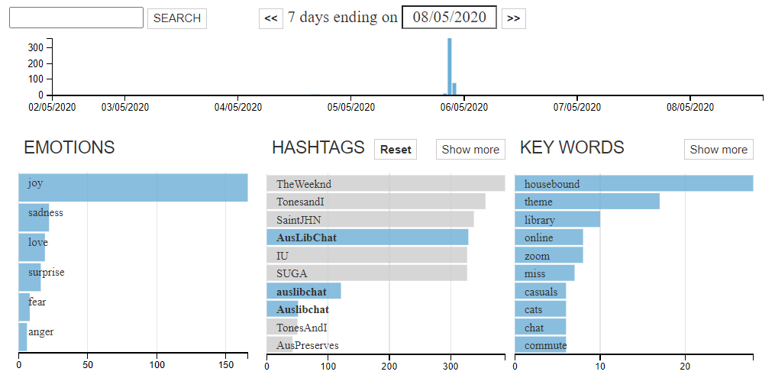
Looking at the EMOTIONS associated with these HASHTAGS, when we exclude #AusLibChat we are left with only joy:
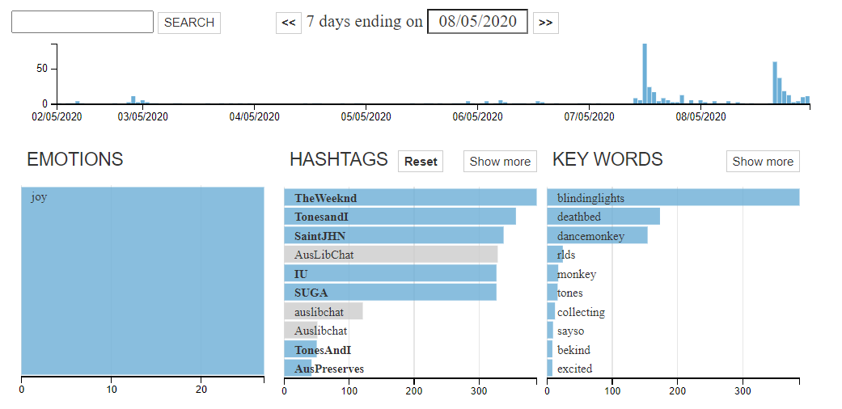
This suggests that all the other EMOTIONS we see associated with #AusLibChat – sadness, love, surprise, fear, and anger – are exclusively associated with that HASHTAG. This is valuable information for Library and Information Studies educators to know about their students’ well-being.
I am currently enrolled as a student on a Masters of Information Studies course. My instructor is active on Twitter and has encouraged us as students to sign up, follow her, and participate in the library Twitterverse. This is an example of how university educators in the creative and cultural industries can make use of technologies such as social media both to provide students with social support and professional networking opportunities, as well as taking advantage of the feedback available from these systems to monitor student morale and wellbeing.

