#DataCreatives Workshop – Digital methods for research led teaching & learning practices in the COVID new normal
  - Session 3: Research practices as teaching practices

3.1 Sharing creative and research outputs with Figshare
The #DataCreativities collaboration have been publishing our research outputs using the University’s Figshare repository.
Melbourne.figshare.com is the University’s platform for sharing creative and research outputs (that are not traditional outputs like journal articles or theses). University researchers can login to Melbourne.figshare.com using their University credentials.
When you publish an item on Figshare, you can choose whether to make it public, restricted, embargoed, or private. Published items receive a digital object identifier (DOI), which means they can be cited by other researchers. Figshare is part of a wider network of systems, both within and outside of the University, for disseminating and measuring the impact of research outputs. DOIs, as unique identifiers, help with doing this.
One of the tools the #DataCreativities collaboration has used to disseminate our research outputs, once they have been published on Figshare, is social media such as Twitter. Altmetrics is a system for measuring the impact of research based on how frequently it has been shared via social media. Figshare integrates with Altmetrics, so University researchers can leverage that social media data.

3.2 Case study: Using shared outputs in teaching – publishing

Learning from publishing data – Simon Fraser University
I want to look at a case study in which the data generated by scholarly publishing platforms like Figshare were used for and fed back into teaching practices. Scholarly publishing platforms generate a huge amount of data that are used by researchers and universities to demonstrate the impact and value of research. But I also want to show you an example of how this same data can also be used for teaching.
Juan Pablo Alperin at Simon Fraser University in Canada worked with colleagues to integrate analysis of data from scholarly publishing systems into two subjects in their Masters of Publishing degree. The subjects Technology and Evolving Forms of Publising (PUB802) and Technology Project (PUB607) both gave students the opportunity to explore scholarly publishing and altmetrics datasets.
One student from PUB802 wrote an assignment on how the insights generated from altmetrics can be implemented by publishers of fiction. Students from PUB607 went on to publish their own research, which examined the relationship between the day a research article is published and the likelihood of that article being shared on social media.
There are a number of virtuous feedback loops here. The scholarly publishing system interacted with the wider ecosystem of social media. The data from these interactions was used to feedback into teaching, which then generated further research publications, and more social media interactions.
I’d like to handover now to my colleague Kenna, who will talk about how the teaching, research and social media practices at Simon Fraser University feed into the teaching, research and social media practices of publishing academics here at the University of Melbourne.

Canadian publishing pedagogies – Hannah McGregor
https://hybridpedagogy.org/fandom-feminism-maker-pedagogy/
Thank you, Gene! I want to talk a bit about my experience researching and teaching within the UniMelb Publishing and Communication program this year, specifically focusing on the loops created between podcasts, Canvas, and social media. As Gene has stated above, there are many opportunities to create feedback loops that combine research with teaching practice. As her Simon Fraser Uni staff bio states, “Hannah McGregor’s research and teaching focuses on the links between publishing and social change” including “the role podcasts might play in expanding public engagement with research.” She sees “education as an event — an unpredictable engagement between students, material, and instructor — that takes place within the confines of the university.’” Publishing programs straddle the line between research and industry, so they are the perfect place to experiment with a range of outputs and new forms of engagement through feedback loops. In combining her research with her teaching practice, Hannah has helped develop the Amplify Podcast Network, a platform that on focuses podcasting as a form of scholarly communication as both a teaching tool and publishing platform. Simon Fraser have formalised this loop, however there are ways that the UniMelb publishing program are working with similar loops across teaching and research.
In 2020, Millicent Weber from ANU launched DarntonWatch, a podcast for showcasing academic papers on book culture and book studies across the globe. DarntonWatch is not peer-reviewed, but all the content featured on the podcast is owned by the original researcher. DarntonWatch is therefore a non-traditional publishing platform with affordances that allow each paper or “episode” to be shared widely across social media, LMSs, and across additional research repositories.

Feeding back to UoM – Podcasts and social media
Scholarly podcast DarntonWatch - https://anchor.fm/darntonwatch
DarntonWatch launched with a paper from Dr Alexandra Dane, a lecturer in Media and Comms at UniMelb. This episode was set as a reading for the Masters of Publishing and Comms core unit “The Contemporary Publishing Industry” in Semester 1, 2020 as Dane is one of the leading scholars on gender and literary prize culture, which was one of the focuses for that week. The podcast was linked via the Canvas module for that week. If it had been on Figshare, this engagement could have been tracked. When the unit ran, Dane's 2020 monograph and a series of journal articles on prize culture had not been published yet and this podcast episode initially served as an interim research output for students to get a grip on current debates and theoretical understandings of prize culture from a leading scholar in the field. However, the podcast would still have been set as the primary reading even if Dane’s outputs had already been published. Three students who had decided to write on the literary prize culture question for their final essay emailed me with questions about how to cite the podcast because they too perceived the output to be of value to their critical engagement with the unit despite being somewhat unfamiliar with citing non-trad outputs. Students in the Masters of Publishing and Communication degree at UniMelb also have the chance to take a unit called Writing and Editing for Digital Media, where they must develop content for their own blog and podcast over the course of the semester and learn how to write for social media, much like some of the units offered at Simon Fraser. Dane has coordinated and taught into that unit as well, creating a neat loop of researcher, educator, subject builder, podcast guest, and back to researcher.
As an example of the use of social media in research and teaching, a paper I presented at a conference in November is now featured on Weber’s DarntonWatch. As you can maybe see, my post about delivering my paper was seen by over 2600 accounts. The conference was live tweeted, and Weber found my paper via Twitter and DMed me to ask if I would record it to feature on the podcast. I recorded it in my home studio and uploaded slides to share in a link in the podcast description. Once it had been published on DarntonWatch, I retweeted the launch on Twitter and then linked the podcast back to my Figshare account, so it was more accessible to anyone wishing to cite it with more ease in the future. Scholars from around the world then used Twitter to share links to the episode with their own quote tweet above. Social media, especially Twitter, goes hand in hand with sharing research widely. The live tweeting of my paper led to recording it for a scholarly podcast rather than waiting for the organisers to sort out publishing plans, and so the original delivery format of the paper remains intact. If the paper gets published, great! but for now it’s an exemplar of my research focus and digital methods as an ECR out there in the world.
While the altmetrics case study Gene discussed and this podcasting loop are quite distinct to university publishing programs, the feedback loops generated between researcher, educator, output, and social media can easily be co-opted across a multitude of disciplines.
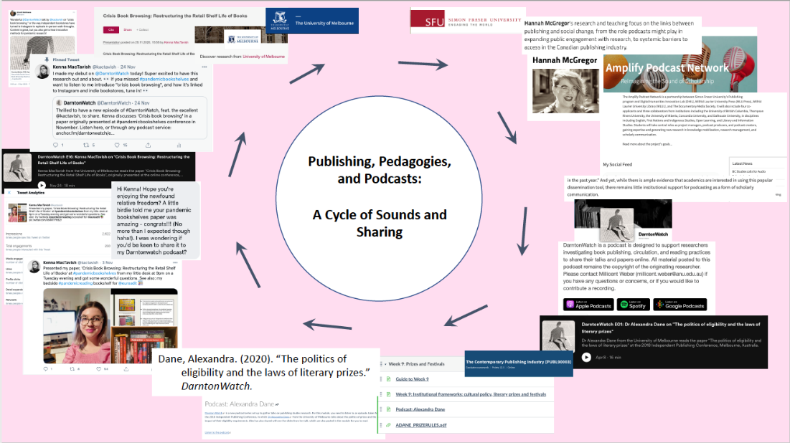

Atenas, Javiera; Havemann, Leo. (2015). Open Data as Open Educational Resources: Case Studies of Emerging Practice. figshare. Book. https://doi.org/10.6084/m9.figshare.1590031.v1
Alperin, Juan Pablo; Bordini, Alessandra; Pouyanne, Sophie. (2015). PLOS, Please publish our articles on Wednesdays: A look at altmetrics by day of publication. The Winnower 7:e142972.29198. Journal article. https://doi.org/10.15200/winn.142972.29198

