Coaching – the word
The meaning of coach as a teacher/tutor has its origins in 19th century English university examinations and this meaning was transferred into the sporting arena¹. (It is therefore somewhat ironic that we are importing coaching concepts from the sporting arena to bring back into education²!) Coaching in its grammatical form is the present participle of coach³ which embodies a sense of ongoing action. Landreville et al. feel that coaching should be considered “a process that guides a learner towards performance improvement”² rather than a discrete event. I agree that coaching is a process, but believe that the focus on performance is too restrictive and overlooks the importance of coaching on identity formation⁴.

“The concept of a coach is slippery”⁵ – Atul Gawande
Coaching is a diverse field with different standards and methodologies, and the diversity of definitions reflects this. (See introductory chapters in Passmore⁶ or van Niewerburgh⁷ for examples.) However, I prefer Stone and Heen’s simple language – they define the purpose of coaching as helping someone “learn, grow or change”⁸. They also distinguish coaching from appreciation⁸ and evaluation^{4,8}. Meanwhile Watling and LaDonna’s qualitative research of coaches (including sports coaches and self-identified medical coaches) discerned themes of relationship building and trust, mutual goal setting, reflective practices and embracing failure⁹ (which could be considered a growth mindset paradigm¹⁰).

Coaching – a definition
Thus I propose a definition of coaching as the complex process² of collaborating with someone to learn, grow or change⁸ that involves relationship building⁹, goal setting⁹ and reflective practices⁹ that acknowledge strengths and embrace failures^{9,10}. During this complex process, the coach may choose from a range of coaching techniques that depend on the coach, the coachee and the environment in which the coaching is taking place – facilitative coaching (where the coach primarily asks questions of the coachee); directive coaching (where the coach primarily tells the coachee what to do); or dialogical coaching (where the coach balances asking and telling)¹¹.

Coaching – a conceptual model
This model attempts to integrate the coaching definition above with other coaching concepts in a Venn diagram format.

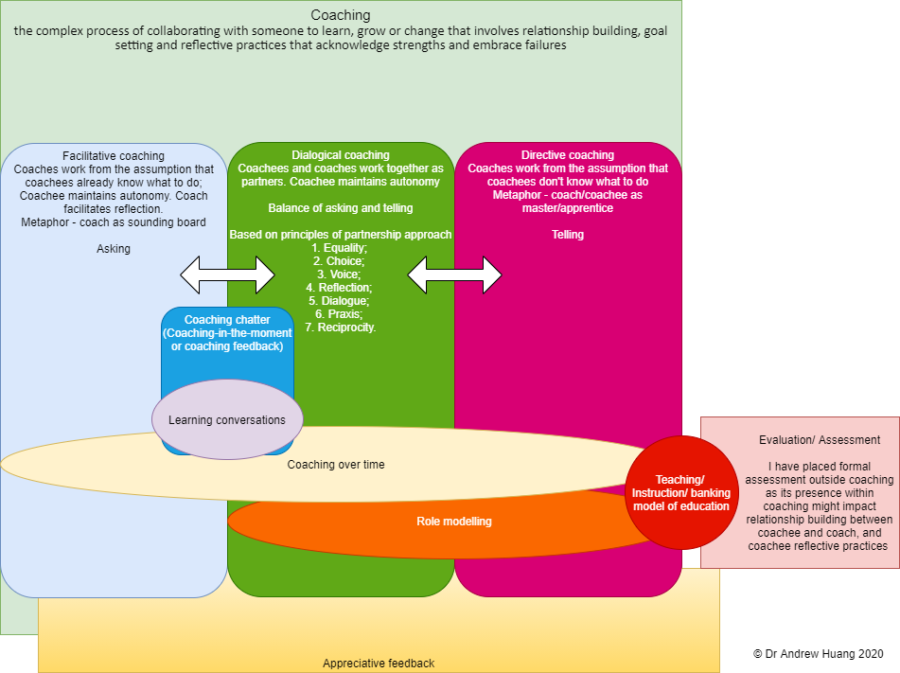

Coaching chatter
In this model, I introduce here the concept of “coaching chatter”- a casual, continual conversation with the goal of learning, growth, or change. I conceive coaching chatter as dialogues that encompass learning conversations (“a dialogue informed by an educator’s observations of a learner’s behaviour in actual or simulated clinical practice, conducted with the intention of improving future performance”¹²), coaching-in-the-moment², and coaching feedback⁸ (both of which might be informed by other people’s observations or a coach’s observations of the coachee’s behaviour outside clinical practice). I have specifically chosen the word “chatter” to emphasise the informal or casual tone of the conversations, the neutralisation or absence of hierarchy or power, the immediacy of the communication (think of online chat rooms), and the frequency with which these conversations should take place. As the concept of a chat involves both asking and telling, coaching chatter straddles the subsets of facilitative and dialogical coaching, but probably not directive coaching (which is more about telling).

Coaching-over-time, role modelling, banking models of education and appreciative feedback
Coaching-over-time² spans all three domains of Knight’s model. Role modelling (e.g. show-and-tell in the Zwisch model of progressive autonomy¹³) is an important part of coaching and spans dialogical and directive coaching domains. Passive training/teaching/instruction models (i.e. banking models of education¹⁴) are limited to directive coaching styles and on occasion sit outside coaching as they sometimes achieve neither growth, learning nor change (i.e. are ineffective). I have created an overlap between appreciative feedback⁸ and coaching (but not coaching feedback to stay true to Stone and Heen⁸) because of the role it might play in relationship building.

Evaluation/Assessment
Evaluation/assessment, especially formal and/or summative assessment has been placed outside coaching because it potentially impedes relationship building between coach and coachee; potentially encourages inauthentic performances that may dwarf the growth of the coachee’s professional identity⁴; and potentially impedes reflective practices¹⁵ through high levels of perceived self-threat invoking self-serving bias¹⁶ and mnemic neglect¹⁷. This is also consistent with Stone and Heen’s conception of coaching⁸.

Mentoring
Finally, while Landreville et al. attempt to define mentoring as “confidential, non-judgemental relationship between two individuals with the ultimate goal of encouraging the mentee to take charge of their own development”²), I share van Niewerburgh’s, and Stone and Heen’s view that splitting coaching and mentoring is unnecessary^{7,8} (and probably a waste of mental energy). I have therefore not included mentoring in this conceptual model.

Conclusion
In conclusion, I hope that this Venn diagram and proposed coaching definition help to further the discussion on what coaching is and is not in medical education.

1. coach, n. In: OED Online. Oxford University Press. Accessed October 7, 2020. https://www.oed.com/view/Entry/34954#eid9212908
2. Landreville J, Cheung W, Frank J, Richardson D. A definition for coaching in medical education. Can Med Educ J. 2019;10(4):e109-e110. doi:10.36834/cmej.68713
3. What Are Present, Past, And Sometimes Perfect Participles? Dictionary.com. Published October 21, 2019. Accessed October 7, 2020. https://www.dictionary.com/e/whats-a-participle/
4. Sawatsky AP, Huffman BM, Hafferty FW. Coaching Versus Competency to Facilitate Professional Identity Formation. Acad Med. 2020;95(10):1511–1514. doi:10.1097/ACM.0000000000003144
5. Gawande A. Personal Best - Top athletes and singers have coaches. Should you? (The Coach in the Operating Room). The New Yorker. Published September 26, 2011. Accessed September 30, 2020. https://www.newyorker.com/magazine/2011/10/03/personal-best
6. Passmore J, ed. Excellence in Coaching: The Industry Guide. Kogan Page; 2015.
7. Nieuwerburgh C van. An Introduction to Coaching Skills: A Practical Guide. SAGE Publications Ltd; 2020.
8. Stone D, Heen S. Thanks for the Feedback: The Science and Art of Receiving Feedback Well. Penguin; 2014.
9. Watling CJ, LaDonna KA. Where philosophy meets culture: exploring how coaches conceptualise their roles. Med Educ. 2019;53(5):467-476. doi:10.1111/medu.13799
10. Dweck CS. Mindset: The New Psychology of Success. Random House Digital, Inc.; 2008.
11. Knight J. The Impact Cycle: What Instructional Coaches Should Do to Foster Powerful Improvements in Teaching. Corwin Press; 2017.
12. Tavares W, Eppich W, Cheng A, et al. Learning Conversations: An Analysis of the Theoretical Roots and Their Manifestations of Feedback and Debriefing in Medical Education. Acad Med. 2020;95(7):1020–1025. doi:10.1097/ACM.0000000000002932
13. DaRosa DA, Zwischenberger JB, Meyerson SL, et al. A Theory-Based Model for Teaching and Assessing Residents in the Operating Room. J Surg Educ. 2013;70(1):24-30. doi:10.1016/j.jsurg.2012.07.007
14. Freire P. Pedagogy of the Oppressed. 30th anniversary ed. Continuum; 2000.
15. Brand PLP, Jaarsma ADC, van der Vleuten CPM. Driving lesson or driving test? Perspect Med Educ. Published online September 9, 2020. doi:10.1007/s40037-020-00617-w
16. Campbell WK, Sedikides C. Self-Threat Magnifies the Self-Serving Bias: A Meta-Analytic Integration. Rev Gen Psychol. 1999;3(1):23-43. doi:10.1037/1089-2680.3.1.23
17. Green JD, Sedikides C, Pinter B, Van Tongeren DR. Two Sides to Self-protection: Self-improvement Strivings and Feedback from Close Relationships Eliminate Mnemic Neglect. Self Identity. 2009;8(2-3):233-250. doi:10.1080/15298860802505145

