Learning to teach from home as a radical collaboration: becoming art educator in lockdown

Sabrina Baker, Kathryn Coleman, Jessica Leslie, Joanne Low and Gemma Saunders.
- Abstract
This is a moment to capture and archive for art education; a moment in time to recall later in a career embarked upon in a global pandemic. This paper presents how we have continued to ‘learn to learn’ how to teach, while learning at home and teaching in remote virtual placements from home as a form radical relatedness (McKernan, 2004). We have developed new agile, responsive and ethical ways to design and co-design learning experiences to create curious and critical encounters for students who were also at home (Coleman & MacDonald, 2020). We have been working in our home studios developing new ways of learning art pedagogies and practices as individuals, as well as within an a/r/tographic collective. We have remained connected several physical ways: co-writing a speculative pandemic zine and sending artworks to each other while sharing all learning experiences as a co-lab for becoming.
Keywords
A/r/tography, becoming teacher, radical, collaborations, COVID-19, art education, home.
2. Context
Melburnians have been living, learning and working in ‘lockdown’ for seven months as the city faced high rates of community transmission, workplace spread of the virus and deaths to coronavirus. The closure of the university physically allowed us to pivot our teaching, learning and research into digital spaces in Canvas™ and Zoom™ as the university went virtual however, like many higher education learning programs we have had to rethink and reimagine new ways of becoming ‘professionals’. In this moment, becoming art teachers from home have developed new ways to design learning experiences, gaining new agency autonomy and developing new digital capabilities. We have learned through persistence and resilience how to differentiate in an inclusive digital classroom, to design lesson plans with new structures as the lesson structure was front loaded for remote learning and gained new insight into our students struggling with mental health, engagement and many lacking confidences to reach out.
The shift to practice/ing in digital and home studio spaces has afforded becoming art teachers’ new opportunities for knowing through experience, and we felt a need to archive and curate this moment in time together as individuals and as part of a radical collaboration.
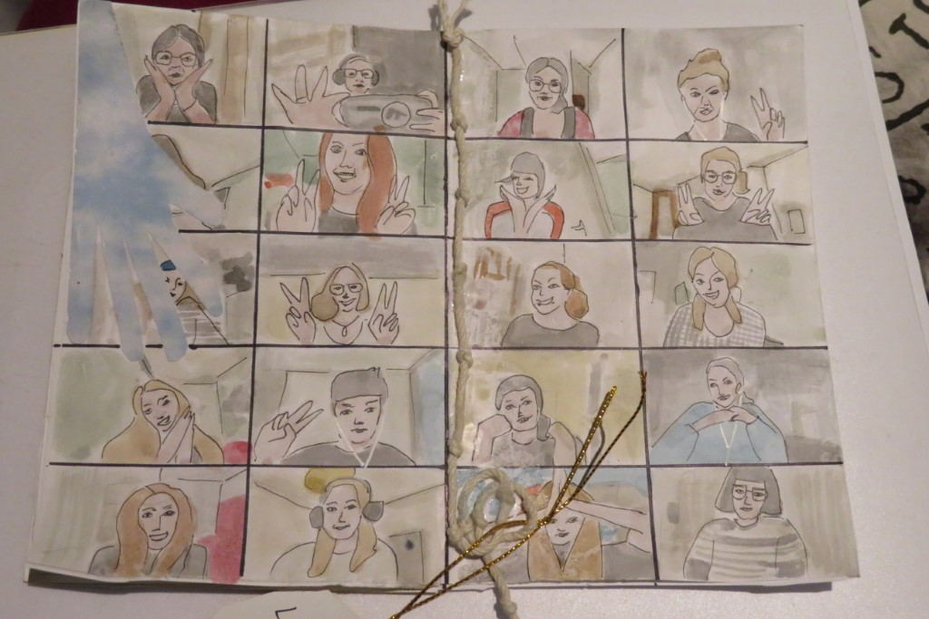
Image 1: Master of Teaching (Secondary Visual Arts and Design) Zoom-ing. Semester 1, 2020
Zine drawing spread by Ella Konrad-East and Lana Vaughan.
Together we, as lecturer, teacher candidates, mentor teachers and their students have learned from and with each other in this post-digital COVID-world. The post-digital (Barrand & Coleman, 2020) in the art world is a space known to us as artists, but how do we navigate, traverse and connect the post-digital art education spaces together? This paper explores through a/r/t-auto-ethnography the stories of four of the becoming teachers and their lecturer, and the things that we together have learned about pandemic post-digital art education and what the post-pandemic world might bring us.
At the Melbourne Graduate School of Education, at the University of Melbourne in Victoria Australia initial teacher education has been, since March 2020 at home. Melburnians have been living, learning and working as the city faced high rates of community transmission, workplace spread of the virus and deaths to coronavirus. The closure of the university physically allowed us to pivot our teaching, learning and research into digital spaces as the university went virtual. This included a shift in how we experience placement and how we integrate the world of work into university learning as becoming teachers. The Master of Teaching, Secondary Visual Art and Design Education is a practice related a/r/tographic degree. Candidates come from art and design degrees with years of practice and experience, clients of their own as Designers, and many with gallery representation as Artists’.
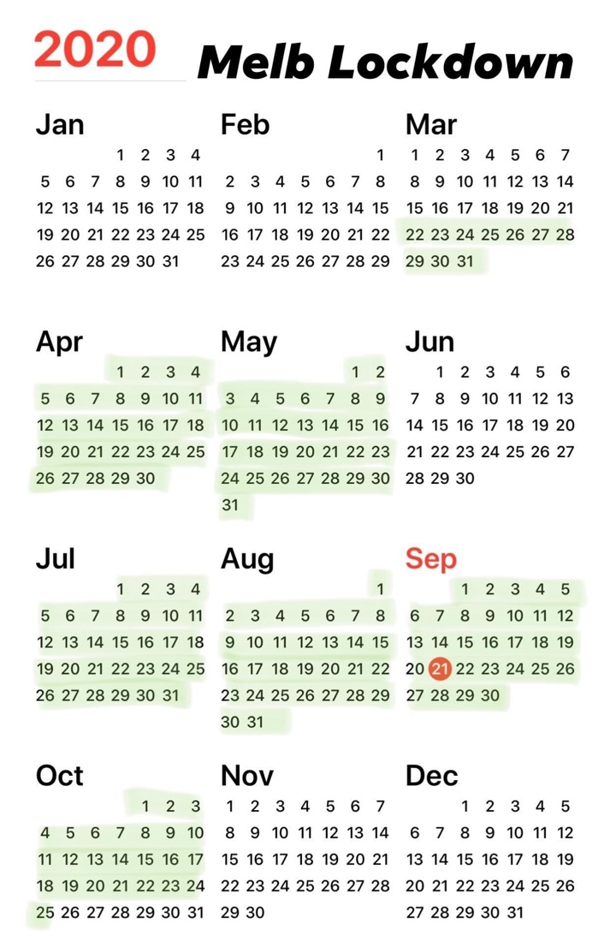
Image 2: Melbourne in lockdown, calendar image captured on 21 September 2020 (fond in many Instagram reposts)
The Master of Teaching degree extends opportunities and possibilities for these artists and designers to wrap pedagogy through practice into their onto-epistemic beliefs. These methodological and pedagogical practices are furthered as they work in schools through an artist and audience curriculum afforded by the Victorian and Australian Visual Arts curriculums. This curriculum is developed through making and responding in relation to each other and allows the initial teacher educator to learn through practice as methodology, as a practitioner about practice in schools.
But then COVID-19 came and an important part of our art education ecology, the digital ecosystem shifted its place in the art education ecology model.
As a first-year teacher candidate and parent to two school-aged children I’m grappling with the problem of identity formation for our young people in lockdown. I look at my 13-year-old son who is in an enormous physical transition and yet socially he has had minimal interaction with peers for months now and I find myself wondering how this might be affecting his emerging sense of self. Explorations of identity are potent sites for education through art and a major focus of education along progressivist lines, in as much as the self is constructed by and for social life. It would be too simplistic to assume that a process so fundamental would be in suspended animation during isolation, but surely there will be changes, and with them new opportunities to define and represent identity.
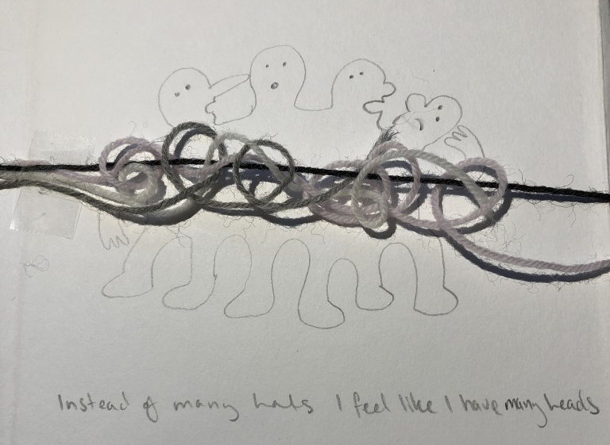
Image 3: Instead of many hands, I feel like I have many heads. Sabrina Baker, 2020

3. Who was the project, or the given pedagogical approach intended for?
Learning to teach from home was forced upon us by COVID-19, but it offered a space and time to look differently at the digital, structural and systemic needs of learners, teachers and schools in and across art education. When students in initial teacher programs learn to teach, they do so alongside experienced classroom teachers and lecturers in the academy. Together we create a safe, yet rigorous place to discover and encounter complex issues as a cooperative. Teacher candidates are mentored and apprenticed within a nurturing but authentic setting to develop skills and knowledge through scaffolded experiences in artistry, materiality, teaching in a studio, learning design and curriculum. When this happens at home as remote learning and teaching, and the ability to communicate with learners directly/opportunities to form relationships with the assistance of online tools changes we needed to rethink how this occurred. Everyone was at home, the lecturer, teacher candidates, mentor teachers and their students and all relationships that are normally learned in close proximity were now connected, but apart. As a class, we have been in close contact to support each other with this new precarity, as a professional learning community of a/r/tographers within a relational inquiry.
A/r/tographers work as a collective, within a shared space to co-create new interactions as a form of “radical collaboration” (Bickel, Springgay, Beer, Irwin, Grauer and Xiong, 2011, p.86). As a radical collaboration we have framed our practices and pedagogies to respond with ethics and care to ensure that all interactions within art education significantly impacting student learning and enhancing the online experience (attendance rates increased, students started using their microphones and cameras to participate in class, etc...) were enabled and explored.
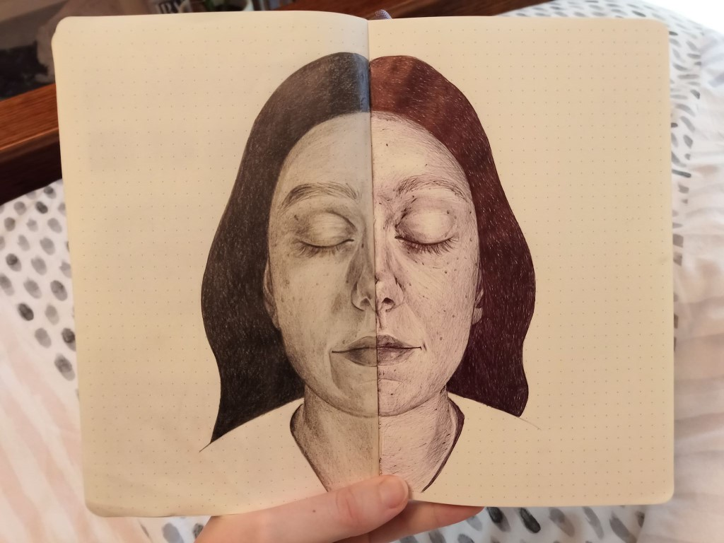
Image 4: Artist (pencil – comfortable, relaxing, escape) v Teacher (pen – constantly learning new skills, patience, practice) Rebecca Pidgeon, 2020

This paper doesn't particularly respond or reflect a project, rather a pedagogical innovation in initial teacher education that has supported and developed through critical and theoretical reflection upon the lived experience within COVID-19 for becoming art educators. This paper serves as a site for a radical collaboration to consider how particular online learning spaces operate similarly to social media platforms (the pros and cons of this) for art education; how we can engage secondary art students through thoughtful, interactive learning experiences that integrate technology in innovative ways for the purpose to entertain as well to educate; how we have connected students to learning by designing tasks that are relevant and responsive to the current world/meaningful (and inclusive) for all students; and ways we have facilitated engagement and assist in learning/support teaching and the delivery of content with visually stimulating presentations/tutorials/video lessons using multiple modes and methods of digital technologies. “Radical relatedness calls for a priority valuation of intersubjective coexistence with others, the environment, the community and the world. It challenges us to move beyond an isolated modernist paradigm and to shift toward an interrelational attunement of mutual respect and care (Gablik, 1992)” (Bickel et al., 2011, p.87).
I was feeling apprehensive about teaching online because I believe a good part of teaching depends on relationship built with the students. That’s hard to do when students keep dropping out because of bad internet, or if they have other siblings wailing in the background.
It was good, however, to see the same students who I had the opportunity to teach in March. It was nice to be called ‘Miss’ again, and it was nice to see student work again, which for some reason, always had a particular innocent quality about them.
4. Objectives and contents of the project or the presented didactic method or approach
As a practice, a/r/tography enables and allows for the contiguity of making and responding, just as our school-based curriculum requires. Through making and writing (graphy) we have felt the renderings of a/r/tography holding us together. “A/r/tography extends the modern and postmodern concept of artist, through acknowledging and drawing forward the internal aspects of the artist, researcher /teacher relationship” (Bickel et al., 2011, p.88). COVID and remote, virtual learning and teaching and offered a new space to discover praxis.
The Getty Museum’s Recreate a Masterpiece challenge has been one of the great global community art offerings of 2020, and its wide success is a signal to art educators about what kinds of art experiences can really activate representational practices for people dealing with the confines of living in lockdown. The task is a great example of designing learning experiences for equitable outcomes: choice of subject, flexibility of materials and media and the playful invitation to reflect on context through acts of appropriation.
While on placement the Getty's challenge was being offered to the year 7 students I was teaching, and I had the wonderful experience of providing feedback on the responses that they posted to the class Padlet. It was exciting to see through Recreate a Masterpiece how much knowledge students at this level already have about visual language and how they can use it to make insightful and potent comments on their contexts, most notably for those students who were tackling representation and identity through the genre of self-portraiture. One of many images that stood out to me for their clarity of perspective showed a slumped seated figure collaged against a digital backdrop of cartoon burgers. The subject holds a gaming controller and gazes blankly past the viewer. We can’t see the screens, but they are present, as if the subject is sandwiched between them like the meat in one of the cartoon burgers. The original artwork: A portrait of Barack Obama seated as if in deep reflection before a vibrant and immaculate hedge. Providing meaningful feedback for this student was a great learning curve: how do you tell a student who doesn’t think they know what representation means that they know exactly what representation means because they have just nailed it? I’m still thinking through that one.
Such moments are for me, as a becoming teacher, the greatest privilege. Seeing a perspective, a visual language and a comment about being in the world right now emerge in the classroom is what motivates me to do this challenging work. To have this affirmed while at home, connecting with students remotely, was the inspiration I need right now to keep at this; knowing that art education is happening for these kids and that even in lockdown they are taking up the complex task of creating the images that will come to define this generation defining period.
Learning to teach within a collaboration allows for a participatory action. It creates an affective participatory pedagogy (Hickey-Moody and Harrison, 2018) for art educators in site to see, experience and view things differently. Together we discover ways of interrogating complex problems, of thinking about the concerns we have for the world, as a collective reflecting and responding to the hopes we had for our new careers and the fears we hold for our futures. COVID-19 has decimated and grown our art and design communities (Coleman and Selkrig, 2020), it has shifted our beliefs and values about the place that art holds in society and made us questions our roles as becoming art educators. Radical collaboration through a/r/tography has created space for us as a class to flatten all hierarchies and to listen deeply listen to what we're learning, listen to what we're feeling and to connect and expand what we know in collaboration with others. The design of the curriculum across the semester also shifted to allow for remote learning just as each becoming teacher had shifted their own practice to learn to teach remotely.
Designing class resources that were clear and interactive that took them out into curated resources or back into their own process in lieu of visual diaries was a strategy I have developed. This was particularly exciting for me as I had been really interested in teaching and learning through process and reflection in visual arts classrooms, in the digital space I was able to create ejournals and class instructions in google classroom that better directed students to do this than I had been able in the physical classroom. By embedding hyperlinks to previous lessons or pages in their journals for example, the students were taken to where they needed to be, it was a more explicit way of structuring this practice. Students no longer forgot their diaries or were missing work from missed lessons and distractions and I could modify individual workbooks to differentiate for individual learners.
5. Description of the solution, methods used, digital tools used, description of the results
We don't normally know where each other live, but when the University went virtual and we all went home, a way to stay connected and be radical, was to share our home addresses and begin a mail art research/creation project.
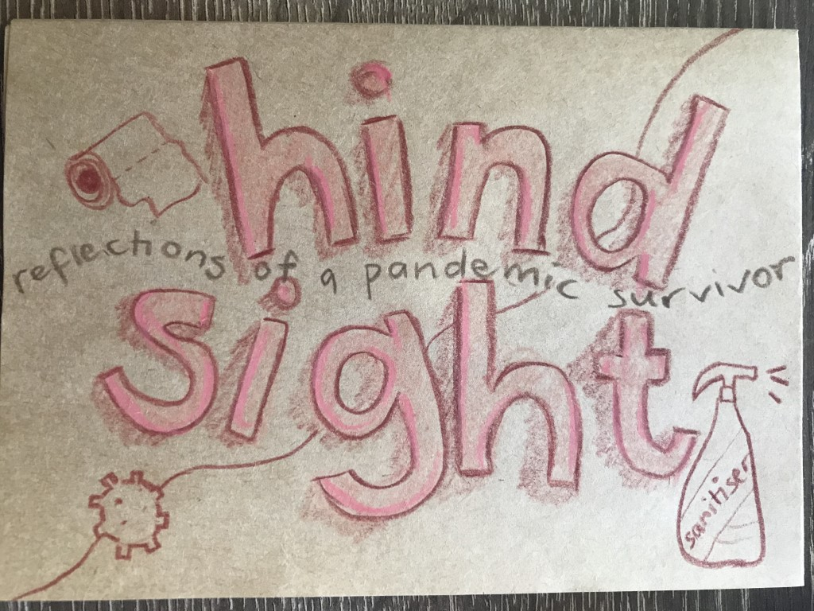
Image 5: Hindsight: Reflections from a Pandemic Survivor... Ellen Collins, 2020

Artists have done swaps and mail art exchanges for decades, but what was different about this is that we were writing about, learning to learn about art teaching in a pandemic. Crazy, right? Documenting and archiving the kinds of material and performative experiences that each of us were feeling as ways to connect, and ways to collaborate and further the cohort experience was important. This paper and its affects are running in parallel to a Project we learn about in subjects studied by teacher candidates: The City of Richgate (“a complex collaboration between community members, community organizations, educational institutions, and a research team comprising artist-educators” Bickel et al., 2011, p.86).
COVID-19 was known to us as we began the school year, we go to school year-round in Australia and the year began amidst a horror of bush fires. We had been in class for about 4 weeks, just coming to know each other’s practice, experiences and seeing how and where our life experiences overlapped. Unlike, The City of Richgate we did not design this a/r/tographical collaboration as a community or socially engaged research study. We found ourselves here, but the conditions were laid in the early weeks as we spend the first part of semester coming to know policy and curriculum, learners and learning through story as a community. We develop our pedagogies through methodology in studioFive, an onto-epistemic space carefully designed to enable practice as research to further what it is that we understand art and design education to be about, and what it can do (Healy and Coleman, 2019). Collegial and peer connections had just been starting to form when we went home to learn, the digital became the avenue for these connections and collaborations, but there was something missing. The artistry the artful exchanges of presenting and publishing work together was lost. So, we kicked off our first pandemic zine series. We have only recently begun series 2, however this paper and sessions doesn’t intend to deep dive how zines have enabled us to story and co-story our teacher becomings, rather it is discussed here as one part our collective process as artist-researcher-teachers and how we have shared “ideas and insights, while questioning our assumptions” (Bickel et al., 2011, p.91) as well as archiving our pandemic present.
Finding new ways to build rapport and class support through class playlists, class hand signs and emojis for understanding has been integral to my becoming.
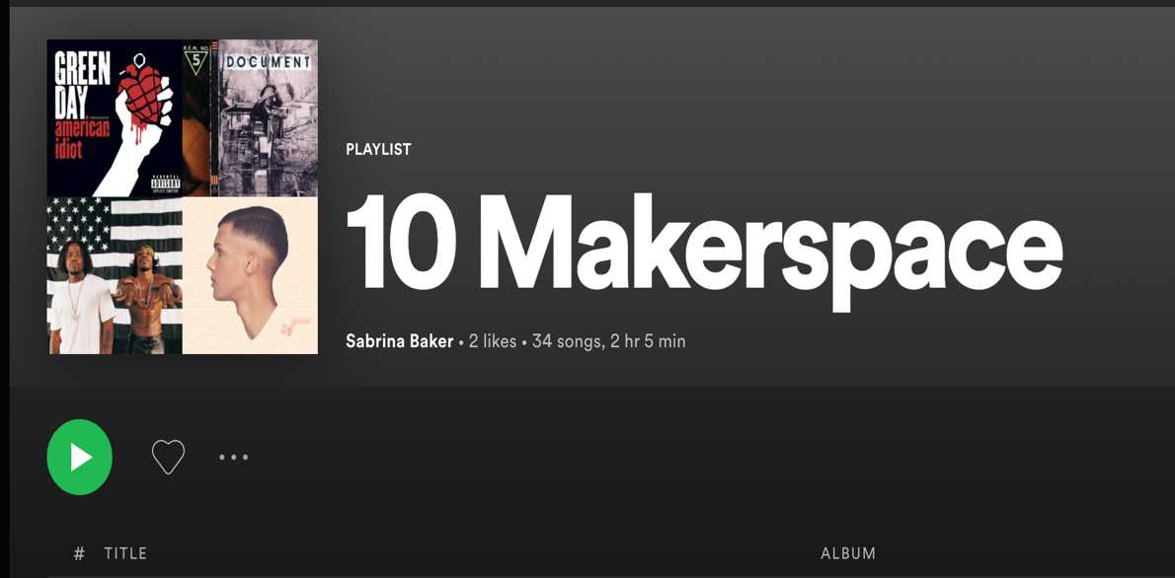
This curated mixtape from a year 10 Makerspace class, with a few tracks taken from each student's individual mixtapes, this set the class a shared soundscape/audio environment whilst working towards assignment submission. In other classes I witnessed teachers who, in response to students disinclination to turn on their mics or type a response in the chat, had created a class short hand: 🤠 if you’re good to go and you understand the task or ☠️ if you’re feeling a bit lost. The class were tight knit and enthusiastic about their shared shorthand and a little frustrated they couldn’t use it in every class as a way to quickly respond
6. Reflections of the project, reactions of its users, feedback from parents of pupils, community, etc.
The method of a/r/tographic curriculum design as radical collaboration archived and curated here have implications for learning and teaching in initial art teacher and Inservice art teacher education post-COVID. Just as Guattari asks, “How do you make a class operate like a work of art?” (1995, p. 133) COVID-19 allowed for new spaces and gaps of creativity in our multi-sited/sighted studio classrooms, that contained imaginative, curious, uncertain, wondering knowledges to be present in the renewed learning spaces, opened in new multi-cited/sited/sighted places. These multiplicitous assemblages have invited empathy, imagination, inquiry, ideation, collaborative practice and new ways of ideating and prototyping art education/al experiences. Upon reflection, this is a new multi-sited radical collaboration installation. We have become a radical work of a/r/t, having got to know the self as a/r/tist and becoming teacher within a community, a collective of knowing, doing and being through practice, alone.
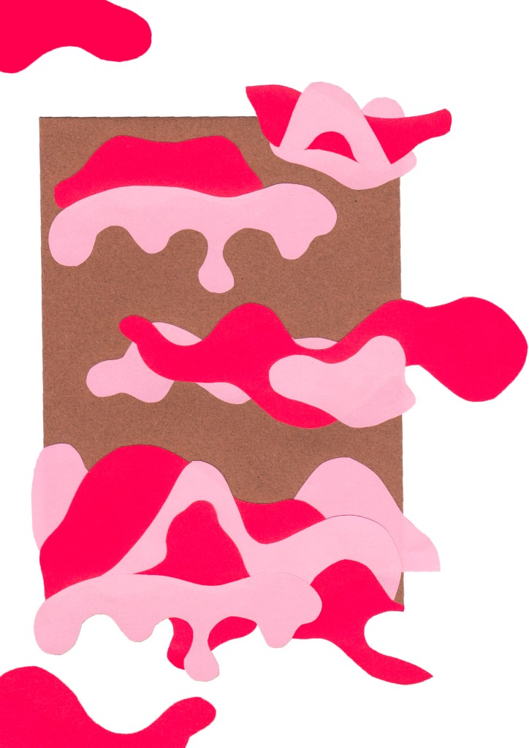

Image 6: Conceptual Collage, Gemma Saunders, 2020

There are implications here for the identity of the becoming teacher. How do I understand myself as an art teacher, having ‘learned to teach’ art from home? How do I understand myself as an a/r/tist and create practice opportunities for students working in a studio environment at/from home? We have reflected upon these shifts in understanding, and found new ways of knowing many things that emerged, including things we thought we knew like medium. We have a renewed understanding of the 3M’s:method, materiality, and immateriality. What will the implications for art education be that we now know these differently? We know that “place and identity are inextricably bound to one another. The two are co-produced as people come to identify with where they live, shape it, however modestly, and are in turn shaped by their environments, creating distinctive environmental autobiographies, the narratives we hold from the memories of those spaces and places that shaped us” (Gieseking & Mangold, 2014, p.73). We won't yet know what this radical collaboration may lead to. We may need to stay together in this multi-sited radical collaboration installation to further stay with(in) the trouble (Haraway, 2016).
7. Conclusion of the case study
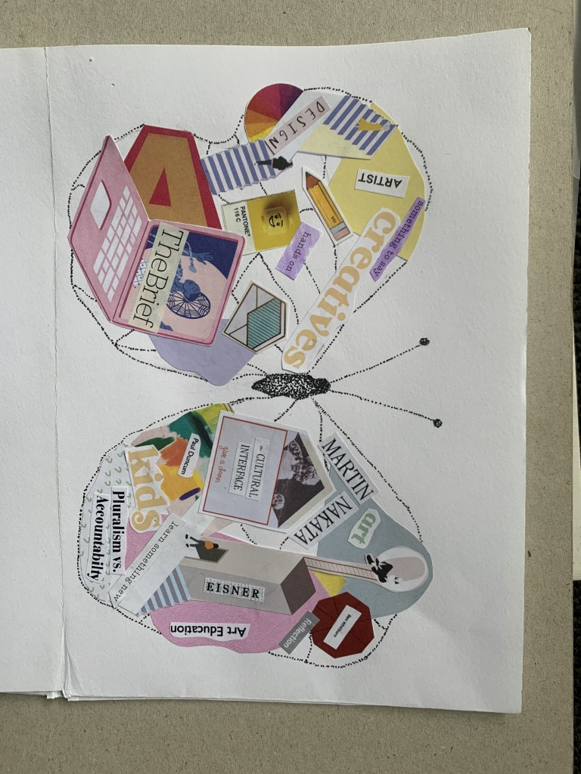

Image 7: The Butterfly: Emerging Designer & Teacher Zine spread, Lucinda Vrzovski, 2020

COVID-19 has been an opportunity to work within a forced, but generative un/bounded space for becoming. We lost the ability to learn in physical proximity, but we have gained new insights and resilience’s in this precarity of loneliness, aloneness and sadness at a world shifted, and future yet to be known. We have learned to learn as a new type of a/r/tographic educator: a radical, collaborative innovator, who can co-design maker spaces Spotify™ playlists with year 10, bridge wide digital distances between art classrooms in Australia and America through responsive gallery learning experiences, teach drawing in a flipped pedagogy in our own YouTube channels and we can see and listen differently to the place we learn on and in. Learning to listen deeply to ourselves has been a learning that as becoming art educator in lockdown, we feel rich to have been gifted. We have learned to pause, reflect and be with people who care about us and our new ways of knowing. We have learned why we are in or transitioning within art education and we see more closely than ever why radical collaborative art education matters.
References
Barrand, K. & Coleman, K. (2020). Learning through a/r/t: Post-digital art education. Coutts, G (Ed.). Eca, T (Ed.). Learning through Art: International Perspectives, (2), pp.335-347. InSEA Publications.
Bickel, B., Springgay, S., Beer, R., Irwin, R.L., Grauer, K. & Xiong, G.(2011). A/r/tographic Collaboration as Radical Relatedness. International Journal of Qualitative Methods, 10(1). Pp. 86-102.
Coleman, K. & MacDonald, A. (2020). What Are Artists and Art Educators Teaching Us About How We Can Conceive and Deliver Teacher Professional Learning into the Future? Ferdig, R (Ed.). Baumgartner, E (Ed.). Hartshorne, R (Ed.). Kaplan-Rakowski, R (Ed.). Mouza, C (Ed.). Teaching, Technology, and Teacher Education During the COVID-19 Pandemic: Stories from the Field., (1), pp.13-16. AACE-Association for the Advancement of Computing in Education.
Coleman, K. & Selkrig, M. (2020). When the going gets tough, artists and arts educators get going, Edu Research Matters Blog, Australian Association and Research in Education, May 11th, 2020. Retrieved from: https://www.aare.edu.au/blog/?p=5463
Gieseking, J., W. Mangold, C. Katz, S. Low, and S. Saegert (eds.). The People, Place, and Space Reader. New York, Routledge.
Haraway, D. 2016. Staying with the trouble: Making Kin in the Chthulucene, Duke University Press, North Carolina, United States.
Healy, S., & Coleman, K. (2019). A place to practice: Becoming practitioner in SPACE. In the InSEA 2019 World Congress proceedings. Vancouver: UBC. Retrieved from: https://www.insea2019.org/congressproceedings
Hickey-Moody, A. & Harrison, M. (2018). Socially Engaged Art and Affective Pedagogy: A Study in Inter-Faith Understanding, in Tate Papers, no.29, Spring 2018, https://www.tate.org.uk/research/publications/tate-papers/29/socially-engaged-art-and- affective-pedagogy
McKernan, M. (2004). Radical relatedness: Exploring the spiritual dimension of family service work. Edmonton: Muttart Foundation.

Learning in Visual Arts, VCAA https://victoriancurriculum.vcaa.vic.edu.au/the-arts/visual-arts/introduction/rationale-and-aims
Learning in Visual Arts involves students making and responding to artworks, drawing on the world as a source of ideas. Students engage with the knowledge of visual arts, develop skills, techniques and processes, and use materials as they explore a range of forms, styles and contexts, ACARA. https://www.australiancurriculum.edu.au/f-10-curriculum/the-arts/visual-arts/

