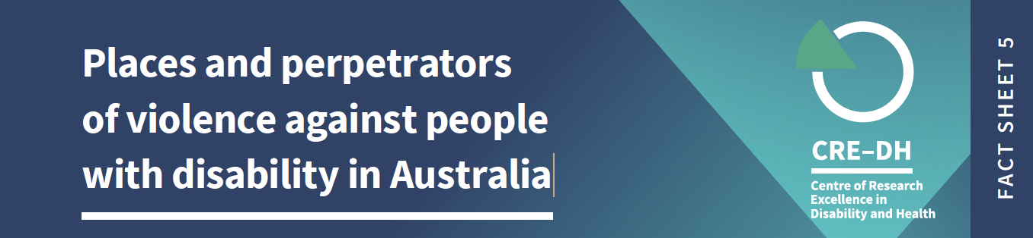

Plain language summary

In Australia people with disability are more likely to experience violence from someone they know, than by a stranger.
This is the final fact sheet in the series on violence against people with disability in Australia. We use data from national surveys where people reported their experience of violence in the last 12 months and since the age of 15. We report on people aged 18-64 only. Not all people with disability are represented in the surveys, and reports of violence may be under-reported.
When we refer to violence, it includes the most recent incident of physical or sexual violence experienced in the last 10 years and includes physical assault, physical threat, sexual assault and sexual threat.

Key facts

- 35% of people with disability experience violence from someone they know, compared to 18% of people without disability.

- 13% of people with disability experience violence from strangers, compared to 11% of people without disability.

GENDER AND VIOLENCE

There are differences between how men and women experience violence when it comes to people they know and those unknown to them.

- 30% of men with disability experience violence from someone they know, compared to 15% of men without disability.

- 40% of women with disability experience violence from someone they know, compared to 21% of women without disability.

- Men with and without disability experience similar levels of violence (18%) from a stranger.

- 8% of women with disability experience violence from a stranger, compared to 4% of women without disability.

PERPETRATORS

People with disability are more likely to experience violence by a current or former intimate partner or someone they know*.

- 17% of people with disability experience violence from an intimate partner (current or former), compared to 8% of people without disability,

- 4% if people with disability experience violence from a family member, compared to 2% of people without disability.

- 14% of people with disability experience violence from someone they know, compared to 8% of people without disability.

*Someone they know includes friends, housemate, neighbour, acquaintance, co-worker, employer, client, customer and other known people.

PARTNER VIOLENCE - Differences by gender

Women with disability are more likely to experience violence from a current or former partner. Men with disability are more likely to experience violence by someone they know.

- 11% of men with disability experience violence from an intimate partner (current or former), compared to 4% of men without disability.

- 22% of women with disability experience violence from an intimate partner (current or former), compared to 12% of women without disability.

OTHER KNOWN PERSON VIOLENCE - Differences by gender

- 17% of men with disability experience violence from someone they know compared to 9% of men without disability.

- 11% of women with disability experience violence from someone they know compared to 6% of women without disability.

WHERE VIOLENCE OCCURS

People with disability experience more violence at home and in public places than people without disability.

- 17% of people with disability experience violence in the home, compared to 8% of people without disability.

- 16 % of people with disability experience violence in public, compared to 12% of people without disability.

WHERE VIOLENCE OCCURS – Differences by gender

Women with disability are more likely to experience violence in their own home.

- 11% of men with disability experience violence at home, compared to 6% of men without disability.

- 22% of women with disability experience violence at home, compared to 11% of women without disability.

Men with disability are more likely to experience violence in public places.

- 20% of men with disability experience violence in public, compared to 18% of men without disability.

- 12% of women with disability experience violence in public to 6% of women without disability.

Notes on data and definitions

Violence against people with disability is a significant human rights issue. We acknowledge the strength and resilience of people with disability who have survived violence. We thank those who have reported their experiences for making this work possible.
We have used data from the Personal Safety Survey 2016. There is no support available for people who need assistance to complete the survey, and therefore the data does not represent the experiences of all people with disability.
Most recent incident data does not provide information about patterns of violence; it only provides information about the most recent incident. We acknowledge that violence is often experienced as
an ongoing pattern of abusive behaviors not as a single event.
In this fact sheet we refer to men and women, and not to other gender identities. This is because of the way gender is labeled in the data sources we have reported on. Estimates are directly age-adjusted to the June 2018 Australian population. Age adjusting is a statistical technique that helps make fairer comparisons between groups with different age distributions. In the data, violence refers to events and threat. It includes violence used by people who are strangers, and by people who know each other. Violence includes physical or sexual violence, emotional abuse, intimate partner violence, stalking and/or harassment. Intimate Partner Violence refers to a current or previous partner with whom the respondent lived, or current or former boyfriend, girlfriend, or dating partner with whom the respondent did not live. For more information on how disability is collected in the survey, go to this website

Further information
The Violence against People with Disability Fact Sheets were produced by the team at the Centre of Research Excellence in Disability and Health (CRE-DH) and funded by the Melbourne Disability Institute.
Data source: ABS (Australian Bureau of Statistics) 2017. Microdata: Personal Safety, Australia, 2016. ABS cat. No.4906.0.55.001 Canberra: ABS. CRE-DH analysis of Datalab.: Figures are rounded.
www.credh.org.au

