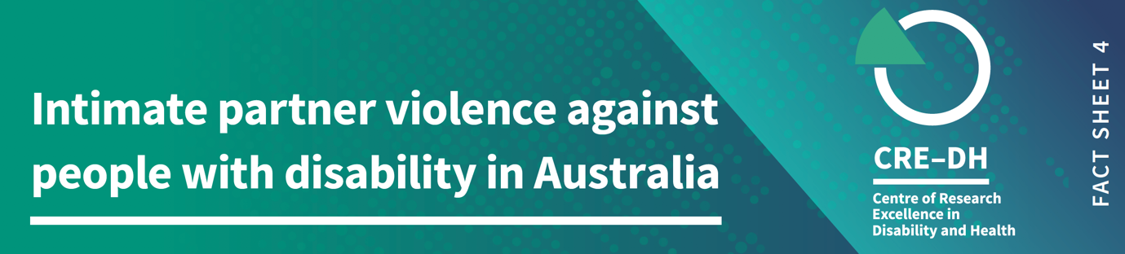

Plain language summary

In Australia people with disability are more likely to experience violence by a partner than people without disability.
This fact sheet is fourth in the series on violence against people with disability in Australia and is based on current data for men and women aged 18-64 years. Intimate partner violence (sometimes called domestic violence) is generally described as abuse that happens in the context of a current or former intimate partner relationship (married, living with or dating). Data are sourced from the Australian Bureau of Statistics 2016 Personal Safety Survey where people have reported on their experience of violence in the last 12 months and since the age of 15. We recognise that not all people with disability are represented in this survey and that experiences of violence are under-reported.

When we refer to violence, it includes physical or sexual violence, emotional abuse, intimate partner violence, stalking and harassment.

Key facts

- 26% of people with disability compared to 14% of people without disability, reported an incident of intimate partner violence since the age of 15.
- 4% of people with disability compared to 1.5% of people without disability reported an incident of intimate partner violence in the last 12 months.
Intimate Partner Violence by gender
- 15% of men with disability experienced an incident of partner violence since the age of 15, compared with 7% of men without disability
- 36% of women with disability have experienced an incident of partner violence since the age of 15, compared to 21% of women without disability. That’s one in three women with disability have experienced at least one violent incident from an intimate partner in their lifetime.
- In the last 12 months, 4% of men with disability experienced an incident of partner violence compared to 1% of men without disability.
- 5% of women with disability experienced an incident of partner violence compared with 2% of women without disability. Women with disability are twice as likely to report a violent incident by an intimate partner, than women without disability.

Intimate Partner Violence by impairment

- 52% of women and 17% of men with cognitive impairments have experienced intimate partner violence since the age of 15
- 51% of women and 26% of men with psychological impairments have experienced intimate partner violence since the age of 15
- 37% of women and 15% of men with physical impairments have experienced intimate partner violence since the age of 15
- 38% of women and 17% of men with sensory or speech impairments have experienced intimate partner violence since the age of 15

Emotional Abuse by a Partner
- 31% of people with disability report almost twice the levels of emotional abuse by a partner across the lifetime, compared to 18% of people without disability
- Similarly, people with disability (8%) are twice as likely to report emotional abuse by a partner than people without disability (4%) in the last 12 months

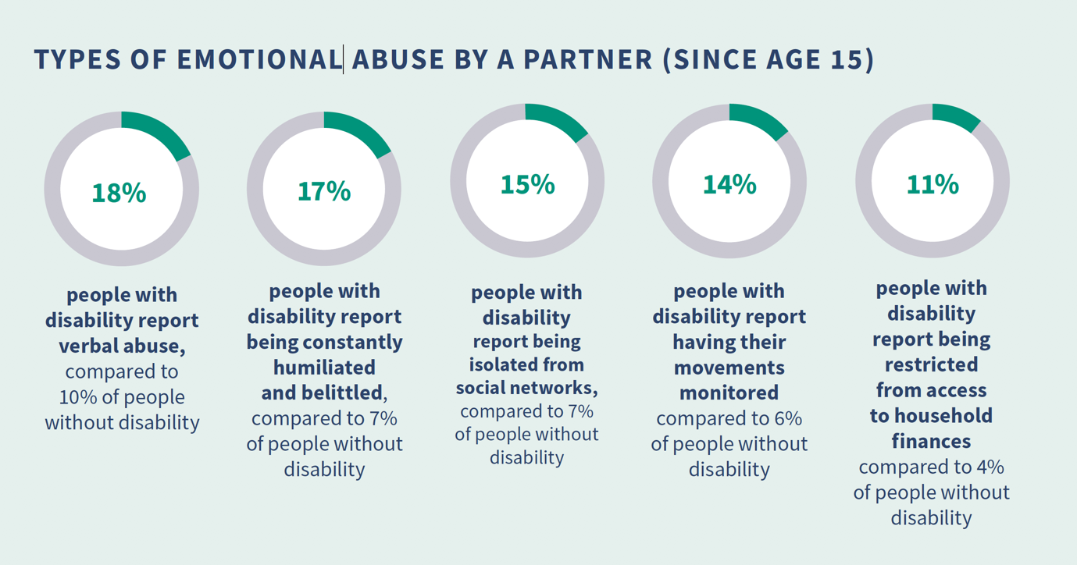

Emotional Abuse by a Partner by gender
- 24% of men with disability have experienced emotional abuse from their partner in their lifetime, compared to 15% of men without disability
- 37% of women with disability have experienced emotional abuse from their partner in their lifetime, compared to 20% of women without disability
- Over a 12-month period, women with disability (9%) are twice as likely than women with no disability (5%) to report emotional abuse by their partner
- 7% of men with disability reported emotional abuse by their partner in the last 12 months, compared to 4% of men without disability

Emotional Abuse by a Partner by impairment
- 51% of women and 21% of men with cognitive impairments have experienced emotional abuse from a partner violence since the age of 15
- 50% of women and 34% of men with psychological impairments have experienced emotional abuse from a partner violence since the age of 15
- 37% of women and 26% of men with physical impairments have experienced emotional abuse from a partner violence since the age of 15
- 41% of women and 22% of men with sensory or speech impairments have emotional abuse from a partner violence since the age of 15
Notes on data and definitions
Violence against people with disability is a significant human rights issue. We acknowledge the strength and resilience of people with disability who have survived violence. We thank those who have disclosed their experiences for making this work possible.
We have used data from the Personal Safety Survey 2016 for most of this fact sheet. We are aware that there is no support available for people who need assistance to complete the survey and therefore does not represent the experiences of all people with disability.
We report on experiences of violence in the last 12 months which provides an indication of recent experience. We also report on violence across the lifespan from the age of 15, which estimates the total number of people affected by violence.
In this fact sheet we refer to men and women, and not to other gender identities. This is because of the way gender is labeled in the data sources we have reported on.
Estimates are directly age-adjusted to the June 2018 Australian population. Age adjusting is a statistical technique that helps make fairer comparisons between groups with different age distributions.
In the data, violence refers to events and threat. It includes violence used by people who are strangers, and by people who know each other. Violence includes physical or sexual violence, emotional abuse, intimate partner violence, stalking and/or harassment. Intimate Partner Violence refers to a current or previous partner with whom the respondent lived, or current or former boyfriend, girlfriend, or dating partner with whom the respondent did not live. For more information on how disability is collected in the survey, go to this website
Further information
The Violence against People with Disability Fact Sheets were produced by the team at the Centre of Research Excellence in Disability and Health (CRE-DH) and funded by the Melbourne Disability Institute.
Data source: ABS (Australian Bureau of Statistics) 2017. Microdata: Personal Safety, Australia, 2016. ABS cat. No.4906.0.55.001 Canberra: ABS. CRE-DH analysis of Datalab. Note: Figures are rounded.
www.credh.org.au

