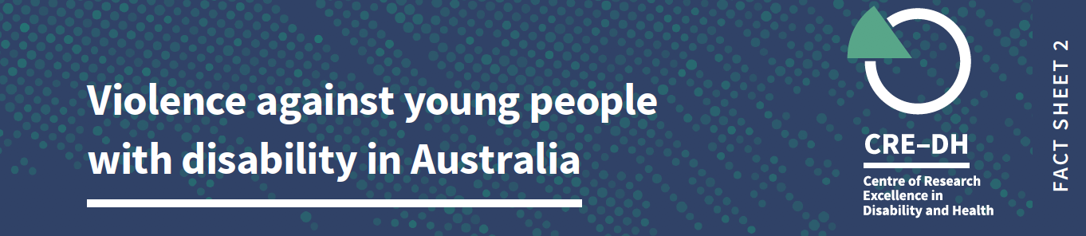

Plain language summary

In Australia, young people with disability experience high rates of violence. This is the second fact sheet in a series about violence against people with disability in Australia. In this fact sheet, young people are defined as between 18-29 years. The data are sourced from the Australian Bureau of Statistics 2016 Personal Safety Survey where people reported on their experience of violence in the last 12 months. We recognise that not all people with disability are represented in the survey and that rates of violence may be under-reported.

When we refer to violence, it includes physical or sexual violence, emotional abuse, intimate partner violence, stalking and/or harassment.

Key facts

- 25% of young people with disability have experienced violence, compared to 13% of young people without disability.

- Young women with disability (27%) are more than twice as likely to experience violence, compared to young women without disability (13%).

- 23% of young men with disability report experiences of violence, compared to 12% of young men without disability.

Stalking and Harassment
- 9% of young people with disability were stalked or harassed in the last 12 months, compared with 3% of young people without disability.

- 10% of young women with disability were stalked or harassed in the last year, compared with 5% of women without disability. 7% of young men with disability were stalked or harassed compared to 1% of young men without disability.

Intimate Partner Violence

- Young people with disability (7.5%) are three times as likely to have experienced intimate partner violence** in the last 12 months compared to young people without disability (2.5%).

- Young women with disability (8%) and young men with disability (7%) experience more intimate partner violence than women (4%) and men (1%) without disability.

Sexual Violence

- 6% of young people with disability report sexual violence compared to 3% of young people without disability.
- In terms of sexual violence against women, young women with disability (9%) are twice as likely than young women without disability (4%) to report sexual violence in the last 12 months.

- Young men, both with and without disability, report lower rates of sexual violence than young women with and without disability.

Physical Violence
- 13% of young people with disability report physical violence in the last 12 months compared to 7% of young people without disability.

- 14% of young men with disability and 13% of young women with disability report some form of physical violence in the last year, compared to 9% of young men and 5% of young women without disability.

Notes on data and definitions

Violence against people with disability is a significant human rights issue. We acknowledge the strength and resilience of people with disability who have survived violence. We thank those who have reported their experiences for making this work possible.
We have used data from the Personal Safety Survey 2016. There is no support available for people who need assistance to complete the survey, and therefore the data does not represent the experiences of all people with disability.
In this fact sheet we refer to men and women, and not to other gender identities. This is because of the way gender is labeled in the data sources we have reported on.
In the data, violence refers to events and threat. It includes violence used by people who are strangers, and by people who know each other. Violence includes physical or sexual violence, emotional abuse, intimate partner violence, stalking and/or harassment. Intimate Partner Violence refers to a current or previous partner with whom the respondent lived, or current or former boyfriend, girlfriend, or dating partner with whom the respondent did not live.
For more information on how disability is collected in the survey, go to this website
Further information
The Violence against People with Disability Fact Sheets were produced by the team at the Centre of Research Excellence in Disability and Health (CRE-DH) and funded by the Melbourne Disability Institute.
Data source: ABS (Australian Bureau of Statistics) 2017. Microdata: Personal Safety, Australia, 2016. ABS cat. No.4906.0.55.001 Canberra: ABS. CRE-DH analysis of Datalab.: Figures are rounded.

www.credh.org.au

